System bazodanowy dla zespołu regionalnego ZPiT Mietniowiacy[1] (do wypożyczania strojów)

Autorzy KKK: Kaczor Filip, Kowalski Jakub, Kogut Jakub

Spis Treści

Spis pojęć 8

Opis projektu 8

Wymagania Klient 8

Wymagania Strój 8

Wymagania User 9

Wymagania Kostiumolog 9

Wymagania Członka Chóru 9

Wymagania Członka Kapeli 9

Wymagania Członka Baletu 9

Schemat bazy danych 10

Tabele 11

Countries 11

Regions 12

Settlements 13

Locations 14

Genders 15

Users 16

Roles 19

Types_of_voices 20

Types_of_instruments 21

Dances 22

Costumiers 23

Singers 25

Singer_voices 27

Musicians 29

Musician_instrument 31

Dancers 33

Dancer_dance 35

Colors 36

Collections 37

Costumes_items 38

Patterns 40

Head_accessory_categories 41

Head_accessories 42

Aprons 44

Caftans 46

Petticoats 48

Corsets 50

Skirts 52

Belts 54

Shirts 56

Pants 58

Boots 60

Neck_accessories 61

Costumes 63

States_of_requests 68

Requests 69

Rental_costume_item_requests 71

Return_costume_item_requests 73

Borrow_costume_item_requests 75

Notifications 77

Rentals 79

Wyzwalacze 81

prevent_invalid_costume_item_insert 81

prevent_invalid_costume_insert_update 84

prevent_invalid_request_delete 85

prevent_invalid_request_insert 86

prevent_invalid_rental_costume_item_request_insert 87

prevent_invalid_return_costume_item_request_insert 88

prevent_invalid_borrow_costume_item_request_insert 89

prevent_invalid_notification_insert 90

prevent_invalid_rental_insert 91

Widoki 92

Locations_with_settlements_regions_countries 92

User_count_by_settlement 93

User_function_counts 94

Detailed_users 95

Detailed_singers 97

Detailed_musicians 98

Detailed_dancers 99

Singer_count_by_voice_type 100

Musician_count_by_instrument_type 101

Dancer_count_by_dance_type 102

Costume_item_count_by_collection_and_class 103

Costume_item_count_by_class 107

Detailed_aprons 108

Detailed_boots 109

Detailed_petticoats 110

Detailed_skirts 111

Detailed_caftans 112

Detailed_corsets 113

Detailed_neck_accessories 114

Detailed_head_accessories 115

Detailed_belts 116

Detailed_pants 117

Detailed_shirts 118

Costume_with_costume_items_name 119

Not_read_notifications 121

Detailed_rental_costume_item_requests 122

Detailed_return_costume_item_requests 123

Detailed_borrow_costume_item_requests 124

Detailed_costume_item_requests 125

Current_rentals_count_by_costume_item_class 126

Current_rentals_count_by_user_function 128

Detailed_rentals 129

Detailed_current_rentals 130

Funkcje 131

check_costume_inconsistency 131

check_rental_inconsistency 138

get_costume_item_rental_history 140

check_if_error_in_costume_item_common_part 141

get_user_rental_history 143

get_costumier_unresolved_requests 144

get_user_unresolved_borrow_requests 146

get_user_current_rentals 148

get_user_function_percentage 149

get_fits_aprons 150

get_fits_boots 151

get_fits_petticoats 152

get_fits_skirts 154

get_fits_caftans 155

get_fits_corsets 157

get_fits_neck_accessories 159

get_fits_head_accessories 160

get_fits_belts 162

get_fits_pants 163

get_fits_shirts 165

get_user_unread_notifications 167

get_user_unclosed_costume_item_requests 168

Procedury 169

add_country 169

add_region 170

add_settlement 171

add_location 173

add_gender 175

add_role 176

add_type_of_voice 177

add_type_of_instrument 178

add_dance 179

add_color 180

add_collection 181

add_pattern 182

add_head_accessory_category 183

add_state_of_request 184

add_user 185

make_user_costumier 189

make_user_singer 191

make_user_musician 193

make_user_dancer 195

add_voice_to_singer 197

add_instrument_to_musician 199

add_dance_to_dancer 201

add_apron 203

add_head_accessory 205

add_caftan 207

add_petticoat 209

add_corset 211

add_skirt 214

add_belt 216

add_shirt 218

add_pants 221

add_boots 223

add_neck_accessory 225

update_apron 227

update_head_accessory 229

update_caftan 231

update_petticoat 234

update_corset 236

update_skirt 239

update_belt 241

update_shirt 243

update_pants 246

update_boots 248

update_neck_accessory 250

add_costume 252

add_rental_costume_item_request 257

add_return_costume_item_request 259

add_borrow_costume_item_request 261

add_notification 263

add_rental 265

update_costume_item_location 267

delete_request 269

accept_rental_costume_item_request 270

deny_rental_costume_item_request 272

accept_return_costume_item_request 274

deny_return_costume_item_request 276

accept_borrow_costume_item_request 278

deny_borrow_costume_item_request 280

mark_notification_as_read 282

rent_costume_item 283

borrow_costume_item 285

Indeksy 287

Idx_users_first_last 288

Idx_users_phone_number 289

Idx_users_home_location_id 290

Idx_costumiers_role_id 291

Idx_costumiers_work_location_id 293

Idx_singers_role_id 295

Idx_musicians_role_id 296

Idx_dancers_role_id 297

Idx_costumes_items_collection_id 298

Idx_costumes_items_gender_id 299

Idx_costumes_items_color_id 300

Idx_costumes_items_location_id 301

Idx_head_accessories_category_id 302

Idx_aprons_pattern_id 303

Idx_costumes_collection_id 304

Idx_costumes_gender_id 305

Idx_costumes_apron_id 306

Idx_costumes_caftan_id 307

Idx_costumes_petticoat_id 308

Idx_costumes_petticoat_id 309

Idx_costumes_skirt_id 310

Idx_costumes_belt_id 311

Idx_costumes_shirt_id 312

Idx_costumes_pants_id 313

Idx_costumes_boots_id 314

Idx_costumes_neck_accessory_id 315

Idx_costumes_head_accessory_id 316

Idx_requests_state_id 317

Idx_requests_requester_user_id 318

Idx_requests_datetime 319

Idx_rental_requests_costume_item_id 320

Idx_rental_requests_approver_costumier_id 321

Idx_return_requests_costume_item_id 322

Idx_return_requests_approver_costumier_id 323

Idx_borrow_requests_costume_item_id 324

Idx_borrow_requests_approver_costumier_id 325

Idx_notifications_user_id 326

Idx_notifications_datetime 327

Idx_notifications_due_to_request_id 328

Idx_rentals_user_id 329

Idx_rentals_costume_item_id 330

Idx_rentals_date_of_rental 331

Idx_rentals_date_of_return 332

Idx_rentals_done_due_request_id 332

Użytkownicy 334

Normal_user 334

Costumier 335

Manager 337

Para_admin 339

Przykłady użycia 343

Akceptacja request’u wypożycz 343

Finalizacja wypożyczenia 343

Odmowa request’u pożycz 343

Użytkownik wypożycza koszulę 344

Dodanie i poprawa informacji o fartuszku 344

Sprawdzenie wypożyczenia elementu stroju. 344

# Spis pojęć

Klient – Kierownik Zespół Pieśni i Tańca Mietniowiacy.

User – Członek zespołu.

Strój – Pojedynczy element kostiumu regionalnego lub zbiór elementów stanowiący jedną całość.

Kostiumolog – Członek zespołu odpowiedzialny za utrzymanie Strój.

Wypożyczyć – Udostępnienie Strój przez Kostiumolog dla User do jego przechowywania w domu.

Oddać – Zwrócenie Strój do Kostiumolog przez User w konkretnej lokalizacji.

Pożyczyć - User swój wypożyczony Strój przekazuje innemu User. Transakcja inicjowana jest przez User, a wymagana jest jedynie zgoda drugiego User. Nie jest wymagana zgoda Kostiumolog.

# Opis projektu

Głównym celem projektu jest dostarczenie kompleksowego systemu bazodanowego umożliwiającego zarządzanie zespołem. Część podlegająca ocenie jako zaliczenie z przedmiotu Bazy Danych skupia się na części umożliwiającej User przeprowadzanie wypożyczenia Strój. Przedstawicielem Klient od spraw ww. projektu jest członek zespołu – Jakub Kowalski.

## Wymagania Klient

* Wypożyczyć i Oddać Strój odbywa się wyłącznie za zgodą Kostiumolog.
* Możliwe jest pożyczenie Strój innemu User. Odbywa się to bez zgody Kostiumolog, natomiast wymagana jest zgoda od User obecnie posiadającego Strój, do wykonania takiej transakcji.
* User, Kostiumolog zostają poinformowani o zgłoszeniach o Wypożyczyć, Oddać lub Pożyczyć.
* User może pełnić funkcje: tancerz, śpiewaka, muzyka, kostiumologa.

### Wymagania Strój

* Strój posiada informacje o swoich właściwościach fizycznych (przekazanych przez Przedstawiciela).
* Dodatkowo Strój powinien posiadać informacje o jego obecnej lokalizacji.
* Jeśli został Wypożyczyć to lokalizacja to adres User, jeśli Oddać to miejsce ośrodka do którego został zwrócony Strój.

### Wymagania User

* User może zobaczyć Strój, swoje Strój, Strój który pasuje wymiarowo.
* User może Wypożyczyć Strój lub go Oddać.
* User może zainicjować Pożyczyć Strój.
* User może zobaczyć stan Wypożyczyć, Oddać lub Pożyczyć.
* User może anulować Wypożyczyć, Oddać lub Pożyczyć Strój.
* User może wyrazić zgodę na Pożyczyć lub jej nie wyrazić.
* User może zobaczyć i oznaczyć jako przeczytaną informację o decyzji związanej z Wypożyczyć, Oddać i Pożyczyć Strój.
* User może zobaczyć historię swoich Wypożyczyć, Oddać i Pożyczyć Strój.

### Wymagania Kostiumolog

* Kostiumolog dziedziczy po User.
* Posiada dodatkowe informacje o lokalizacji miejsca pracy i pełniącej roli.
* Kostiumolog może zobaczyć Strój należący do innego User
* Kostiumolog może dodawać i edytować informacje o Strój.
* Kostiumolog może zobaczyć prośby o Wypożyczyć i Oddać.
* Kostiumolog może wyrazić zgodę na Wypożyczyć lub Oddać Strój lub jej nie wyrazić.
* Kostiumolog może zobaczyć historię Wypożyczyć, Oddać i Pożyczyć Strój innych User.

### Wymagania Członka Chóru

* Członek chóru dziedziczy po User
* Posiada informację o pełniącej roli oraz jakimi głosami potrafi śpiewać.

### Wymagania Członka Kapeli

* Członek chóru dziedziczy po User
* Posiada informację o pełniącej roli oraz na jakich instrumentach potrafi grać.

### Wymagania Członka Baletu

* Członek chóru dziedziczy po User
* Posiada informację o pełniącej roli oraz jakie tańce potrafi tańczyć.

# Schemat bazy danych

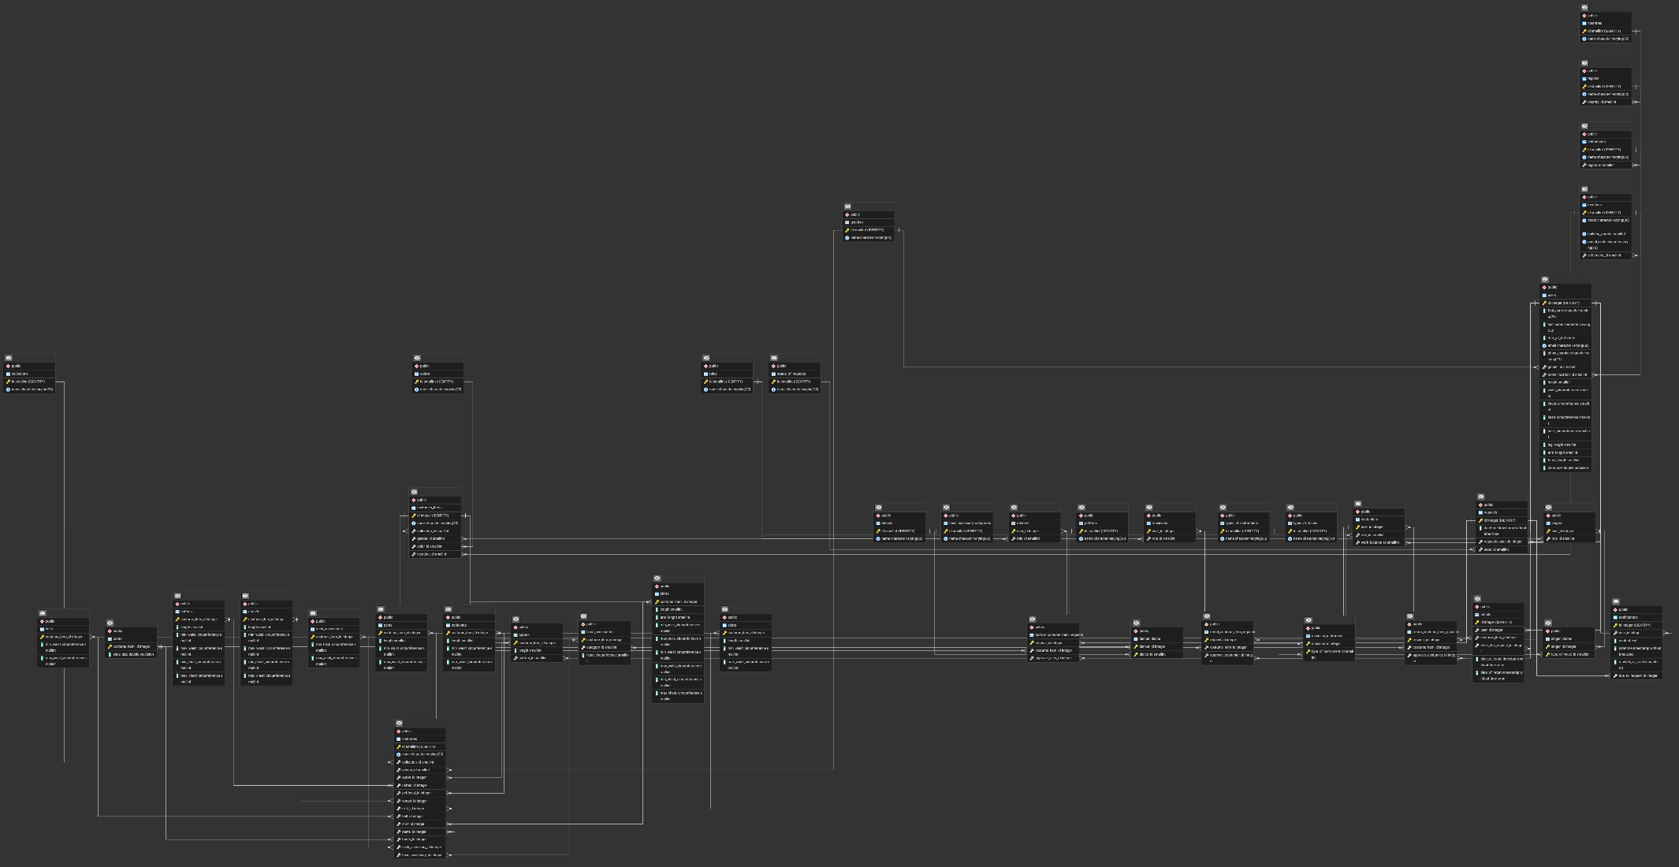

# Tabele

## Countries

**Opis:**

* Tabela zawiera informacje o krajach.

**Warunki integralności:**

* Nazwa danego kraju może wystąpić tylko raz.

**Implementacja:**

CREATE TABLE Countries

(

id SMALLINT GENERATED ALWAYS AS IDENTITY NOT NULL ,

name VARCHAR(30) NOT NULL

)

;

ALTER TABLE Countries

ADD CONSTRAINT Countries_PK PRIMARY KEY ( id ) ;

ALTER TABLE Countries

ADD CONSTRAINT Countries_UN UNIQUE ( name ) ;

## Regions

**Opis:**

* Tabela zawiera informacje o regionach danego kraju.
* Kraj – klucz obcy do tabeli Countries.

**Warunki integralności:**

* Nazwa danego regionu może wystąpić tylko raz dla danego kraju.

**Implementacja**:

CREATE TABLE Regions

(

id SMALLINT GENERATED ALWAYS AS IDENTITY NOT NULL ,

name VARCHAR (30) NOT NULL ,

country_id SMALLINT NOT NULL

)

;

ALTER TABLE Regions

ADD CONSTRAINT Regions_PK PRIMARY KEY ( id ) ;

ALTER TABLE Regions

ADD CONSTRAINT Regions_UN UNIQUE ( name , country_id ) ;

ALTER TABLE Regions

ADD CONSTRAINT Regions_Countries_FK FOREIGN KEY

(

country_id

)

REFERENCES Countries

(

id

)

ON DELETE RESTRICT

ON UPDATE CASCADE

;

## Settlements

**Opis:**

* Tabela zawiera informacje o miejscowościach danego regionu.
* Region – klucz obcy do tabeli Regions

**Warunki integralności:**

* Nazwa danej miejscowości może wystąpić tylko raz dla danego regionu.

**Implementacja:**

CREATE TABLE Settlements

(

id SMALLINT GENERATED ALWAYS AS IDENTITY NOT NULL,

name VARCHAR(30) NOT NULL ,

region_id SMALLINT NOT NULL

)

;

ALTER TABLE Settlements

ADD CONSTRAINT Settlements_PK PRIMARY KEY ( id ) ;

ALTER TABLE Settlements

ADD CONSTRAINT Settlements_UN UNIQUE ( name , region_id ) ;

ALTER TABLE Settlements

ADD CONSTRAINT Settlements_Regions_FK FOREIGN KEY

(

region_id

)

REFERENCES Regions

(

id

)

ON DELETE RESTRICT

ON UPDATE CASCADE

;

## Locations

**Opis:**

* Tabela zawiera informacje o konkretnym miejscu (lokacji).
* Lokacja składa się z ulicy, numeru budynki, kodu pocztowego i konkretnego miasta/wsi.
* Miasto/wieś – klucz obcy do tabeli Settlements

**Warunki integralności:**

* Dana lokacja (ulica, numer budynku, kod pocztowy, id miasta/wsi) musi być unikatowa.

**Implementacja:**

CREATE TABLE Locations

(

id SMALLINT GENERATED ALWAYS AS IDENTITY NOT NULL ,

street VARCHAR (30) NOT NULL ,

building_number SMALLINT NOT NULL ,

postal_code VARCHAR (10) NOT NULL ,

settlement_id SMALLINT NOT NULL

)

;

ALTER TABLE Locations

ADD CONSTRAINT Locations_PK PRIMARY KEY ( id ) ;

ALTER TABLE Locations

ADD CONSTRAINT Locations_UN UNIQUE ( street , building_number , postal_code , settlement_id ) ;

ALTER TABLE Locations

ADD CONSTRAINT Locations_Settlements_FK FOREIGN KEY

(

settlement_id

)

REFERENCES Settlements

(

id

)

ON DELETE RESTRICT

ON UPDATE CASCADE

;

## Genders

**Opis:**

* Tabela zawiera informacje o płciach.

**Warunki integralności:**

* Dana płeć może wystąpić tylko raz.
* Id:
  + 1: male
  + 2: female
  + 3: bigender

**Implementacja:**

CREATE TABLE Genders

(

id SMALLINT GENERATED ALWAYS AS IDENTITY NOT NULL ,

name VARCHAR (25) NOT NULL

)

;

ALTER TABLE Genders

ADD CONSTRAINT Genders_PK PRIMARY KEY ( id ) ;

ALTER TABLE Genders

ADD CONSTRAINT Genders_UN UNIQUE ( name ) ;

INSERT INTO Genders (name) VALUES ('male'), ('female'), ('bigender');

## Users

**Opis:**

* Tabela zawiera ogólne informacje o członkach zespołu (użytkownikach).
* Informacje przechowywane to: pierwsze imię, nazwisko, data urodzenia, adres email, numer telefonu (kierunkowy), płeć, lokalizacje zamieszkania, wysokość, obwód w pasie, obwód w klatce piersiowej, obwód głowy, obwód szyi, długość nogi (od pasa do kostki), długość ręki (od ramienia do nadgarstku), długość torsu (od szyi do pasa) i rozmiar buta (miara EU). Wszystkie miary są podawane w cm.
* Płeć – klucz obcy do tabeli Genders.
* Lokalizacja zamieszkania – klucz obcy do tabeli Locations.

**Warunki integralności:**

* Użytkownik musi posiadać unikatowy adres email.
* Email musi posiadać odpowiednią formę.
* Numer telefonu musi posiadać odpowiednią formę.
* Parametry fizyczne (np. wzrost) nie mogą być ujemne lub 0.

**Implementacja:**

CREATE TABLE Users

(

id INTEGER GENERATED ALWAYS AS IDENTITY NOT NULL ,

first_name VARCHAR (25) NOT NULL ,

last_name VARCHAR (30) NOT NULL ,

date_of_birth DATE NOT NULL ,

email VARCHAR (50) NOT NULL ,

phone_number VARCHAR (12) NOT NULL ,

gender_id SMALLINT NOT NULL ,

home_location_id SMALLINT NOT NULL ,

height SMALLINT NOT NULL ,

waist_circumference SMALLINT NOT NULL ,

chest_circumference SMALLINT NOT NULL ,

head_circumference SMALLINT NOT NULL ,

neck_circumference SMALLINT NOT NULL ,

leg_length SMALLINT NOT NULL ,

arm_length SMALLINT NOT NULL ,

torso_length SMALLINT NOT NULL ,

shoe_size FLOAT NOT NULL

)

;

ALTER TABLE Users

ADD CONSTRAINT Users_PK PRIMARY KEY ( id ) ;

ALTER TABLE Users

ADD CONSTRAINT Users_UN UNIQUE ( email ) ;

ALTER TABLE Users

ADD CONSTRAINT chk_email_format CHECK (email ~* '^[a-zA-Z0-9._%+-]+@[a-zA-Z0-9.-]+\.[a-zA-Z]{2,}$');

ALTER TABLE Users

ADD CONSTRAINT chk_phone_format CHECK (phone_number ~* '^\+\d{2}\d{9}$');

ALTER TABLE Users

ADD CONSTRAINT chk_height_value CHECK (height > 0);

ALTER TABLE Users

ADD CONSTRAINT chk_waist_circumference_value CHECK (waist_circumference > 0);

ALTER TABLE Users

ADD CONSTRAINT chk_chest_circumference_value CHECK (chest_circumference > 0);

ALTER TABLE Users

ADD CONSTRAINT chk_head_circumference_value CHECK (head_circumference > 0);

ALTER TABLE Users

ADD CONSTRAINT chk_neck_circumference_value CHECK (neck_circumference > 0);

ALTER TABLE Users

ADD CONSTRAINT chk_leg_length_value CHECK (leg_length > 0 AND leg_length < height);

ALTER TABLE Users

ADD CONSTRAINT chk_arm_length_value CHECK (arm_length > 0 AND arm_length < height);

ALTER TABLE Users

ADD CONSTRAINT chk_torso_length_value CHECK (torso_length > 0 AND torso_length < height);

ALTER TABLE Users

ADD CONSTRAINT chk_shoe_size_value CHECK (shoe_size > 0);

ALTER TABLE Users

ADD CONSTRAINT Users_Genders_FK FOREIGN KEY

(

gender_id

)

REFERENCES Genders

(

id

)

ON DELETE RESTRICT

ON UPDATE CASCADE

;

ALTER TABLE Users

ADD CONSTRAINT Users_Locations_FK FOREIGN KEY

(

home_location_id

)

REFERENCES Locations

(

id

)

ON DELETE RESTRICT

ON UPDATE CASCADE

;

## Roles

**Opis:**

* Tabela zawiera informacje o roli danego członka zespołu.

**Warunki integralności:**

* Dana rola może wystąpić tylko raz.

**Implementacja:**

CREATE TABLE Roles

(

id SMALLINT GENERATED ALWAYS AS IDENTITY NOT NULL ,

name VARCHAR (20) NOT NULL

)

;

ALTER TABLE Roles

ADD CONSTRAINT Roles_PK PRIMARY KEY ( id ) ;

ALTER TABLE Roles

ADD CONSTRAINT Roles_UN UNIQUE ( name ) ;

## Types_of_voices

**Opis:**

* Tabela zawiera informacje o rodzajach głosów w śpiewie.

**Warunki integralności:**

* Dany rodzaj głosu może wystąpić tylko raz.

**Implementacja:**

CREATE TABLE Types_of_voices

(

id SMALLINT GENERATED ALWAYS AS IDENTITY NOT NULL ,

name VARCHAR (10) NOT NULL

)

;

ALTER TABLE Types_of_voices

ADD CONSTRAINT Types_of_voices_PK PRIMARY KEY ( id ) ;

ALTER TABLE Types_of_voices

ADD CONSTRAINT Types_of_voices_UN UNIQUE ( name ) ;

## Types_of_instruments

**Opis:**

* Tabela zawiera informacje o rodzajach instumentów muzycznych.

**Warunki integralności:**

* Dany rodzaj instrumentu może wystąpić tylko raz.

**Implementacja:**

CREATE TABLE Types_of_instruments

(

id SMALLINT GENERATED ALWAYS AS IDENTITY NOT NULL ,

name VARCHAR (20) NOT NULL

)

;

ALTER TABLE Types_of_instruments

ADD CONSTRAINT Types_of_instruments_PK PRIMARY KEY ( id ) ;

ALTER TABLE Types_of_instruments

ADD CONSTRAINT Types_of_instruments_UN UNIQUE ( name ) ;

## Dances

**Opis:**

* Tabela zawiera informacje o tańcach.

**Warunki integralności:**

* Dany taniec może wystąpić tylko raz.

**Implementacja:**

CREATE TABLE Dances

(

id SMALLINT GENERATED ALWAYS AS IDENTITY NOT NULL ,

name VARCHAR (20) NOT NULL

)

;

ALTER TABLE Dances

ADD CONSTRAINT Dances_PK PRIMARY KEY ( id ) ;

ALTER TABLE Dances

ADD CONSTRAINT Dances_UN UNIQUE ( name ) ;

## Costumiers

**Opis:**

* Tabela rozszerza informacje o członku zespołu.
* Zawiera dodatkowe informacje specyficzne dla członka będącego kostiumologiem: rolę jaką posiada na tym stanowisku i miejsce (lokację) w której pracuje.
* User_id – klucz obcy do tabeli Users.
* Rola – klucz obcy do tabeli Roles.
* Lokację pracy – klucz obcy do tabeli Locations.

**Warunki integralności:**

* Dany członek może posiadać tylko jeden zestaw dodatkowych atrybutów odpowiadających kostiumologowi.
* W przypadku usunięcia członka zespołu, dodatkowe dane z tej tabeli też powinny zostać usunięte.

**Implementacja:**

CREATE TABLE Costumiers

(

user_id INTEGER NOT NULL ,

role_id SMALLINT NOT NULL ,

work_location_id SMALLINT NOT NULL

)

;

ALTER TABLE Costumiers

ADD CONSTRAINT Costumiers_PK PRIMARY KEY ( user_id ) ;

ALTER TABLE Costumiers

ADD CONSTRAINT Costumiers_Locations_FK FOREIGN KEY

(

work_location_id

)

REFERENCES Locations

(

id

)

ON DELETE RESTRICT

ON UPDATE CASCADE

;

ALTER TABLE Costumiers

ADD CONSTRAINT Costumiers_Roles_FK FOREIGN KEY

(

role_id

)

REFERENCES Roles

(

id

)

ON DELETE RESTRICT

ON UPDATE CASCADE

;

ALTER TABLE Costumiers

ADD CONSTRAINT Costumiers_Users_FK FOREIGN KEY

(

user_id

)

REFERENCES Users

(

id

)

ON DELETE CASCADE

ON UPDATE CASCADE

;

## Singers

**Opis:**

* Tabela rozszerza informacje o członku zespołu.
* Zawiera dodatkowe informacje specyficzne dla członka będącego członkiem chóru: rolę jaką posiada na tym stanowisku.
* User_id – klucz obcy do tabeli Users.
* Rola – klucz obcy do tabeli Roles.

**Warunki integralności:**

* Dany członek może posiadać tylko jeden zestaw dodatkowych atrybutów odpowiadających członkowi chóru.
* W przypadku usunięcia członka zespołu, dodatkowe dane z tej tabeli też powinny zostać usunięte.

Implementacja:

CREATE TABLE Singers

(

user_id INTEGER NOT NULL ,

role_id SMALLINT NOT NULL

)

;

ALTER TABLE Singers

ADD CONSTRAINT Singers_PK PRIMARY KEY ( user_id ) ;

ALTER TABLE Singers

ADD CONSTRAINT Singers_Roles_FK FOREIGN KEY

(

role_id

)

REFERENCES Roles

(

id

)

ON DELETE RESTRICT

ON UPDATE CASCADE

;

ALTER TABLE Singers

ADD CONSTRAINT Singers_Users_FK FOREIGN KEY

(

user_id

)

REFERENCES Users

(

id

)

ON DELETE CASCADE

ON UPDATE CASCADE

;

## Singer_voices

**Opis:**

* Tabela zawiera informacje o tym jakim głosem umie śpiewać dany śpiewak.
* Singer_id – klucz obcy do tabeli Singers.
* Głos – klucz obcy do tabeli Types_of_voices.

**Warunki integralności:**

* Członek chóru może umieć śpiewać tylko raz tym samym głosem.
* W przypadku usunięcia rekordu z tabeli Singers, dane z tej tabeli też powinny zostać usunięte.

**Implementacja:**

CREATE TABLE Singer_voices

(

singer_id INTEGER NOT NULL ,

type_of_voice_id SMALLINT NOT NULL

)

;

ALTER TABLE Singer_voices

ADD CONSTRAINT Singer_voices_PK PRIMARY KEY ( singer_id, type_of_voice_id ) ;

ALTER TABLE Singer_voices

ADD CONSTRAINT Singer_voices_Singers_FK FOREIGN KEY

(

singer_id

)

REFERENCES Singers

(

user_id

)

ON DELETE CASCADE

ON UPDATE CASCADE

;

ALTER TABLE Singer_voices

ADD CONSTRAINT Singer_voices_Types_of_voices_FK FOREIGN KEY

(

type_of_voice_id

)

REFERENCES Types_of_voices

(

id

)

ON DELETE RESTRICT

ON UPDATE CASCADE

;

## Musicians

**Opis:**

* Tabela rozszerza informacje o członku zespołu.
* Zawiera dodatkowe informacje specyficzne dla członka będącego członkiem kapeli: rolę jaką posiada na tym stanowisku.
* User_id – klucz obcy do tabeli Users.
* Rola – klucz obcy do tabeli Roles.

**Warunki integralności:**

* Dany członek może posiadać tylko jeden zestaw dodatkowych atrybutów odpowiadających członkowi kapeli.
* W przypadku usunięcia członka zespołu, dodatkowe dane z tej tabeli też powinny zostać usunięte.

**Implementacja:**

CREATE TABLE Musicians

(

user_id INTEGER NOT NULL ,

role_id SMALLINT NOT NULL

)

;

ALTER TABLE Musicians

ADD CONSTRAINT Musicians_PK PRIMARY KEY ( user_id ) ;

ALTER TABLE Musicians

ADD CONSTRAINT Musicians_Roles_FK FOREIGN KEY

(

role_id

)

REFERENCES Roles

(

id

)

ON DELETE RESTRICT

ON UPDATE CASCADE

;

ALTER TABLE Musicians

ADD CONSTRAINT Musicians_Users_FK FOREIGN KEY

(

user_id

)

REFERENCES Users

(

id

)

ON DELETE CASCADE

ON UPDATE CASCADE

;

## Musician_instrument

**Opis:**

* Tabela zawiera informacje o tym na jakim instrumencie umie grać dany członek kapeli.
* Musician_id – klucz obcy do tabeli Musicians.
* Instrument – klucz obcy do tabeli Types_of_instruments.

**Warunki integralności:**

* Członek kapeli może umieć grać tylko raz tym samym instrumentem.
* W przypadku usunięcia rekordu z tabli Musicians, dane z tej tabeli też powinny zostać usunięte.

**Implementacja:**

CREATE TABLE Musician_instrument

(

musician_id INTEGER NOT NULL ,

type_of_instrument_id SMALLINT NOT NULL

)

;

ALTER TABLE Musician_instrument

ADD CONSTRAINT Musician_instrument_PK PRIMARY KEY ( musician_id, type_of_instrument_id ) ;

ALTER TABLE Musician_instrument

ADD CONSTRAINT Musician_instrument_Musicians_FK FOREIGN KEY

(

musician_id

)

REFERENCES Musicians

(

user_id

)

ON DELETE CASCADE

ON UPDATE CASCADE

;

ALTER TABLE Musician_instrument

ADD CONSTRAINT Musician_instrument_Types_of_instruments_FK FOREIGN KEY

(

type_of_instrument_id

)

REFERENCES Types_of_instruments

(

id

)

ON DELETE RESTRICT

ON UPDATE CASCADE

;

## Dancers

**Opis:**

* Tabela rozszerza informacje o członku zespołu.
* Zawiera dodatkowe informacje specyficzne dla członka będącego członkiem baletu: rolę jaką posiada na tym stanowisku.
* User_id – klucz obcy do tabeli Users.
* Rola – klucz obcy do tabeli Roles.

**Warunki integralności:**

* Dany członek może posiadać tylko jeden zestaw dodatkowych atrybutów odpowiadających członkowi baletu.
* W przypadku usunięcia członka zespołu, dodatkowe dane z tej tabeli też powinny zostać usunięte.

**Implementacja:**

CREATE TABLE Dancers

(

user_id INTEGER NOT NULL ,

role_id SMALLINT NOT NULL

)

;

ALTER TABLE Dancers

ADD CONSTRAINT Dancers_PK PRIMARY KEY ( user_id ) ;

ALTER TABLE Dancers

ADD CONSTRAINT Dancers_Roles_FK FOREIGN KEY

(

role_id

)

REFERENCES Roles

(

id

)

ON DELETE RESTRICT

ON UPDATE CASCADE

;

ALTER TABLE Dancers

ADD CONSTRAINT Dancers_Users_FK FOREIGN KEY

(

user_id

)

REFERENCES Users

(

id

)

ON DELETE CASCADE

ON UPDATE CASCADE

;

## Dancer_dance

**Opis:**

* Tabela zawiera informacje o tym na jakie tańce umie tancerz.
* Dancer_id – klucz obcy do tabeli Dancers.
* Taniec – klucz obcy do tabeli Types_of_dances.

**Warunki integralności:**

* Tancerz może umieć tańczyć tylko raz ten sam taniec.
* W przypadku usunięcia rekordu z tabeli Dancers, dane z tej tabeli też powinny zostać usunięte.

**Implementacja:**

CREATE TABLE Dancer_dance

(

dancer_id INTEGER NOT NULL ,

dance_id SMALLINT NOT NULL

)

;

ALTER TABLE Dancer_dance

ADD CONSTRAINT Dancer_dance_PK PRIMARY KEY ( dancer_id, dance_id ) ;

ALTER TABLE Dancer_dance

ADD CONSTRAINT Dancer_dance_Dancers_FK FOREIGN KEY

(

dancer_id

)

REFERENCES Dancers

(

user_id

)

ON DELETE CASCADE

ON UPDATE CASCADE

;

ALTER TABLE Dancer_dance

ADD CONSTRAINT Dancer_dance_Dances_FK FOREIGN KEY

(

Dance_id

)

REFERENCES Dances

(

id

)

ON DELETE RESTRICT

ON UPDATE CASCADE

;

## Colors

**Opis:**

* Tabela zawiera informacje o kolorach.

**Warunki integralności:**

* Dany kolor może wystąpić tylko raz.

**Implementacja:**

CREATE TABLE Colors

(

id SMALLINT GENERATED ALWAYS AS IDENTITY NOT NULL ,

name VARCHAR (25) NOT NULL

)

;

ALTER TABLE Colors

ADD CONSTRAINT Colors_PK PRIMARY KEY ( id ) ;

ALTER TABLE Colors

ADD CONSTRAINT Colors_UN UNIQUE ( name ) ;

## Collections

**Opis:**

* Tabela zawiera informacje o rodzajach kolekcji, do której mogą należeć dane elementu strojów lub stroje.

**Warunki integralności:**

* Dany rodzaj może wystąpić tylko raz.
* id
  + 1: Universal

**Implementacja:**

CREATE TABLE Collections

(

id SMALLINT GENERATED ALWAYS AS IDENTITY NOT NULL ,

name VARCHAR (20) NOT NULL

)

;

ALTER TABLE Collections

ADD CONSTRAINT Collections_PK PRIMARY KEY ( id ) ;

ALTER TABLE Collections

ADD CONSTRAINT Collections_UN UNIQUE ( name ) ;

INSERT INTO collections (name) VALUES ('universal');

## Costumes_items

**Opis:**

* Tabela zawiera informacje element stroju, jego nazwę, kolekcję do jakiej należy, płeć dla jakiej element jest przeznaczony, dominujący kolor i w jakiej lokacji się znajduje.
* Kolekcja – klucz obcy do tabeli Collections.
* Płeć – klucz obcy do tabeli Genders.
* Kolor – klucz obcy do tabeli Colors.
* Lokacja – klucz obcy do tabeli Locations.

**Warunki integralności:**

* Nazwa elementu musi być unikatowa.
* Gender_id
  + 1: male
  + 2: female
  + 3: bigender

**Implementacja:**

CREATE TABLE Costumes_items

(

id INTEGER GENERATED ALWAYS AS IDENTITY NOT NULL ,

name VARCHAR (30) NOT NULL ,

collection_id SMALLINT NOT NULL ,

gender_id SMALLINT NOT NULL ,

color_id SMALLINT NOT NULL ,

location_id SMALLINT NOT NULL

)

;

ALTER TABLE Costumes_items

ADD CONSTRAINT Costumes_items_PK PRIMARY KEY ( id ) ;

ALTER TABLE Costumes_items

ADD CONSTRAINT Costumes_items_UN UNIQUE ( name ) ;

ALTER TABLE Costumes_items ADD CONSTRAINT chk_gender_id_value CHECK (gender_id in (1, 2, 3));

ALTER TABLE Costumes_items

ADD CONSTRAINT Costumes_items_Collections_FK FOREIGN KEY

(

collection_id

)

REFERENCES Collections

(

id

)

ON DELETE RESTRICT

ON UPDATE CASCADE

;

ALTER TABLE Costumes_items

ADD CONSTRAINT Costumes_items_Colors_FK FOREIGN KEY

(

color_id

)

REFERENCES Colors

(

id

)

ON DELETE RESTRICT

ON UPDATE CASCADE

;

ALTER TABLE Costumes_items

ADD CONSTRAINT Costumes_items_Genders_FK FOREIGN KEY

(

gender_id

)

REFERENCES Genders

(

id

)

ON DELETE RESTRICT

ON UPDATE CASCADE

;

ALTER TABLE Costumes_items

ADD CONSTRAINT Costumes_items_Locations_FK FOREIGN KEY

(

location_id

)

REFERENCES Locations

(

id

)

ON DELETE RESTRICT

ON UPDATE CASCADE

;

## Patterns

**Opis:**

* Tabela zawiera informacje o wzorach.

**Warunki integralności:**

* Dany wzór może być tylko jeden raz.

**Implementacja:**

CREATE TABLE Patterns

(

id SMALLINT GENERATED ALWAYS AS IDENTITY NOT NULL ,

name VARCHAR (20) NOT NULL

)

;

ALTER TABLE Patterns

ADD CONSTRAINT Patterns_PK PRIMARY KEY ( id ) ;

ALTER TABLE Patterns

ADD CONSTRAINT Patterns_UN UNIQUE ( name ) ;

## Head_accessory_categories

**Opis:**

* Tabela zawiera informacje o rodzajach akcesoriów głowy.

**Warunki integralności:**

* Dany rodzaj akcesoria występuje tylko raz

**Implementacja:**

CREATE TABLE Head_accessory_categories

(

id SMALLINT GENERATED ALWAYS AS IDENTITY NOT NULL ,

name VARCHAR (20) NOT NULL

)

;

ALTER TABLE Head_accessory_categories

ADD CONSTRAINT Head_accessory_categories_PK PRIMARY KEY ( id ) ;

ALTER TABLE Head_accessory_categories

ADD CONSTRAINT Head_accessory_categories_UN UNIQUE ( name ) ;

## Head_accessories

**Opis:**

* Tabela rozszerzająca informacje o elemencie stroju.
* Zawiera dodatkowe informacje specyficzne dla akcesoria głowy: kategorię akcesoria i ewentualnie rekomendowany obwód głowy (wartość NULL oznacza, że obwód głowy nie ma znaczenia).
* Costume_item_id – klucz obcy do tabeli Costume_items.
* Kategoria – klucz obcy do tabeli Head_accessory_categories.

**Warunki integralności:**

* Element stroju nie może posiadać kilku rozszerzających informacji należących do różnych klas – TRIGGER - prevent_invalid_costume_item_insert.
* Element stroju może posiadać tylko jedno rozszerzenie informacji należących danej klasy.
* W przypadku usunięcia rekordu z tabeli Costume_items, dane z tej tabeli też powinny zostać usunięte.
* head_circumference może przyjąć wartości > 0 lub NULL

**Implementacja:**

CREATE TABLE Head_accessories

(

costume_item_id INTEGER NOT NULL ,

category_id SMALLINT NOT NULL ,

head_circumference SMALLINT

)

;

ALTER TABLE Head_accessories

ADD CONSTRAINT Head_accessories_PK PRIMARY KEY ( costume_item_id ) ;

ALTER TABLE Head_accessories

ADD CONSTRAINT chk_head_circumference_value CHECK (head_circumference > 0 OR head_circumference IS NULL);

ALTER TABLE Head_accessories

ADD CONSTRAINT Head_accessories_Costumes_items_FK FOREIGN KEY

(

costume_item_id

)

REFERENCES Costumes_items

(

id

)

ON DELETE CASCADE

ON UPDATE CASCADE

;

ALTER TABLE Head_accessories

ADD CONSTRAINT Head_accessories_Head_accessory_categories_FK FOREIGN KEY

(

category_id

)

REFERENCES Head_accessory_categories

(

id

)

ON DELETE RESTRICT

ON UPDATE CASCADE

;

## Aprons

**Opis:**

* Tabela rozszerzająca informacje o elemencie stroju.
* Zawiera dodatkowe informacje specyficzne dla fartuszka: wzór jaki jest na nim i jego długość.
* Costume_item_id – klucz obcy do tabeli Costume_items.
* Wzór – klucz obcy do tabeli Patterns.

**Warunki integralności:**

* Element stroju nie może posiadać kilku rozszerzających informacji należących do różnych klas – TRIGGER - prevent_invalid_costume_item_insert.
* Element stroju może posiadać tylko jedno rozszerzenie informacji należących danej klasy.
* W przypadku usunięcia rekordu z tabeli Costume_items, dane z tej tabeli też powinny zostać usunięte.
* Parametry fizyczne (np. długość) powinny być większe od 0.

**Implementacja:**

CREATE TABLE Aprons

(

costume_item_id INTEGER NOT NULL ,

length SMALLINT NOT NULL ,

pattern_id SMALLINT NOT NULL

)

;

ALTER TABLE Aprons

ADD CONSTRAINT Aprons_PK PRIMARY KEY ( costume_item_id ) ;

ALTER TABLE Aprons

ADD CONSTRAINT chk_length_value CHECK (length > 0);

ALTER TABLE Aprons

ADD CONSTRAINT Aprons_Costumes_items_FK FOREIGN KEY

(

costume_item_id

)

REFERENCES Costumes_items

(

id

)

ON DELETE CASCADE

ON UPDATE CASCADE

;

ALTER TABLE Aprons

ADD CONSTRAINT Aprons_Patterns_FK FOREIGN KEY

(

pattern_id

)

REFERENCES Patterns

(

id

)

ON DELETE RESTRICT

ON UPDATE CASCADE

;

## Caftans

**Opis:**

* Tabela rozszerzająca informacje o elemencie stroju.
* Zawiera dodatkowe informacje specyficzne dla kaftanów: jego długość, rekomendowany zakres obwodu w pasie i klatce piersiowe.
* Costume_item_id – klucz obcy do tabeli Costume_items.

**Warunki integralności:**

* Element stroju nie może posiadać kilku rozszerzających informacji należących do różnych klas – TRIGGER - prevent_invalid_costume_item_insert.
* Element stroju może posiadać tylko jedno rozszerzenie informacji należących danej klasy.
* W przypadku usunięcia rekordu z tabeli Costume_items, dane z tej tabeli też powinny zostać usunięte.
* Parametry fizyczne (np. długość) powinny być większe od 0, wartość max ma być większa lub równa wartości min.

**Implementacja:**

CREATE TABLE Caftans

(

costume_item_id INTEGER NOT NULL ,

length SMALLINT NOT NULL ,

min_waist_circumference SMALLINT NOT NULL ,

max_waist_circumference SMALLINT NOT NULL ,

min_chest_circumference SMALLINT NOT NULL ,

max_chest_circumference SMALLINT NOT NULL

)

;

ALTER TABLE Caftans

ADD CONSTRAINT Caftans_PK PRIMARY KEY ( costume_item_id ) ;

ALTER TABLE Caftans

ADD CONSTRAINT chk_length_value CHECK (length > 0);

ALTER TABLE Caftans

ADD CONSTRAINT chk_min_waist_circumference_value CHECK (min_waist_circumference > 0);

ALTER TABLE Caftans

ADD CONSTRAINT chk_max_waist_circumference_value CHECK (max_waist_circumference > 0);

ALTER TABLE Caftans

ADD CONSTRAINT chk_min_chest_circumference_value CHECK (min_chest_circumference > 0);

ALTER TABLE Caftans

ADD CONSTRAINT chk_max_chest_circumference_value CHECK (max_chest_circumference > 0);

ALTER TABLE Caftans

ADD CONSTRAINT chk_min_max_waist_circumference_value CHECK (min_waist_circumference <= max_waist_circumference);

ALTER TABLE Caftans

ADD CONSTRAINT chk_min_max_chest_circumference_value CHECK (min_chest_circumference <= max_chest_circumference);

ALTER TABLE Caftans

ADD CONSTRAINT Caftans_Costumes_items_FK FOREIGN KEY

(

costume_item_id

)

REFERENCES Costumes_items

(

id

)

ON DELETE CASCADE

ON UPDATE CASCADE

;

## Petticoats

**Opis:**

* Tabela rozszerzająca informacje o elemencie stroju.
* Zawiera dodatkowe informacje specyficzne dla halek: jej długość i rekomendowany zakres obwodu w pasie.
* Costume_item_id – klucz obcy do tabeli Costume_items.

**Warunki integralności:**

* Element stroju nie może posiadać kilku rozszerzających informacji należących do różnych klas – TRIGGER - prevent_invalid_costume_item_insert.
* Element stroju może posiadać tylko jedno rozszerzenie informacji należących danej klasy.
* W przypadku usunięcia rekordu z tabli Costume_items, dane z tej tabeli też powinny zostać usunięte.
* Parametry fizyczne (np. długość) powinny być większe od 0, wartość max ma być większ lub równa wartości min.

**Implementacja:**

CREATE TABLE Petticoats

(

costume_item_id INTEGER NOT NULL ,

length SMALLINT NOT NULL ,

min_waist_circumference SMALLINT NOT NULL ,

max_waist_circumference SMALLINT NOT NULL

)

;

ALTER TABLE Petticoats

ADD CONSTRAINT Petticoats_PK PRIMARY KEY ( costume_item_id ) ;

ALTER TABLE Petticoats

ADD CONSTRAINT chk_length_value CHECK (length > 0);

ALTER TABLE Petticoats

ADD CONSTRAINT chk_min_waist_circumference_value CHECK (min_waist_circumference > 0);

ALTER TABLE Petticoats

ADD CONSTRAINT chk_max_waist_circumference_value CHECK (max_waist_circumference > 0);

ALTER TABLE Petticoats

ADD CONSTRAINT chk_min_max_waist_circumference_value CHECK (min_waist_circumference <= max_waist_circumference);

ALTER TABLE Petticoats

ADD CONSTRAINT Petticoats_Costumes_items_FK FOREIGN KEY

(

costume_item_id

)

REFERENCES Costumes_items

(

id

)

ON DELETE CASCADE

ON UPDATE CASCADE

;

## Corsets

**Opis:**

* Tabela rozszerzająca informacje o elemencie stroju.
* Zawiera dodatkowe informacje specyficzne dla gorsetu: jego długość, rekomendowany obwód w pasie i klatce piersiowej.
* Costume_item_id – klucz obcy do tabeli Costume_items.

**Warunki integralności:**

* Element stroju nie może posiadać kilku rozszerzających informacji należących do różnych klas – TRIGGER - prevent_invalid_costume_item_insert.
* Element stroju może posiadać tylko jedno rozszerzenie informacji należących danej klasy.
* W przypadku usunięcia rekordu z tabeli Costume_items, dane z tej tabeli też powinny zostać usunięte.
* Parametry fizyczne (np. długość) powinny być większe od 0, wartość max ma być większa lub równa wartości min.

**Implementacja:**

CREATE TABLE Corsets

(

costume_item_id INTEGER NOT NULL ,

length SMALLINT NOT NULL ,

min_waist_circumference SMALLINT NOT NULL ,

max_waist_circumference SMALLINT NOT NULL ,

min_chest_circumference SMALLINT NOT NULL ,

max_chest_circumference SMALLINT NOT NULL

)

;

ALTER TABLE Corsets

ADD CONSTRAINT Corsets_PK PRIMARY KEY ( costume_item_id ) ;

ALTER TABLE Corsets

ADD CONSTRAINT chk_length_value CHECK (length > 0);

ALTER TABLE Corsets

ADD CONSTRAINT chk_min_waist_circumference_value CHECK (min_waist_circumference > 0);

ALTER TABLE Corsets

ADD CONSTRAINT chk_max_waist_circumference_value CHECK (max_waist_circumference > 0);

ALTER TABLE Corsets

ADD CONSTRAINT chk_min_max_waist_circumference_value CHECK (min_waist_circumference <= max_waist_circumference);

ALTER TABLE Corsets

ADD CONSTRAINT chk_min_chest_circumference_value CHECK (min_chest_circumference > 0);

ALTER TABLE Corsets

ADD CONSTRAINT chk_max_chest_circumference_value CHECK (max_chest_circumference > 0);

ALTER TABLE Corsets

ADD CONSTRAINT chk_min_max_chest_circumference_value CHECK (min_chest_circumference <= max_chest_circumference);

ALTER TABLE Corsets

ADD CONSTRAINT Corsets_Costumes_items_FK FOREIGN KEY

(

costume_item_id

)

REFERENCES Costumes_items

(

id

)

ON DELETE CASCADE

ON UPDATE CASCADE

;

## Skirts

**Opis:**

* Tabela rozszerzająca informacje o elemencie stroju.
* Zawiera dodatkowe informacje specyficzne dla spódnicy: jej długość i rekomendowany zakres obwodu w pasie.
* Costume_item_id – klucz obcy do tabeli Costume_items.

**Warunki integralności:**

* Element stroju nie może posiadać kilku rozszerzających informacji należących do różnych klas – TRIGGER - prevent_invalid_costume_item_insert.
* Element stroju może posiadać tylko jedno rozszerzenie informacji należących danej klasy.
* W przypadku usunięcia rekordu z tabeli Costume_items, dane z tej tabeli też powinny zostać usunięte.
* Parametry fizyczne (np. długość) powinny być większe od 0, wartość max ma być większa lub równa wartości min.

**Implementacja:**

CREATE TABLE Skirts

(

costume_item_id INTEGER NOT NULL ,

length SMALLINT NOT NULL ,

min_waist_circumference SMALLINT NOT NULL ,

max_waist_circumference SMALLINT NOT NULL

)

;

ALTER TABLE Skirts

ADD CONSTRAINT Skirts_PK PRIMARY KEY ( costume_item_id ) ;

ALTER TABLE Skirts

ADD CONSTRAINT chk_length_value CHECK (length > 0);

ALTER TABLE Skirts

ADD CONSTRAINT chk_min_waist_circumference_value CHECK (min_waist_circumference > 0);

ALTER TABLE Skirts

ADD CONSTRAINT chk_max_waist_circumference_value CHECK (max_waist_circumference > 0);

ALTER TABLE Skirts

ADD CONSTRAINT chk_min_max_waist_circumference_value CHECK (min_waist_circumference <= max_waist_circumference);

ALTER TABLE Skirts

ADD CONSTRAINT Skirts_Costumes_items_FK FOREIGN KEY

(

costume_item_id

)

REFERENCES Costumes_items

(

id

)

ON DELETE CASCADE

ON UPDATE CASCADE

;

## Belts

**Opis:**

* Tabela rozszerzająca informacje o elemencie stroju.
* Zawiera dodatkowe informacje specyficzne dla pasa: rekomendowany zakres obwodu w pasie.
* Costume_item_id – klucz obcy do tabeli Costume_items.

**Warunki integralności:**

* Element stroju nie może posiadać kilku rozszerzających informacji należących do różnych klas – TRIGGER - prevent_invalid_costume_item_insert.
* Element stroju może posiadać tylko jedno rozszerzenie informacji należących danej klasy.
* W przypadku usunięcia rekordu z tabeli Costume_items, dane z tej tabeli też powinny zostać usunięte.
* Parametry fizyczne (np. obwód) powinny być większe od 0, wartość max ma być większa lub równa wartości min.

**Implementacja:**

CREATE TABLE Belts

(

costume_item_id INTEGER NOT NULL ,

min_waist_circumference SMALLINT NOT NULL ,

max_waist_circumference SMALLINT NOT NULL

)

;

ALTER TABLE Belts

ADD CONSTRAINT Belts_PK PRIMARY KEY ( costume_item_id ) ;

ALTER TABLE Belts

ADD CONSTRAINT chk_min_waist_circumference_value CHECK (min_waist_circumference > 0);

ALTER TABLE Belts

ADD CONSTRAINT chk_max_waist_circumference_value CHECK (max_waist_circumference > 0);

ALTER TABLE Belts

ADD CONSTRAINT chk_min_max_waist_circumference_value CHECK (min_waist_circumference <= max_waist_circumference);

ALTER TABLE Belts

ADD CONSTRAINT Belts_Costumes_items_FK FOREIGN KEY

(

costume_item_id

)

REFERENCES Costumes_items

(

id

)

ON DELETE CASCADE

ON UPDATE CASCADE

;

## Shirts

**Opis:**

* Tabela rozszerzająca informacje o elemencie stroju.
* Zawiera dodatkowe informacje specyficzne dla koszuli: jej długość, długość rękawa oraz rekomendowane obwody pasa, szyi i klatki piersiowej.
* Costume_item_id – klucz obcy do tabeli Costume_items.

**Warunki integralności:**

* Element stroju nie może posiadać kilku rozszerzających informacji należących do różnych klas – TRIGGER - prevent_invalid_costume_item_insert.
* Element stroju może posiadać tylko jedno rozszerzenie informacji należących danej klasy.
* W przypadku usunięcia rekordu z tabeli Costume_items, dane z tej tabeli też powinny zostać usunięte.
* Parametry fizyczne (np. długość) powinny być większe od 0, wartość max ma być większa lub równa wartości min.

**Implementacja:**

CREATE TABLE Shirts

(

costume_item_id INTEGER NOT NULL ,

length SMALLINT NOT NULL ,

arm_length SMALLINT NOT NULL ,

min_neck_circumference SMALLINT NOT NULL ,

max_neck_circumference SMALLINT NOT NULL ,

min_waist_circumference SMALLINT NOT NULL ,

max_waist_circumference SMALLINT NOT NULL ,

min_chest_circumference SMALLINT NOT NULL ,

max_chest_circumference SMALLINT NOT NULL

)

;

ALTER TABLE Shirts

ADD CONSTRAINT Shirts_PK PRIMARY KEY ( costume_item_id ) ;

ALTER TABLE Shirts

ADD CONSTRAINT chk_length_value CHECK (length > 0);

ALTER TABLE Shirts

ADD CONSTRAINT chk_arm_length_value CHECK (arm_length > 0);

ALTER TABLE Shirts

ADD CONSTRAINT chk_min_waist_circumference_value CHECK (min_waist_circumference > 0);

ALTER TABLE Shirts

ADD CONSTRAINT chk_max_waist_circumference_value CHECK (max_waist_circumference > 0);

ALTER TABLE Shirts

ADD CONSTRAINT chk_min_max_waist_circumference_value CHECK (min_waist_circumference <= max_waist_circumference);

ALTER TABLE Shirts

ADD CONSTRAINT chk_min_chest_circumference_value CHECK (min_chest_circumference > 0);

ALTER TABLE Shirts

ADD CONSTRAINT chk_max_chest_circumference_value CHECK (max_chest_circumference > 0);

ALTER TABLE Shirts

ADD CONSTRAINT chk_min_max_chest_circumference_value CHECK (min_chest_circumference <= max_chest_circumference);

ALTER TABLE Shirts

ADD CONSTRAINT chk_min_neck_circumference_value CHECK (min_neck_circumference > 0);

ALTER TABLE Shirts

ADD CONSTRAINT chk_max_neck_circumference_value CHECK (max_neck_circumference > 0);

ALTER TABLE Shirts

ADD CONSTRAINT chk_min_max_neck_circumference_value CHECK (min_neck_circumference <= max_neck_circumference);

ALTER TABLE Shirts

ADD CONSTRAINT Shirts_Costumes_items_FK FOREIGN KEY

(

costume_item_id

)

REFERENCES Costumes_items

(

id

)

ON DELETE CASCADE

ON UPDATE CASCADE

;

## Pants

**Opis:**

* Tabela rozszerzająca informacje o elemencie stroju.
* Zawiera dodatkowe informacje specyficzne dla spodni: ich długość i rekomendowany zakres obwodu w pasie.
* Costume_item_id – klucz obcy do tabeli Costume_items.

**Warunki integralności:**

* Element stroju nie może posiadać kilku rozszerzających informacji należących do różnych klas – TRIGGER - prevent_invalid_costume_item_insert.
* Element stroju może posiadać tylko jedno rozszerzenie informacji należących danej klasy.
* W przypadku usunięcia rekordu z tabeli Costume_items, dane z tej tabeli też powinny zostać usunięte.
* Parametry fizyczne (np. długość) powinny być większe od 0, wartość max ma być większa lub równa wartości min.

**Implementacja:**

CREATE TABLE Pants

(

costume_item_id INTEGER NOT NULL ,

length SMALLINT NOT NULL ,

min_waist_circumference SMALLINT NOT NULL ,

max_waist_circumference SMALLINT NOT NULL

)

;

ALTER TABLE Pants

ADD CONSTRAINT Pants_PK PRIMARY KEY ( costume_item_id ) ;

ALTER TABLE Pants

ADD CONSTRAINT chk_length_value CHECK (length > 0);

ALTER TABLE Pants

ADD CONSTRAINT chk_min_waist_circumference_value CHECK (min_waist_circumference > 0);

ALTER TABLE Pants

ADD CONSTRAINT chk_max_waist_circumference_value CHECK (max_waist_circumference > 0);

ALTER TABLE Pants

ADD CONSTRAINT chk_min_max_waist_circumference_value CHECK (min_waist_circumference <= max_waist_circumference);

ALTER TABLE Pants

ADD CONSTRAINT Pants_Costumes_items_FK FOREIGN KEY

(

costume_item_id

)

REFERENCES Costumes_items

(

id

)

ON DELETE CASCADE

ON UPDATE CASCADE

;

## Boots

**Opis:**

* Tabela rozszerzająca informacje o elemencie stroju.
* Zawiera dodatkowe informacje specyficzne dla butów: rozmiar.
* Costume_item_id – klucz obcy do tabeli Costume_items.

**Warunki integralności:**

* Element stroju nie może posiadać kilku rozszerzających informacji należących do różnych klas – TRIGGER - prevent_invalid_costume_item_insert.
* Element stroju może posiadać tylko jedno rozszerzenie informacji należących danej klasy.
* W przypadku usunięcia rekordu z tabeli Costume_items, dane z tej tabeli też powinny zostać usunięte.
* Numer buta musi być większy od 0.

**Implementacja:**

CREATE TABLE Boots

(

costume_item_id INTEGER NOT NULL ,

shoe_size FLOAT NOT NULL

)

;

ALTER TABLE Boots

ADD CONSTRAINT Boots_PK PRIMARY KEY ( costume_item_id ) ;

ALTER TABLE Boots

ADD CONSTRAINT chk_shoe_size_value CHECK (shoe_size > 0);

ALTER TABLE Boots

ADD CONSTRAINT Boots_Costumes_items_FK FOREIGN KEY

(

costume_item_id

)

REFERENCES Costumes_items

(

id

)

ON DELETE CASCADE

ON UPDATE CASCADE

;

## Neck_accessories

**Opis:**

* Tabela rozszerzająca informacje o elemencie stroju.
* Zawiera dodatkowe informacje specyficzne dla ozdób na szyję: rekomendowany zakres obwodu szyi.
* Costume_item_id – klucz obcy do tabeli Costume_items.

**Warunki integralności:**

* Element stroju nie może posiadać kilku rozszerzających informacji należących do różnych klas – TRIGGER - prevent_invalid_costume_item_insert.
* Element stroju może posiadać tylko jedno rozszerzenie informacji należących danej klasy.
* W przypadku usunięcia rekordu z tabeli Costume_items, dane z tej tabeli też powinny zostać usunięte.
* Parametry fizyczne (np. obwód) powinny być większe od 0, wartość max ma być większa lub równa wartości min.

**Implementacja:**

CREATE TABLE Neck_accessories

(

costume_item_id INTEGER NOT NULL ,

min_neck_circumference SMALLINT NOT NULL ,

max_neck_circumference SMALLINT NOT NULL

)

;

ALTER TABLE Neck_accessories

ADD CONSTRAINT Neck_accessories_PK PRIMARY KEY ( costume_item_id ) ;

ALTER TABLE Neck_accessories

ADD CONSTRAINT chk_min_neck_circumference_value CHECK (min_neck_circumference > 0);

ALTER TABLE Neck_accessories

ADD CONSTRAINT chk_max_neck_circumference_value CHECK (max_neck_circumference > 0);

ALTER TABLE Neck_accessories

ADD CONSTRAINT chk_min_max_neck_circumference_value CHECK (min_neck_circumference <= max_neck_circumference);

ALTER TABLE Neck_accessories

ADD CONSTRAINT Neck_accessories_Costumes_items_FK FOREIGN KEY

(

costume_item_id

)

REFERENCES Costumes_items

(

id

)

ON DELETE CASCADE

ON UPDATE CASCADE

;

## Costumes

**Opis:**

* Zawiera zestawienie elementów stroju tworzący kompletny strój.
* Kilka strojów może zawierać ten sam element.

**Warunki integralności:**

* Nazwa stroju musi być unikalna.
* Gender_id
  + 1: male
  + 2: female
  + 3: bigender
* Strój musi być zgodny pod względem rekomendowanej płci i kolekcji, do której należą elementy.
* Kolekcja universal (id = 1) może wystąpić w zestawieniu.
* Płeć bigender (id = 3) może wystąpić w zestawieniu – TRIGGER prevent_invalid_costume_insert_update

**Implementacja:**

CREATE TABLE Costumes

(

id SMALLINT GENERATED ALWAYS AS IDENTITY NOT NULL ,

name VARCHAR (30) NOT NULL ,

collection_id SMALLINT NOT NULL ,

gender_id SMALLINT NOT NULL ,

apron_id INTEGER ,

caftan_id INTEGER ,

petticoat_id INTEGER ,

corset_id INTEGER ,

skirt_id INTEGER ,

belt_id INTEGER ,

shirt_id INTEGER ,

pants_id INTEGER ,

boots_id INTEGER ,

neck_accessory_id INTEGER ,

head_accessory_id INTEGER

)

;

ALTER TABLE Costumes

ADD CONSTRAINT Costumes_PK PRIMARY KEY ( id ) ;

ALTER TABLE Costumes

ADD CONSTRAINT Costumes_UN UNIQUE ( name ) ;

ALTER TABLE Costumes ADD CONSTRAINT chk_gender_id_value CHECK (gender_id in (1, 2, 3));

ALTER TABLE Costumes

ADD CONSTRAINT Costumes_Aprons_FK FOREIGN KEY

(

apron_id

)

REFERENCES Aprons

(

costume_item_id

)

ON DELETE RESTRICT

ON UPDATE CASCADE

;

ALTER TABLE Costumes

ADD CONSTRAINT Costumes_Belts_FK FOREIGN KEY

(

belt_id

)

REFERENCES Belts

(

costume_item_id

)

ON DELETE RESTRICT

ON UPDATE CASCADE

;

ALTER TABLE Costumes

ADD CONSTRAINT Costumes_Boots_FK FOREIGN KEY

(

boots_id

)

REFERENCES Boots

(

costume_item_id

)

ON DELETE RESTRICT

ON UPDATE CASCADE

;

ALTER TABLE Costumes

ADD CONSTRAINT Costumes_Caftans_FK FOREIGN KEY

(

caftan_id

)

REFERENCES Caftans

(

costume_item_id

)

ON DELETE RESTRICT

ON UPDATE CASCADE

;

ALTER TABLE Costumes

ADD CONSTRAINT Costumes_Collections_FK FOREIGN KEY

(

collection_id

)

REFERENCES Collections

(

id

)

ON DELETE RESTRICT

ON UPDATE CASCADE

;

ALTER TABLE Costumes

ADD CONSTRAINT Costumes_Corsets_FK FOREIGN KEY

(

corset_id

)

REFERENCES Corsets

(

costume_item_id

)

ON DELETE RESTRICT

ON UPDATE CASCADE

;

ALTER TABLE Costumes

ADD CONSTRAINT Costumes_Genders_FK FOREIGN KEY

(

gender_id

)

REFERENCES Genders

(

id

)

ON DELETE RESTRICT

ON UPDATE CASCADE

;

ALTER TABLE Costumes

ADD CONSTRAINT Costumes_Head_accessories_FK FOREIGN KEY

(

head_accessory_id

)

REFERENCES Head_accessories

(

costume_item_id

)

ON DELETE RESTRICT

ON UPDATE CASCADE

;

ALTER TABLE Costumes

ADD CONSTRAINT Costumes_Neck_accessories_FK FOREIGN KEY

(

neck_accessory_id

)

REFERENCES Neck_accessories

(

costume_item_id

)

ON DELETE RESTRICT

ON UPDATE CASCADE

;

ALTER TABLE Costumes

ADD CONSTRAINT Costumes_Pants_FK FOREIGN KEY

(

pants_id

)

REFERENCES Pants

(

costume_item_id

)

ON DELETE RESTRICT

ON UPDATE CASCADE

;

ALTER TABLE Costumes

ADD CONSTRAINT Costumes_Petticoats_FK FOREIGN KEY

(

petticoat_id

)

REFERENCES Petticoats

(

costume_item_id

)

ON DELETE RESTRICT

ON UPDATE CASCADE

;

ALTER TABLE Costumes

ADD CONSTRAINT Costumes_Shirts_FK FOREIGN KEY

(

shirt_id

)

REFERENCES Shirts

(

costume_item_id

)

ON DELETE RESTRICT

ON UPDATE CASCADE

;

ALTER TABLE Costumes

ADD CONSTRAINT Costumes_Skirts_FK FOREIGN KEY

(

skirt_id

)

REFERENCES Skirts

(

costume_item_id

)

ON DELETE RESTRICT

ON UPDATE CASCADE

;

## States_of_requests

**Opis:**

* Tabela zawiera informacje o stanie żądania.

**Warunki integralności:**

* Dany stan może być tylko raz.
* Id statusów
  + 1: pending
  + 2: accept
  + 3: deny

**Implementacja:**

CREATE TABLE States_of_requests

(

id SMALLINT GENERATED ALWAYS AS IDENTITY NOT NULL ,

name VARCHAR (15) NOT NULL

)

;

ALTER TABLE States_of_requests

ADD CONSTRAINT States_of_requests_PK PRIMARY KEY ( id ) ;

ALTER TABLE States_of_requests

ADD CONSTRAINT States_of_requests_UN UNIQUE ( name ) ;

INSERT INTO States_of_requests (name) VALUES ('PENDING'), ('ACCEPT'), ('DENY');

## Requests

**Opis:**

* Tabela zawiera informacje o requestach: kto go złożył (user), kiedy, i jaki jest jego stan.
* Kto – klucz obcy do tabeli Users.
* Stan – klucz obcy do tabeli States_of_requests.

**Warunki integralności:**

* Nie można usunąć request jeśli zapadła decyzja (state różny od PENDING) – TRIGGER prevent_invalid_request_delete

**Implementacja:**

CREATE TABLE Requests

(

id INTEGER GENERATED ALWAYS AS IDENTITY NOT NULL ,

datetime TIMESTAMP NOT NULL ,

requester_user_id INTEGER NOT NULL ,

state_id SMALLINT NOT NULL

)

;

ALTER TABLE Requests

ADD CONSTRAINT Requests_PK PRIMARY KEY ( id ) ;

ALTER TABLE Requests

ADD CONSTRAINT Requests_States_of_requests_FK FOREIGN KEY

(

state_id

)

REFERENCES States_of_requests

(

id

)

ON DELETE RESTRICT

ON UPDATE CASCADE

;

ALTER TABLE Requests

ADD CONSTRAINT Requests_Users_FK FOREIGN KEY

(

requester_user_id

)

REFERENCES Users

(

id

)

ON DELETE RESTRICT

ON UPDATE CASCADE

;

## Rental_costume_item_requests

**Opis:**

* Tabela rozszerza informacjie o request (z tablicy Requests): jaki element stroju będzie wypożyczony i jaki Kostiumolog dane żądzanie obsłużył.
* NULL w approver_costumier_id oznacza to, że dowolny Kostiumolog może zaakceptować request.
* approver_costumier_id - klucz obcy do tabeli Costumiers.
* element stroju - klucz obcy do tabeli Costume_elements.

**Warunki integralności:**

* Request nie może posiadać kilku rozszerzających informacji należących do różnych typów requestu – TRIGGER - prevent_invalid_request_insert.
* Request można stworzyć jedynie, jeśli element stroju jest nie wypożyczony – TRIGGER prevent_invalid_rental_costume_item_request_insert
* Jeśli został usunięty request to dane z tej tabeli też powinny zostać usunięte.

**Implementacja:**

CREATE TABLE Rental_costume_item_requests

(

request_id INTEGER NOT NULL ,

costume_item_id INTEGER NOT NULL ,

approver_costumier_id INTEGER

)

;

ALTER TABLE Rental_costume_item_requests

ADD CONSTRAINT Rental_costume_item_requests_PK PRIMARY KEY ( request_id ) ;

ALTER TABLE Rental_costume_item_requests

ADD CONSTRAINT Rental_costume_item_requests_Costumes_items_FK FOREIGN KEY

(

costume_item_id

)

REFERENCES Costumes_items

(

id

)

ON DELETE RESTRICT

ON UPDATE CASCADE

;

ALTER TABLE Rental_costume_item_requests

ADD CONSTRAINT Rental_costume_item_requests_Costumiers_FK FOREIGN KEY

(

approver_costumier_id

)

REFERENCES Costumiers

(

user_id

)

ON DELETE RESTRICT

ON UPDATE CASCADE

;

ALTER TABLE Rental_costume_item_requests

ADD CONSTRAINT Rental_costume_item_requests_Requests_FK FOREIGN KEY

(

request_id

)

REFERENCES Requests

(

id

)

ON DELETE CASCADE

ON UPDATE CASCADE

;

## Return_costume_item_requests

**Opis:**

* Tabela rozszerza informacje o request (z tablicy Requests): jaki element stroju będzie oddany i jaki Kostiumolog dane żądanie obsłużył.
* NULL w approver_costumier_id oznacza to, że dowolny Kostiumolog może zaakceptować request.
* approver_costumier_id - klucz obcy do tabeli Costumiers.
* Element stroju - klucz obcy do tabeli Costume_elements.

**Warunki integralności:**

* Request nie może posiadać kilku rozszerzających informacji należących do różnych typów requestu – TRIGGER - prevent_invalid_request_insert.
* Request można stworzyć tylko jak się posiada element stroju – TRIGGER prevent_invalid_return_costume_item_request_insert.
* Jeśli został usunięty request to dane z tej tabeli też powinny zostać usunięte.

**Implementacja:** CREATE TABLE Return_costume_item_requests

(

request_id INTEGER NOT NULL ,

costume_item_id INTEGER NOT NULL ,

approver_costumier_id INTEGER

)

;

ALTER TABLE Return_costume_item_requests

ADD CONSTRAINT Return_costume_item_requests_PK PRIMARY KEY ( request_id ) ;

ALTER TABLE Return_costume_item_requests

ADD CONSTRAINT Return_costume_item_requests_Costumes_items_FK FOREIGN KEY

(

costume_item_id

)

REFERENCES Costumes_items

(

id

)

ON DELETE RESTRICT

ON UPDATE CASCADE

;

ALTER TABLE Return_costume_item_requests

ADD CONSTRAINT Return_costume_item_requests_Costumiers_FK FOREIGN KEY

(

approver_costumier_id

)

REFERENCES Costumiers

(

user_id

)

ON DELETE RESTRICT

ON UPDATE CASCADE

;

ALTER TABLE Return_costume_item_requests

ADD CONSTRAINT Return_costume_item_requests_Requests_FK FOREIGN KEY

(

request_id

)

REFERENCES Requests

(

id

)

ON DELETE CASCADE

ON UPDATE CASCADE

;

## Borrow_costume_item_requests

**Opis:**

* Tabela rozszerza informacjie o request (z tablicy Requests): jaki element stroju będzie pożyczony i jaki członek zespołu dane żądzanie ma zaakceptować.
* approver_user_id - klucz obcy do tabeli Users.
* element stroju - klucz obcy do tabeli Costume_elements.

**Warunki integralności:**

* Request nie może posiadać kilku rozszerzających informacji należących do różnych typów requestu – TRIGGER - prevent_invalid_request_insert.
* Jeśli został usunięty request to dane z tej tabeli też powinny zostać usunięte.
* approver_user_id musi posiadać strój przed jego pożyczeniem, nie można pożyczyć sam sobie elementu – TRIGGER prevent_invalid_borrow_costume_item_request_insert

**Implementacja:**

CREATE TABLE Borrow_costume_item_requests

(

request_id INTEGER NOT NULL ,

costume_item_id INTEGER NOT NULL ,

approver_user_id INTEGER NOT NULL

)

;

ALTER TABLE Borrow_costume_item_requests

ADD CONSTRAINT Borrow_costume_item_requests_PK PRIMARY KEY ( request_id ) ;

ALTER TABLE Borrow_costume_item_requests

ADD CONSTRAINT Borrow_costume_item_requests_Costumes_items_FK FOREIGN KEY

(

costume_item_id

)

REFERENCES Costumes_items

(

id

)

ON DELETE RESTRICT

ON UPDATE CASCADE

;

ALTER TABLE Borrow_costume_item_requests

ADD CONSTRAINT Borrow_costume_item_requests_Requests_FK FOREIGN KEY

(

request_id

)

REFERENCES Requests

(

id

)

ON DELETE CASCADE

ON UPDATE CASCADE

;

ALTER TABLE Borrow_costume_item_requests

ADD CONSTRAINT Borrow_costume_item_requests_Users_FK FOREIGN KEY

(

approver_user_id

)

REFERENCES Users

(

id

)

ON DELETE RESTRICT

ON UPDATE CASCADE

;

## Notifications

**Opis:**

* Tabela zawiera informacje o powiadomieniach dostępnych dla użytkownika: do kogo jest skierowane powiadomieni, treść, czas powstania, czy został już odczytany oraz czy jest związany z jakim reqestem.
* User_id - klucz obcy do tabeli Users.
* Request - klucz obcy do tabeli Requests.

**Warunki integralności:**

* Jeśli request którego dotyczy wiadomość zostanie usunięty należy usunąć powiadomienia.  
  marked_as_read może przyjąć tylko dwie wartości.
* Jeśli request jest związany z requestem user_id i requester z requestu powinny być takie same – TRIGGER prevent_invalid_notification_insert.

**Implementacja:**

CREATE TABLE Notifications

(

id INTEGER GENERATED ALWAYS AS IDENTITY NOT NULL ,

user_id INTEGER NOT NULL ,

content TEXT NOT NULL ,

datetime TIMESTAMP NOT NULL ,

marked_as_read CHAR (1) DEFAULT 'F' NOT NULL,

due_to_request_id INTEGER

)

;

ALTER TABLE Notifications

ADD CONSTRAINT Notifications_PK PRIMARY KEY ( id ) ;

ALTER TABLE Notifications

ADD CONSTRAINT chk_marked_as_read CHECK (marked_as_read in ('F', 'T'));

ALTER TABLE Notifications

ADD CONSTRAINT Notifications_Requests_FK FOREIGN KEY

(

due_to_request_id

)

REFERENCES Requests

(

id

)

ON DELETE CASCADE

ON UPDATE CASCADE

;

ALTER TABLE Notifications

ADD CONSTRAINT Notifications_Users_FK FOREIGN KEY

(

user_id

)

REFERENCES Users

(

id

)

ON DELETE RESTRICT

ON UPDATE CASCADE

;

## Rentals

**Opis:**

* Tabela zawiera informacje o wypożyczeniach: kto, co, na podstawie jakiego requestu, czas wypożyczenia i oddania (jeśli został oddany).
* User_id - klucz obcy do tabeli Users.
* Costume_item_id – klucz obcy do tabeli Costume_items.
* Request - klucz obcy do tabeli Costume_item_rental_requests.

**Warunki integralności:**

* Czas oddanie musi być późniejszy od wypożyczenia.
* User_id i costume_item_id są zgodne z danymi w request – TRIGGER prevent_invalid_rental_insert.

**Implementacja:**

CREATE TABLE Rentals

(

id INTEGER GENERATED ALWAYS AS IDENTITY NOT NULL ,

user_id INTEGER NOT NULL ,

costume_item_id INTEGER NOT NULL ,

done_due_request_id INTEGER NOT NULL ,

date_of_rental TIMESTAMP NOT NULL ,

date_of_return TIMESTAMP

)

;

ALTER TABLE Rentals

ADD CONSTRAINT Rentals_PK PRIMARY KEY ( id ) ;

ALTER TABLE Rentals

ADD CONSTRAINT chk_date_of_rental_and_return_value CHECK (date_of_return IS NULL OR date_of_return > date_of_rental);

ALTER TABLE Rentals

ADD CONSTRAINT Rentals_Requests_FK FOREIGN KEY

(

done_due_request_id

)

REFERENCES Requests

(

id

)

ON DELETE RESTRICT

ON UPDATE CASCADE

;

ALTER TABLE Rentals

ADD CONSTRAINT Rentals_Costumes_items_FK FOREIGN KEY

(

costume_item_id

)

REFERENCES Costumes_items

(

id

)

ON DELETE RESTRICT

ON UPDATE CASCADE

;

ALTER TABLE Rentals

ADD CONSTRAINT Rentals_Users_FK FOREIGN KEY

(

user_id

)

REFERENCES Users

(

id

)

ON DELETE RESTRICT

ON UPDATE CASCADE

;

# Wyzwalacze

TODO? Dodac dla update??? Chyba nie

## prevent_invalid_costume_item_insert

**Opis:**

* Zadaniem wyzwalacza jest uniemożliwienie stworzenie elementu stroju, który posiadałby dodatkowe informacje zawarte w więcej niż jednej klasie.
* Element stroju nie może byś jednocześnie np. fartuszkiem i butami.

**Implementacja:**

CREATE FUNCTION check_costume_item_has_class_extenction() RETURNS TRIGGER AS $$

BEGIN

IF NOT EXISTS (

SELECT 1

FROM ((SELECT 1 AS "is_in" FROM Neck_accessories WHERE costume_item_id = NEW.costume_item_id)

UNION

(SELECT 1 AS "is_in" FROM Boots WHERE costume_item_id = NEW.costume_item_id)

UNION

(SELECT 1 AS "is_in" FROM Pants WHERE costume_item_id = NEW.costume_item_id)

UNION

(SELECT 1 AS "is_in" FROM Shirts WHERE costume_item_id = NEW.costume_item_id)

UNION

(SELECT 1 AS "is_in" FROM Belts WHERE costume_item_id = NEW.costume_item_id)

UNION

(SELECT 1 AS "is_in" FROM Skirts WHERE costume_item_id = NEW.costume_item_id)

UNION

(SELECT 1 AS "is_in" FROM Corsets WHERE costume_item_id = NEW.costume_item_id)

UNION

(SELECT 1 AS "is_in" FROM Petticoats WHERE costume_item_id = NEW.costume_item_id)

UNION

(SELECT 1 AS "is_in" FROM Caftans WHERE costume_item_id = NEW.costume_item_id)

UNION

(SELECT 1 AS "is_in" FROM Aprons WHERE costume_item_id = NEW.costume_item_id)

UNION

(SELECT 1 AS "is_in" FROM Head_accessories WHERE costume_item_id = NEW.costume_item_id)) t

GROUP BY

t.is_in

HAVING

SUM(t.is_in) > 0

) THEN

RETURN NEW;

END IF;

RETURN NULL;

END;

$$ LANGUAGE plpgsql;

CREATE TRIGGER prevent_invalid_costume_item_insert BEFORE INSERT ON Head_accessories

FOR EACH ROW EXECUTE FUNCTION check_costume_item_has_class_extenction();

CREATE TRIGGER prevent_invalid_costume_item_insert BEFORE INSERT ON Aprons

FOR EACH ROW EXECUTE FUNCTION check_costume_item_has_class_extenction();

CREATE TRIGGER prevent_invalid_costume_item_insert BEFORE INSERT ON Caftans

FOR EACH ROW EXECUTE FUNCTION check_costume_item_has_class_extenction();

CREATE TRIGGER prevent_invalid_costume_item_insert BEFORE INSERT ON Petticoats

FOR EACH ROW EXECUTE FUNCTION check_costume_item_has_class_extenction();

CREATE TRIGGER prevent_invalid_costume_item_insert BEFORE INSERT ON Corsets

FOR EACH ROW EXECUTE FUNCTION check_costume_item_has_class_extenction();

CREATE TRIGGER prevent_invalid_costume_item_insert BEFORE INSERT ON Skirts

FOR EACH ROW EXECUTE FUNCTION check_costume_item_has_class_extenction();

CREATE TRIGGER prevent_invalid_costume_item_insert BEFORE INSERT ON Belts

FOR EACH ROW EXECUTE FUNCTION check_costume_item_has_class_extenction();

CREATE TRIGGER prevent_invalid_costume_item_insert BEFORE INSERT ON Shirts

FOR EACH ROW EXECUTE FUNCTION check_costume_item_has_class_extenction();

CREATE TRIGGER prevent_invalid_costume_item_insert BEFORE INSERT ON Pants

FOR EACH ROW EXECUTE FUNCTION check_costume_item_has_class_extenction();

CREATE TRIGGER prevent_invalid_costume_item_insert BEFORE INSERT ON Boots

FOR EACH ROW EXECUTE FUNCTION check_costume_item_has_class_extenction();

CREATE TRIGGER prevent_invalid_costume_item_insert BEFORE INSERT ON Neck_accessories

FOR EACH ROW EXECUTE FUNCTION check_costume_item_has_class_extenction();

## prevent_invalid_costume_insert_update

**Opis:**

* Zadaniem wyzwalacza jest sprawdzenie (i poinformowanie) czy elementy wchodzące w skład stroju są zgodne pod względem płci (gender) i kolekcji (collection) z opisem całego stroju.
* Zgodna kolekcja to taka sama co kolekcja całego stroju lub uniwersalna o id=1.
* Zgodna płeć to taka sama co płeć całego stroju lub bigender o id=3.

**Implementacja:**

CREATE FUNCTION check_costume_consistency()

RETURNS TRIGGER AS $$

BEGIN

IF check_costume_inconsistency(

NEW.collection_id, NEW.gender_id, NEW.apron_id, NEW.caftan_id, NEW.petticoat_id, NEW.corset_id,

NEW.skirt_id, NEW.belt_id, NEW.shirt_id, NEW.pants_id, NEW.boots_id, NEW.neck_accessory_id,

NEW.head_accessory_id) THEN

RAISE EXCEPTION 'Costume is inconsistancy';

END IF;

RETURN NEW;

END;

$$ LANGUAGE plpgsql;

CREATE TRIGGER prevent_invalid_costume_insert_update BEFORE INSERT OR UPDATE ON Costumes

FOR EACH ROW EXECUTE FUNCTION check_costume_consistency();

## prevent_invalid_request_delete

**Opis:**

* Zadaniem wyzwalacza jest uniemożliwienie usunięcia zamkniętych requestów o stanie różnym od PENDING (id = 1).

**Implementacja:**

CREATE FUNCTION check_request_state()

RETURNS TRIGGER AS $$

BEGIN

IF OLD.state_id = 1 THEN

RETURN OLD;

END IF;

RAISE NOTICE 'Cannot delete closed request';

RETURN NULL;

END;

$$ LANGUAGE plpgsql;

CREATE TRIGGER prevent_invalid_request_delete BEFORE DELETE ON Requests

FOR EACH ROW EXECUTE FUNCTION check_request_state();

## prevent_invalid_request_insert

**Opis:**

* Zadaniem wyzwalacza jest uniemożliwienie stworzenie requestu który posiadałby dodatkowe informacje specyficzne dla więcej niż jednego danego typy requestu. Request nie może być jednocześnie np. borrow_costume_item_requests i return_costume_item_requests.

**Implementacja:**

CREATE FUNCTION check_request_has_type_extenction()

RETURNS TRIGGER AS $$

BEGIN

IF NOT EXISTS (

SELECT 1

FROM ((SELECT 1 AS "is_in" FROM Return_costume_item_requests WHERE request_id = NEW.request_id)

UNION

(SELECT 1 AS "is_in" FROM Rental_costume_item_requests WHERE request_id = NEW.request_id)

UNION

(SELECT 1 AS "is_in" FROM Borrow_costume_item_requests WHERE request_id = NEW.request_id)) t

GROUP BY

t.is_in

HAVING

SUM(t.is_in) > 0

) THEN

RETURN NEW;

END IF;

RAISE NOTICE 'Request has already extenction';

RETURN NULL;

END;

$$ LANGUAGE plpgsql;

CREATE TRIGGER prevent_invalid_request_insert BEFORE INSERT ON Rental_costume_item_requests

FOR EACH ROW EXECUTE FUNCTION check_request_has_type_extenction();

CREATE TRIGGER prevent_invalid_request_insert BEFORE INSERT ON Return_costume_item_requests

FOR EACH ROW EXECUTE FUNCTION check_request_has_type_extenction();

CREATE TRIGGER prevent_invalid_request_insert BEFORE INSERT ON Borrow_costume_item_requests

FOR EACH ROW EXECUTE FUNCTION check_request_has_type_extenction();

## prevent_invalid_rental_costume_item_request_insert

**Opis:**

* Zadaniem wyzwalacza jest uniemożliwienie stworzenia requestu rental_costume_item dla elementu stroju, który już jest wypożyczony.

**Implementacja:**

CREATE FUNCTION check_rental_costume_item_request_costume_item()

RETURNS TRIGGER AS $$

BEGIN

PERFORM 1

FROM Rentals

WHERE costume_item_id = NEW.costume_item_id AND date_of_return IS NULL;

IF FOUND THEN

RAISE EXCEPTION 'Cannot create request to rent costume item with id % because it is already rented', NEW.costume_item_id;

END IF;

RETURN NEW;

END;

$$ LANGUAGE plpgsql;

CREATE TRIGGER prevent_invalid_rental_costume_item_request_insert BEFORE INSERT ON Rental_costume_item_requests

FOR EACH ROW EXECUTE FUNCTION check_rental_costume_item_request_costume_item();

## prevent_invalid_return_costume_item_request_insert

**Opis:**

* Zadaniem wyzwalacza jest uniemożliwienie stworzenia requestu return_costume_item, jeśli członek zespołu nie posiada danego elementu stroju.

**Implementacja:**

CREATE FUNCTION check_return_costume_item_request_costume_item()

RETURNS TRIGGER AS $$

DECLARE

r_user_id INT;

BEGIN

SELECT requester_user_id INTO r_user_id

FROM Requests

WHERE id = NEW.request_id;

PERFORM 1

FROM Rentals

WHERE user_id = r_user_id AND costume_item_id = NEW.costume_item_id AND date_of_return IS NULL;

IF NOT FOUND THEN

RAISE EXCEPTION 'Cannot create request to return costume item which you do not rent';

END IF;

RETURN NEW;

END;

$$ LANGUAGE plpgsql;

CREATE TRIGGER prevent_invalid_return_costume_item_request_insert BEFORE INSERT ON Return_costume_item_requests

FOR EACH ROW EXECUTE FUNCTION check_return_costume_item_request_costume_item();

## prevent_invalid_borrow_costume_item_request_insert

**Opis:**

* Zadaniem wyzwalacza jest uniemożliwienie stworzenia requestu borrow_costume_item, który będzie skierowany do osoby, która nie posiada żądanego elementu stroju oraz uniemożliwienie pożyczenia elementu od samego siebie.

**Implementacja:**

CREATE FUNCTION check_borrow_costume_item_request_approver_and_costume_item()

RETURNS TRIGGER AS $$

DECLARE

r_user_id INT;

BEGIN

PERFORM 1

FROM Rentals

WHERE costume_item_id = NEW.costume_item_id AND user_id = NEW.approver_user_id AND date_of_return IS NULL;

IF NOT FOUND THEN

RAISE EXCEPTION 'User % does not have requested costume item', NEW.approver_user_id;

END IF;

SELECT requester_user_id INTO r_user_id

FROM Requests

WHERE id = NEW.request_id;

IF NEW.approver_user_id = r_user_id THEN

RAISE EXCEPTION 'You cannot borrow costume item to yourself';

END IF;

RETURN NEW;

END;

$$ LANGUAGE plpgsql;

CREATE TRIGGER prevent_invalid_borrow_costume_item_request_insert BEFORE INSERT ON Borrow_costume_item_requests

FOR EACH ROW EXECUTE FUNCTION check_borrow_costume_item_request_approver_and_costume_item();

## prevent_invalid_notification_insert

**Opis:**

* Zadaniem wyzwalacza jest uniemożliwienie stworzenia powiadomienia, który jest związany z requestem jeśli user z requestu i powiadomienia nie są takie same.

**Implementacja:**

CREATE FUNCTION check_notification_due_to_request()

RETURNS TRIGGER AS $$

DECLARE

r_user_id INT;

BEGIN

IF NEW.due_to_request_id IS NOT NULL THEN

SELECT requester_user_id INTO r_user_id

FROM Requests

WHERE id = NEW.due_to_request_id;

IF NEW.user_id = r_user_id THEN

RAISE EXCEPTION 'User id and requester id from request are not the same';

END IF;

END IF;

RETURN NEW;

END;

$$ LANGUAGE plpgsql;

CREATE TRIGGER prevent_invalid_notification_insert BEFORE INSERT ON Notifications

FOR EACH ROW EXECUTE FUNCTION check_notification_due_to_request();

## prevent_invalid_rental_insert

**Opis:**

* Zadaniem wyzwalacza jest uniemożliwienie stworzenia i zaktualizowania wypożyczenia jeśli user_id i costume_item_id nie są zgodne z tymi zawartymi w request zezwalającym na wypożyczenie.

**Implementacja:**

CREATE FUNCTION check_rental_consistency()

RETURNS TRIGGER AS $$

BEGIN

IF check_rental_inconsistency(NEW.user_id, NEW.costume_item_id, NEW.done_due_request_id) THEN

RAISE EXCEPTION 'Rental is inconsistancy';

END IF;

RETURN NEW;

END;

$$ LANGUAGE plpgsql;

CREATE TRIGGER prevent_invalid_rental_insert BEFORE INSERT ON Rentals

FOR EACH ROW EXECUTE FUNCTION check_rental_consistency();

# Widoki

## Locations_with_settlements_regions_countries

**Opis:**

* Umożliwia zobaczenie pełnych danych lokalizacji.

**Implementacja:**

CREATE OR REPLACE VIEW Locations_with_settlements_regions_countries ( id, street, building_number, postal_code, settlement, region, country ) AS

SELECT l.id, l.street, l.building_number, l.postal_code, s.name AS "settlement", r.name AS "region", c.name AS "country"

FROM Locations l

INNER JOIN Settlements s

ON l.settlement_id=s.id

INNER JOIN Regions r

ON s.region_id=r.id

INNER JOIN Countries c

ON r.country_id=c.id

;

## User_count_by_settlement

**Opis:**

* Pokazuje, ile członków mieszka w danym wsi/mieście.

**Implementacja:**

CREATE OR REPLACE VIEW User_count_by_settlement ( settlement, number_of_users ) AS

SELECT s.name AS "settlement", COUNT(*) AS "number_of_users"

FROM Users u

INNER JOIN Locations l

ON u.home_location_id=l.id

INNER JOIN Settlements s

ON l.settlement_id=s.id

GROUP BY

s.name

ORDER BY

s.name

ASC

;

## User_function_counts

**Opis:**

* Pokazuje, ile członków należy do chóru, baletu, kapeli lub jest odpowiedzialnych za stroje.

**Implementacja:**

CREATE OR REPLACE VIEW User_function_counts ( user_function, number_of_users_with_this_function ) AS

SELECT 'Costumiers' AS "function", COUNT(*) AS "number_of_users_with_this_function"

FROM Costumiers

UNION

SELECT 'Singers' AS "function", COUNT(*) AS "number_of_users_with_this_function"

FROM Singers

UNION

SELECT 'Musicians' AS "function", COUNT(*) AS "number_of_users_with_this_function"

FROM Musicians

UNION

SELECT 'Dancers' AS "function", COUNT(*) AS "number_of_users_with_this_function"

FROM Dancers

;

## Detailed_users

**Opis:**

* Pokazuje dokładne informacje (wszystkie wraz z szczegółowymi) o członku zespołu.

**Implementacja:**

CREATE OR REPLACE VIEW Detailed_users ( id, first_name, last_name, date_of_birth, email, phone_number, gender, home_address_street, home_address_building_number, home_address_postal_code, home_address_settlement, home_address_region, home_address_country, height, waist_circumference, chest_circumference, head_circumference, neck_circumference, leg_length, arm_length, torso_length, shoe_size, singer_role, musician_role, dancer_role, costumier_role, costumier_work_address_street, costumier_work_address_building_number, costumier_work_address_postal_code, costumier_work_address_settlement, costumier_work_address_region, costumier_work_address_country ) AS

SELECT u.id, u.first_name, u.last_name, u.date_of_birth, u.email, u.phone_number, g.name AS "gender", l.street AS "home_address_street", l.building_number AS "home_address_building_number", l.postal_code AS "home_address_postal_code", l.settlement AS "home_address_settlement", l.region AS "home_address_region", l.country AS "home_address_country", u.height, u.waist_circumference, u.chest_circumference, u.head_circumference, u.neck_circumference, u.leg_length, u.arm_length, u.torso_length, u.shoe_size, sr.name AS "singer_role", mr.name AS "musician_role", dr.name AS "dancer_role", cr.name AS "costumier_role", w.street AS "costumier_work_address_street", w.building_number AS "costumier_work_address_building_number", w.postal_code AS "costumier_work_address_postal_code", w.settlement AS "costumier_work_address_settlement", w.region AS "costumier_work_address_region", w.country AS "costumier_work_address_country"

FROM Users u

INNER JOIN Genders g

ON u.gender_id=g.id

INNER JOIN Locations_with_settlements_regions_countries l

ON u.home_location_id=l.id

LEFT JOIN Singers s

ON u.id=s.user_id

LEFT JOIN Roles sr

ON s.role_id=sr.id

LEFT JOIN Musicians m

ON u.id=m.user_id

LEFT JOIN Roles mr

ON m.role_id=mr.id

LEFT JOIN Dancers d

ON u.id=d.user_id

LEFT JOIN Roles dr

ON d.role_id=dr.id

LEFT JOIN Costumiers c

ON u.id=c.user_id

LEFT JOIN Roles cr

ON c.role_id=cr.id

LEFT JOIN Locations_with_settlements_regions_countries w

ON c.work_location_id=w.id

;

## Detailed_singers

**Opis:**

* Pokazuje dokładne informacje o członkach chóru (z informacją jakimi głosami potrafi śpiewać).

**Implementacja:**

CREATE OR REPLACE VIEW Detailed_singers ( id, first_name, last_name, date_of_birth, email, phone_number, gender, home_address_street, home_address_building_number, home_address_postal_code, home_address_settlement, home_address_region, home_address_country, height, waist_circumference, chest_circumference, head_circumference, neck_circumference, leg_length, arm_length, torso_length, shoe_size, role, voices ) AS

SELECT u.id, u.first_name, u.last_name, u.date_of_birth, u.email, u.phone_number, g.name AS "gender", l.street AS "home_address_street", l.building_number AS "home_address_building_number", l.postal_code AS "home_address_postal_code", l.settlement AS "home_address_settlement", l.region AS "home_address_region", l.country AS "home_address_country", u.height, u.waist_circumference, u.chest_circumference, u.head_circumference, u.neck_circumference, u.leg_length, u.arm_length, u.torso_length, u.shoe_size, sr.name AS "role", STRING_AGG(tov.name, ', ') AS "voices"

FROM Users u

INNER JOIN Genders g

ON u.gender_id=g.id

INNER JOIN Locations_with_settlements_regions_countries l

ON u.home_location_id=l.id

INNER JOIN Singers s

ON u.id=s.user_id

INNER JOIN Roles sr

ON s.role_id=sr.id

INNER JOIN Singer_voices sv

ON s.user_id=sv.singer_id

INNER JOIN Types_of_voices tov

ON sv.type_of_voice_id=tov.id

GROUP BY

u.id, u.first_name, u.last_name, u.date_of_birth, u.email, u.phone_number, g.name, l.street, l.building_number, l.postal_code, l.settlement, l.region, l.country, u.height, u.waist_circumference, u.chest_circumference, u.head_circumference, u.neck_circumference, u.leg_length, u.arm_length, u.torso_length, u.shoe_size, sr.name

ORDER BY

u.last_name, u.first_name

ASC

;

## Detailed_musicians

**Opis:**

* Pokazuje dokładne informacje o członkach kapeli (z informacją na jakim instrumencie potrafi grać).

**Implementacja:**

CREATE OR REPLACE VIEW Detailed_musicians ( id, first_name, last_name, date_of_birth, email, phone_number, gender, home_address_street, home_address_building_number, home_address_postal_code, home_address_settlement, home_address_region, home_address_country, height, waist_circumference, chest_circumference, head_circumference, neck_circumference, leg_length, arm_length, torso_length, shoe_size, role, instruments ) AS

SELECT u.id, u.first_name, u.last_name, u.date_of_birth, u.email, u.phone_number, g.name AS "gender", l.street AS "home_address_street", l.building_number AS "home_address_building_number", l.postal_code AS "home_address_postal_code", l.settlement AS "home_address_settlement", l.region AS "home_address_region", l.country AS "home_address_country", u.height, u.waist_circumference, u.chest_circumference, u.head_circumference, u.neck_circumference, u.leg_length, u.arm_length, u.torso_length, u.shoe_size, mr.name AS "role", STRING_AGG(toi.name, ', ') AS "instruments"

FROM Users u

INNER JOIN Genders g

ON u.gender_id=g.id

INNER JOIN Locations_with_settlements_regions_countries l

ON u.home_location_id=l.id

INNER JOIN Musicians m

ON u.id=m.user_id

INNER JOIN Roles mr

ON m.role_id=mr.id

INNER JOIN Musician_instrument mi

ON m.user_id=mi.musician_id

INNER JOIN Types_of_instruments toi

ON mi.type_of_instrument_id=toi.id

GROUP BY

u.id, u.first_name, u.last_name, u.date_of_birth, u.email, u.phone_number, g.name, l.street, l.building_number, l.postal_code, l.settlement, l.region, l.country, u.height, u.waist_circumference, u.chest_circumference, u.head_circumference, u.neck_circumference, u.leg_length, u.arm_length, u.torso_length, u.shoe_size, mr.name

ORDER BY

u.last_name, u.first_name

ASC

;

## Detailed_dancers

**Opis:**

* Pokazuje dokładne informacje o członkach baletu (z informacją jakie tańce umie tańczyć).

**Implementacja:**

CREATE OR REPLACE VIEW Detailed_dancers ( id, first_name, last_name, date_of_birth, email, phone_number, gender, home_address_street, home_address_building_number, home_address_postal_code, home_address_settlement, home_address_region, home_address_country, height, waist_circumference, chest_circumference, head_circumference, neck_circumference, leg_length, arm_length, torso_length, shoe_size, role, dances ) AS

SELECT u.id, u.first_name, u.last_name, u.date_of_birth, u.email, u.phone_number, g.name AS "gender", l.street AS "home_address_street", l.building_number AS "home_address_building_number", l.postal_code AS "home_address_postal_code", l.settlement AS "home_address_settlement", l.region AS "home_address_region", l.country AS "home_address_country", u.height, u.waist_circumference, u.chest_circumference, u.head_circumference, u.neck_circumference, u.leg_length, u.arm_length, u.torso_length, u.shoe_size, dr.name AS "role", STRING_AGG(dan.name, ', ') AS "dances"

FROM Users u

INNER JOIN Genders g

ON u.gender_id=g.id

INNER JOIN Locations_with_settlements_regions_countries l

ON u.home_location_id=l.id

INNER JOIN Dancers d

ON u.id=d.user_id

INNER JOIN Roles dr

ON d.role_id=dr.id

INNER JOIN Dancer_dance dd

ON d.user_id=dd.dancer_id

INNER JOIN Dances dan

ON dd.dance_id=dan.id

GROUP BY

u.id, u.first_name, u.last_name, u.date_of_birth, u.email, u.phone_number, g.name, l.street, l.building_number, l.postal_code, l.settlement, l.region, l.country, u.height, u.waist_circumference, u.chest_circumference, u.head_circumference, u.neck_circumference, u.leg_length, u.arm_length, u.torso_length, u.shoe_size, dr.name

ORDER BY

u.last_name, u.first_name

ASC

;

## Singer_count_by_voice_type

**Opis:**

* Pokazuje, ile członków chóru umie śpiewać danym głosem.

**Implementacja:**

CREATE OR REPLACE VIEW Singer_count_by_voice_type ( type_of_voice, number_of_singers ) AS

SELECT tov.name AS "type_of_voice", COUNT(*) AS "number_of_singers"

FROM Singer_voices sv

INNER JOIN Types_of_voices tov

ON sv.type_of_voice_id=tov.id

GROUP BY

tov.name

ORDER BY

tov.name

ASC

;

## Musician_count_by_instrument_type

**Opis:**

* Pokazuje, ile członków kapeli umie grać na danym instrumencie.

**Implementacja:**

CREATE OR REPLACE VIEW Musician_count_by_instrument_type ( type_of_instrument, number_of_musicians ) AS

SELECT toi.name AS "type_of_instrument", COUNT(*) AS "number_of_musicians"

FROM Musician_instrument mi

INNER JOIN Types_of_instruments toi

ON mi.type_of_instrument_id=toi.id

GROUP BY

toi.name

ORDER BY

toi.name

ASC

;

## Dancer_count_by_dance_type

**Opis:**

* Pokazuje, ile członków baletu umie tańczyć dane tańce.

**Implementacja:**

CREATE OR REPLACE VIEW Dancer_count_by_dance_type ( type_of_dance, number_of_dancers ) AS

SELECT d.name AS "type_of_dance", COUNT(*) AS "number_of_dancers"

FROM Dancer_dance dd

INNER JOIN Dances d

ON dd.dance_id=d.id

GROUP BY

d.name

ORDER BY

d.name

ASC

;

## Costume_item_count_by_collection_and_class

**Opis:**

* Pokazuje, ile elementów stroju (z podziałem na klasę [fartuszki, buty, ...]) należy do danej kolekcji.

**Implementacja:**

CREATE OR REPLACE VIEW Costume_item_count_by_collection_and_class ( costume_item_class, collection, number_of_items) AS

(SELECT 'apron' AS "costume_item_class", c.name AS "collection", COUNT(*) AS "number_of_items"

FROM Aprons type

INNER JOIN Costumes_items ci

ON type.costume_item_id=ci.id

INNER JOIN Collections c

ON ci.collection_id=c.id

GROUP BY

c.name

ORDER BY

c.name

ASC)

UNION

(SELECT 'caftan' AS "costume_item_class", c.name AS "collection", COUNT(*) AS "number_of_items"

FROM Caftans type

INNER JOIN Costumes_items ci

ON type.costume_item_id=ci.id

INNER JOIN Collections c

ON ci.collection_id=c.id

GROUP BY

c.name

ORDER BY

c.name

ASC)

UNION

(SELECT 'petticoat' AS "costume_item_class", c.name AS "collection", COUNT(*) AS "number_of_items"

FROM Petticoats type

INNER JOIN Costumes_items ci

ON type.costume_item_id=ci.id

INNER JOIN Collections c

ON ci.collection_id=c.id

GROUP BY

c.name

ORDER BY

c.name

ASC)

UNION

(SELECT 'corset' AS "costume_item_class", c.name AS "collection", COUNT(*) AS "number_of_items"

FROM Corsets type

INNER JOIN Costumes_items ci

ON type.costume_item_id=ci.id

INNER JOIN Collections c

ON ci.collection_id=c.id

GROUP BY

c.name

ORDER BY

c.name

ASC)

UNION

(SELECT 'skirt' AS "costume_item_class", c.name AS "collection", COUNT(*) AS "number_of_items"

FROM Skirts type

INNER JOIN Costumes_items ci

ON type.costume_item_id=ci.id

INNER JOIN Collections c

ON ci.collection_id=c.id

GROUP BY

c.name

ORDER BY

c.name

ASC)

UNION

(SELECT 'belt' AS "costume_item_class", c.name AS "collection", COUNT(*) AS "number_of_items"

FROM Belts type

INNER JOIN Costumes_items ci

ON type.costume_item_id=ci.id

INNER JOIN Collections c

ON ci.collection_id=c.id

GROUP BY

c.name

ORDER BY

c.name

ASC)

UNION

(SELECT 'shirt' AS "costume_item_class", c.name AS "collection", COUNT(*) AS "number_of_items"

FROM Shirts type

INNER JOIN Costumes_items ci

ON type.costume_item_id=ci.id

INNER JOIN Collections c

ON ci.collection_id=c.id

GROUP BY

c.name

ORDER BY

c.name

ASC)

UNION

(SELECT 'pants' AS "costume_item_class", c.name AS "collection", COUNT(*) AS "number_of_items"

FROM Pants type

INNER JOIN Costumes_items ci

ON type.costume_item_id=ci.id

INNER JOIN Collections c

ON ci.collection_id=c.id

GROUP BY

c.name

ORDER BY

c.name

ASC)

UNION

(SELECT 'boots' AS "costume_item_class", c.name AS "collection", COUNT(*) AS "number_of_items"

FROM Boots type

INNER JOIN Costumes_items ci

ON type.costume_item_id=ci.id

INNER JOIN Collections c

ON ci.collection_id=c.id

GROUP BY

c.name

ORDER BY

c.name

ASC)

UNION

(SELECT 'neck_accessory' AS "costume_item_class", c.name AS "collection", COUNT(*) AS "number_of_items"

FROM Neck_accessories type

INNER JOIN Costumes_items ci

ON type.costume_item_id=ci.id

INNER JOIN Collections c

ON ci.collection_id=c.id

GROUP BY

c.name

ORDER BY

c.name

ASC)

UNION

(SELECT 'head_accessory' AS "costume_item_class", c.name AS "collection", COUNT(*) AS "number_of_items"

FROM Head_accessories type

INNER JOIN Costumes_items ci

ON type.costume_item_id=ci.id

INNER JOIN Collections c

ON ci.collection_id=c.id

GROUP BY

c.name

ORDER BY

c.name

ASC)

;

## Costume_item_count_by_class

**Opis:**

* Pokazuje, ile elementów należy do danej klasy (fartuszki, buty ...)

**Implementacja:**

CREATE OR REPLACE VIEW Costume_item_count_by_class ( costume_item_class, number_of_items) AS

(SELECT 'apron' AS "costume_item_class", COUNT(*) AS "number_of_items"

FROM Aprons)

UNION

(SELECT 'caftan' AS "costume_item_class", COUNT(*) AS "number_of_items"

FROM Caftans)

UNION

(SELECT 'petticoat' AS "costume_item_class", COUNT(*) AS "number_of_items"

FROM Petticoats)

UNION

(SELECT 'corset' AS "costume_item_class", COUNT(*) AS "number_of_items"

FROM Corsets)

UNION

(SELECT 'skirt' AS "costume_item_class", COUNT(*) AS "number_of_items"

FROM Skirts)

UNION

(SELECT 'belt' AS "costume_item_class", COUNT(*) AS "number_of_items"

FROM Belts)

UNION

(SELECT 'shirt' AS "costume_item_class", COUNT(*) AS "number_of_items"

FROM Shirts)

UNION

(SELECT 'pants' AS "costume_item_class", COUNT(*) AS "number_of_items"

FROM Pants)

UNION

(SELECT 'boots' AS "costume_item_class", COUNT(*) AS "number_of_items"

FROM Boots)

UNION

(SELECT 'neck_accessory' AS "costume_item_class", COUNT(*) AS "number_of_items"

FROM Neck_accessories)

UNION

(SELECT 'head_accessory' AS "costume_item_class", COUNT(*) AS "number_of_items"

FROM Head_accessories)

;

## Detailed_aprons

**Opis:**

* Pokazuje dokładne informacje o fartuszkach.

**Implementacja:**

CREATE OR REPLACE VIEW Detailed_aprons ( id, name, collection, color, gender, street, building_number, postal_code, settlement, region, country, length, pattern ) AS

SELECT ci.id, ci.name, collec.name AS "collection", color.name AS "color", g.name AS "gender", l.street, l.building_number, l.postal_code, l.settlement, l.region, l.country, a.length, p.name AS "pattern"

FROM Aprons a

INNER JOIN Costumes_items ci

ON a.costume_item_id=ci.id

INNER JOIN Collections collec

ON ci.collection_id=collec.id

INNER JOIN Colors color

ON ci.color_id=color.id

INNER JOIN Genders g

ON ci.gender_id=g.id

INNER JOIN Locations_with_settlements_regions_countries l

ON ci.location_id=l.id

INNER JOIN Patterns p

ON a.pattern_id=p.id

;

## Detailed_boots

**Opis:**

* Pokazuje dokładne informacje o butach.

**Implementacja:**

CREATE OR REPLACE VIEW Detailed_boots ( id, name, collection, color, gender, street, building_number, postal_code, settlement, region, country, shoe_size ) AS

SELECT ci.id, ci.name, collec.name AS "collection", color.name AS "color", g.name AS "gender", l.street, l.building_number, l.postal_code, l.settlement, l.region, l.country, b.shoe_size

FROM Boots b

INNER JOIN Costumes_items ci

ON b.costume_item_id=ci.id

INNER JOIN Collections collec

ON ci.collection_id=collec.id

INNER JOIN Colors color

ON ci.color_id=color.id

INNER JOIN Genders g

ON ci.gender_id=g.id

INNER JOIN Locations_with_settlements_regions_countries l

ON ci.location_id=l.id

;

## Detailed_petticoats

**Opis**:

* Pokazuje dokłądne informacje o halkach.

**Implementacja:**

CREATE OR REPLACE VIEW Detailed_petticoats ( id, name, collection, color, gender, street, building_number, postal_code, settlement, region, country, length, min_waist_circumference, max_waist_circumference ) AS

SELECT ci.id, ci.name, collec.name AS "collection", color.name AS "color", g.name AS "gender", l.street, l.building_number, l.postal_code, l.settlement, l.region, l.country, p.length, p.min_waist_circumference, p.max_waist_circumference

FROM Petticoats p

INNER JOIN Costumes_items ci

ON p.costume_item_id=ci.id

INNER JOIN Collections collec

ON ci.collection_id=collec.id

INNER JOIN Colors color

ON ci.color_id=color.id

INNER JOIN Genders g

ON ci.gender_id=g.id

INNER JOIN Locations_with_settlements_regions_countries l

ON ci.location_id=l.id

;

## Detailed_skirts

**Opis:**

* Pokazuje dokładne informacje o spódnicach.

**Implementacja:**

CREATE OR REPLACE VIEW Detailed_skirts ( id, name, collection, color, gender, street, building_number, postal_code, settlement, region, country, length, min_waist_circumference, max_waist_circumference ) AS

SELECT ci.id, ci.name, collec.name AS "collection", color.name AS "color", g.name AS "gender", l.street, l.building_number, l.postal_code, l.settlement, l.region, l.country, s.length, s.min_waist_circumference, s.max_waist_circumference

FROM Skirts s

INNER JOIN Costumes_items ci

ON s.costume_item_id=ci.id

INNER JOIN Collections collec

ON ci.collection_id=collec.id

INNER JOIN Colors color

ON ci.color_id=color.id

INNER JOIN Genders g

ON ci.gender_id=g.id

INNER JOIN Locations_with_settlements_regions_countries l

ON ci.location_id=l.id

;

## Detailed_caftans

**Opis:**

* Pokazuje dokładne informacje o kaftanach.

**Implementacja:**

CREATE OR REPLACE VIEW Detailed_caftans ( id, name, collection, color, gender, street, building_number, postal_code, settlement, region, country, length, min_waist_circumference, max_waist_circumference, min_chest_circumference, max_chest_circumference ) AS

SELECT ci.id, ci.name, collec.name AS "collection", color.name AS "color", g.name AS "gender", l.street, l.building_number, l.postal_code, l.settlement, l.region, l.country, c.length, c.min_waist_circumference, c.max_waist_circumference, c.min_chest_circumference, c.max_chest_circumference

FROM Caftans c

INNER JOIN Costumes_items ci

ON c.costume_item_id=ci.id

INNER JOIN Collections collec

ON ci.collection_id=collec.id

INNER JOIN Colors color

ON ci.color_id=color.id

INNER JOIN Genders g

ON ci.gender_id=g.id

INNER JOIN Locations_with_settlements_regions_countries l

ON ci.location_id=l.id

;

## Detailed_corsets

**Opis**:

* Pokazuje dokładne informacje o gorsetach.

**Implementacja**:

CREATE OR REPLACE VIEW Detailed_corsets ( id, name, collection, color, gender, street, building_number, postal_code, settlement, region, country, length, min_waist_circumference, max_waist_circumference, min_chest_circumference, max_chest_circumference ) AS

SELECT ci.id, ci.name, collec.name AS "collection", color.name AS "color", g.name AS "gender", l.street, l.building_number, l.postal_code, l.settlement, l.region, l.country, c.length, c.min_waist_circumference, c.max_waist_circumference, c.min_chest_circumference, c.max_chest_circumference

FROM Corsets c

INNER JOIN Costumes_items ci

ON c.costume_item_id=ci.id

INNER JOIN Collections collec

ON ci.collection_id=collec.id

INNER JOIN Colors color

ON ci.color_id=color.id

INNER JOIN Genders g

ON ci.gender_id=g.id

INNER JOIN Locations_with_settlements_regions_countries l

ON ci.location_id=l.id

;

## Detailed_neck_accessories

**Opis**:

* Pokazuje dokładne informacje o akcesoriach na szyję.

**Implementacja**:

CREATE OR REPLACE VIEW Detailed_neck_accessories ( id, name, collection, color, gender, street, building_number, postal_code, settlement, region, country, min_neck_circumference, max_neck_circumference ) AS

SELECT ci.id, ci.name, collec.name AS "collection", color.name AS "color", g.name AS "gender", l.street, l.building_number, l.postal_code, l.settlement, l.region, l.country, na.min_neck_circumference, na.max_neck_circumference

FROM Neck_accessories na

INNER JOIN Costumes_items ci

ON na.costume_item_id=ci.id

INNER JOIN Collections collec

ON ci.collection_id=collec.id

INNER JOIN Colors color

ON ci.color_id=color.id

INNER JOIN Genders g

ON ci.gender_id=g.id

INNER JOIN Locations_with_settlements_regions_countries l

ON ci.location_id=l.id

;

## Detailed_head_accessories

**Opis**:

* Pokazuje informacje o akcesoriach na głowę.

**Implementacja**:

CREATE OR REPLACE VIEW Detailed_head_accessories ( id, name, collection, color, gender, street, building_number, postal_code, settlement, region, country, head_circumference, category ) AS

SELECT ci.id, ci.name, collec.name AS "collection", color.name AS "color", g.name AS "gender", l.street, l.building_number, l.postal_code, l.settlement, l.region, l.country, ha.head_circumference, hac.name AS "category"

FROM Head_accessories ha

INNER JOIN Costumes_items ci

ON ha.costume_item_id=ci.id

INNER JOIN Collections collec

ON ci.collection_id=collec.id

INNER JOIN Colors color

ON ci.color_id=color.id

INNER JOIN Genders g

ON ci.gender_id=g.id

INNER JOIN Locations_with_settlements_regions_countries l

ON ci.location_id=l.id

INNER JOIN Head_accessory_categories hac

ON ha.category_id=hac.id

;

## Detailed_belts

**Opis**:

* Pokazuje dokładne informacje o pasach.

**Implementacja**:

CREATE OR REPLACE VIEW Detailed_belts ( id, name, collection, color, gender, street, building_number, postal_code, settlement, region, country, min_waist_circumference, max_waist_circumference ) AS

SELECT ci.id, ci.name, collec.name AS "collection", color.name AS "color", g.name AS "gender", l.street, l.building_number, l.postal_code, l.settlement, l.region, l.country, b.min_waist_circumference, b.max_waist_circumference

FROM Belts b

INNER JOIN Costumes_items ci

ON b.costume_item_id=ci.id

INNER JOIN Collections collec

ON ci.collection_id=collec.id

INNER JOIN Colors color

ON ci.color_id=color.id

INNER JOIN Genders g

ON ci.gender_id=g.id

INNER JOIN Locations_with_settlements_regions_countries l

ON ci.location_id=l.id

;

## Detailed_pants

**Opis**:

* Pokazuje dokładne informacje o spodniach.

**Implementacja**:

CREATE OR REPLACE VIEW Detailed_pants ( id, name, collection, color, gender, street, building_number, postal_code, settlement, region, country, length, min_waist_circumference, max_waist_circumference ) AS

SELECT ci.id, ci.name, collec.name AS "collection", color.name AS "color", g.name AS "gender", l.street, l.building_number, l.postal_code, l.settlement, l.region, l.country, p.length, p.min_waist_circumference, p.max_waist_circumference

FROM Pants p

INNER JOIN Costumes_items ci

ON p.costume_item_id=ci.id

INNER JOIN Collections collec

ON ci.collection_id=collec.id

INNER JOIN Colors color

ON ci.color_id=color.id

INNER JOIN Genders g

ON ci.gender_id=g.id

INNER JOIN Locations_with_settlements_regions_countries l

ON ci.location_id=l.id

;

## Detailed_shirts

**Opis**:

* Pokazuje dokładne informacje o koszulach.

**Implementacja**:

CREATE OR REPLACE VIEW Detailed_shirts ( id, name, collection, color, gender, street, building_number, postal_code, settlement, region, country, length, min_waist_circumference, max_waist_circumference, min_chest_circumference, max_chest_circumference, min_neck_circumference, max_neck_circumference, arm_length ) AS

SELECT ci.id, ci.name, collec.name AS "collection", color.name AS "color", g.name AS "gender", l.street, l.building_number, l.postal_code, l.settlement, l.region, l.country, s.length, s.min_waist_circumference, s.max_waist_circumference, s.min_chest_circumference, s.max_chest_circumference, s.min_neck_circumference, s.max_neck_circumference, s.arm_length

FROM Shirts s

INNER JOIN Costumes_items ci

ON s.costume_item_id=ci.id

INNER JOIN Collections collec

ON ci.collection_id=collec.id

INNER JOIN Colors color

ON ci.color_id=color.id

INNER JOIN Genders g

ON ci.gender_id=g.id

INNER JOIN Locations_with_settlements_regions_countries l

ON ci.location_id=l.id

;

## Costume_with_costume_items_name

**Opis**:

* Pokazuje dokładne informacje strojach (zbiorze elementów stroju – tylko nazwy).

**Implementacja**:

CREATE OR REPLACE VIEW Costume_with_costume_items_name ( id, name, collection, gender, apron, caftan, petticoate, corset, skirt, belt, shirt, pants, boots, neck_accessory, head_accessory ) AS

SELECT c.id, c.name, col.name AS "collection", g.name AS "gender", COALESCE(a.name, 'N/A') AS "apron", COALESCE(ca.name, 'N/A') AS "caftan", COALESCE(p.name, 'N/A') AS "petticoate", COALESCE(co.name, 'N/A') AS "corset", COALESCE(sk.name, 'N/A') AS "skirt", COALESCE(b.name, 'N/A') AS "belt", COALESCE(sh.name, 'N/A') AS "shirt", COALESCE(pa.name, 'N/A') AS "pants", COALESCE(bo.name, 'N/A') AS "boots", COALESCE(ne.name, 'N/A') AS "neck_accessory", COALESCE(h.name, 'N/A') AS "head_accessory"

FROM Costumes c

INNER JOIN Collections col

ON c.collection_id=col.id

INNER JOIN Genders g

ON c.gender_id=g.id

LEFT JOIN Aprons ia

ON c.apron_id=ia.costume_item_id

LEFT JOIN Costumes_items a

ON ia.costume_item_id=a.id

LEFT JOIN Caftans ica

ON c.caftan_id=ica.costume_item_id

LEFT JOIN Costumes_items ca

ON ica.costume_item_id=ca.id

LEFT JOIN Petticoats ip

ON c.petticoat_id=ip.costume_item_id

LEFT JOIN Costumes_items p

ON ip.costume_item_id=p.id

LEFT JOIN Corsets ico

ON c.corset_id=ico.costume_item_id

LEFT JOIN Costumes_items co

ON ico.costume_item_id=co.id

LEFT JOIN Skirts isk

ON c.skirt_id=isk.costume_item_id

LEFT JOIN Costumes_items sk

ON isk.costume_item_id=sk.id

LEFT JOIN Belts ib

ON c.belt_id=ib.costume_item_id

LEFT JOIN Costumes_items b

ON ib.costume_item_id=b.id

LEFT JOIN Shirts ish

ON c.shirt_id=ish.costume_item_id

LEFT JOIN Costumes_items sh

ON ish.costume_item_id=sh.id

LEFT JOIN Pants ipa

ON c.pants_id=ipa.costume_item_id

LEFT JOIN Costumes_items pa

ON ipa.costume_item_id=pa.id

LEFT JOIN Boots ibo

ON c.boots_id=ibo.costume_item_id

LEFT JOIN Costumes_items bo

ON ibo.costume_item_id=bo.id

LEFT JOIN Neck_accessories ine

ON c.neck_accessory_id=ine.costume_item_id

LEFT JOIN Costumes_items ne

ON ine.costume_item_id=ne.id

LEFT JOIN Head_accessories ih

ON c.head_accessory_id=ih.costume_item_id

LEFT JOIN Costumes_items h

ON ih.costume_item_id=h.id

;

## Not_read_notifications

**Opis**:

* Pokazuje informacje nieprzeczytanych powiadomieniach.

**Implementacja**:

CREATE OR REPLACE VIEW Not_read_notifications ( id, user_id, content, datetime, due_to_request_id ) AS

SELECT id, user_id, content, datetime, due_to_request_id

FROM Notifications

WHERE marked_as_read = 'F'

;

## Detailed_rental_costume_item_requests

**Opis**:

* Pokazuje dokładne informacje o requestach - wypożyczenie.

**Implementacja**:

CREATE OR REPLACE VIEW Detailed_rental_costume_item_requests ( id, datetime, requester_user_id, state, costume_item_id, approver_costumier_id ) AS

SELECT r.id, r.datetime, r.requester_user_id, s.name AS "state", rr.costume_item_id, rr.approver_costumier_id

FROM Rental_costume_item_requests rr

INNER JOIN Requests r

ON rr.request_id=r.id

INNER JOIN States_of_requests s

ON r.state_id=s.id

;

## Detailed_return_costume_item_requests

**Opis**:

Pokazuje dokładne informacje o requestach - oddanie.

**Implementacja**:

CREATE OR REPLACE VIEW Detailed_return_costume_item_requests ( id, datetime, requester_user_id, state, costume_item_id, approver_costumier_id ) AS

SELECT r.id, r.datetime, r.requester_user_id, s.name AS "state", rr.costume_item_id, rr.approver_costumier_id

FROM Return_costume_item_requests rr

INNER JOIN Requests r

ON rr.request_id=r.id

INNER JOIN States_of_requests s

ON r.state_id=s.id

;

## Detailed_borrow_costume_item_requests

**Opis**:

* Pokazuje dokładne informacje o requestach - pożyczenie.

**Implementacja**:

CREATE OR REPLACE VIEW Detailed_borrow_costume_item_requests ( id, datetime, requester_user_id, state, costume_item_id, approver_user_id ) AS

SELECT r.id, r.datetime, r.requester_user_id, s.name AS "state", rr.costume_item_id, rr.approver_user_id

FROM Borrow_costume_item_requests rr

INNER JOIN Requests r

ON rr.request_id=r.id

INNER JOIN States_of_requests s

ON r.state_id=s.id

;

## Detailed_costume_item_requests

**Opis**:

* Pokazuje dokładne informacje o requestach dotyczących elementu stroju.

**Implementacja**:

CREATE OR REPLACE VIEW Detailed_costume_item_requests ( id, datetime, type, requester_user_id, state, costume_item_id, approver_id ) AS

(SELECT d.id, d.datetime, 'RENTAL' AS "type", d.requester_user_id, d.state, d.costume_item_id, d.approver_costumier_id

FROM Detailed_rental_costume_item_requests d)

UNION

(SELECT d.id, d.datetime, 'RETURN' AS "type", d.requester_user_id, d.state, d.costume_item_id, d.approver_costumier_id

FROM Detailed_return_costume_item_requests d)

UNION

(SELECT d.id, d.datetime, 'BORROW' AS "type", d.requester_user_id, d.state, d.costume_item_id, d.approver_user_id

FROM Detailed_borrow_costume_item_requests d)

;

## Current_rentals_count_by_costume_item_class

**Opis**:

* Pokazuje, ile elementów stroju jest wypożyczonych z podziałem na klasę elementu.

**Implementacja**:

CREATE OR REPLACE VIEW Current_rentals_count_by_costume_item_class ( costume_item_class, number_of_rent_items ) AS

SELECT *

FROM ((SELECT 'apron' AS "costume_item_class", COUNT(*) AS "number_of_rent_items"

FROM Rentals

WHERE date_of_return IS NULL AND costume_item_id IN (SELECT costume_item_id FROM Aprons))

UNION

(SELECT 'caftan' AS "costume_item_class", COUNT(*) AS "number_of_items"

FROM Rentals

WHERE date_of_return IS NULL AND costume_item_id IN (SELECT costume_item_id FROM Caftans))

UNION

(SELECT 'petticoat' AS "costume_item_class", COUNT(*) AS "number_of_items"

FROM Rentals

WHERE date_of_return IS NULL AND costume_item_id IN (SELECT costume_item_id FROM Petticoats))

UNION

(SELECT 'corset' AS "costume_item_class", COUNT(*) AS "number_of_items"

FROM Rentals

WHERE date_of_return IS NULL AND costume_item_id IN (SELECT costume_item_id FROM Corsets))

UNION

(SELECT 'skirt' AS "costume_item_class", COUNT(*) AS "number_of_items"

FROM Rentals

WHERE date_of_return IS NULL AND costume_item_id IN (SELECT costume_item_id FROM Skirts))

UNION

(SELECT 'belt' AS "costume_item_class", COUNT(*) AS "number_of_items"

FROM Rentals

WHERE date_of_return IS NULL AND costume_item_id IN (SELECT costume_item_id FROM Belts))

UNION

(SELECT 'shirt' AS "costume_item_class", COUNT(*) AS "number_of_items"

FROM Rentals

WHERE date_of_return IS NULL AND costume_item_id IN (SELECT costume_item_id FROM Shirts))

UNION

(SELECT 'pants' AS "costume_item_class", COUNT(*) AS "number_of_items"

FROM Rentals

WHERE date_of_return IS NULL AND costume_item_id IN (SELECT costume_item_id FROM Pants))

UNION

(SELECT 'boots' AS "costume_item_class", COUNT(*) AS "number_of_items"

FROM Rentals

WHERE date_of_return IS NULL AND costume_item_id IN (SELECT costume_item_id FROM Boots))

UNION

(SELECT 'neck_accessory' AS "costume_item_class", COUNT(*) AS "number_of_items"

FROM Rentals

WHERE date_of_return IS NULL AND costume_item_id IN (SELECT costume_item_id FROM Neck_accessories))

UNION

(SELECT 'head_accessory' AS "costume_item_class", COUNT(*) AS "number_of_items"

FROM Rentals

WHERE date_of_return IS NULL AND costume_item_id IN (SELECT costume_item_id FROM Head_accessories))) t

ORDER BY

t.costume_item_class

ASC

;

## Current_rentals_count_by_user_function

**Opis**:

* Pokazuje, ile elementów strojów jest wypożyczonych przez członka o danej funkcji [członek chóru, ...]. Co jeśli członek pełni kilka funkcji?

**Implementacja**:

CREATE OR REPLACE VIEW Current_rentals_count_by_user_function ( costume_item_class, number_of_rent_items ) AS

SELECT *

FROM ((SELECT 'costumier' AS "user_function", COUNT(*) AS "number_of_items"

FROM Rentals

WHERE date_of_return IS NULL AND user_id IN (SELECT user_id FROM Costumiers))

UNION

(SELECT 'singer' AS "user_function", COUNT(*) AS "number_of_items"

FROM Rentals

WHERE date_of_return IS NULL AND user_id IN (SELECT user_id FROM Singers))

UNION

(SELECT 'musician' AS "user_function", COUNT(*) AS "number_of_items"

FROM Rentals

WHERE date_of_return IS NULL AND user_id IN (SELECT user_id FROM Musicians))

UNION

(SELECT 'dancer' AS "user_function", COUNT(*) AS "number_of_items"

FROM Rentals

WHERE date_of_return IS NULL AND user_id IN (SELECT user_id FROM Dancers))) t

ORDER BY

t.user_function

ASC

;

## Detailed_rentals

**Opis**:

* Pokazuje, informacje o wypożyczeniach zawierających imię i nazwisko użytkownika oraz nazwę elementu stroju

**Implementacja**:

CREATE OR REPLACE VIEW Detailed_rentals ( id, user_id, user_first_name, user_last_name, costume_item_id, costume_item_name, done_due_request_id, date_of_rental, date_of_return ) AS

SELECT r.id, r.user_id, u.first_name AS "user_first_name", u.last_name AS "user_last_name", r.costume_item_id, ci.name AS "costume_item_name", r.done_due_request_id, r.date_of_rental, r.date_of_return

FROM Rentals r

INNER JOIN Users u

ON r.user_id = u.id

INNER JOIN Costumes_items ci

ON r.costume_item_id = ci.id

;

## Detailed_current_rentals

**Opis**:

* Pokazuje, informacje o obecnych wypożyczeniach zawierających imię i nazwisko użytkownika oraz nazwę elementu stroju

**Implementacja**:

CREATE OR REPLACE VIEW Detailed_current_rentals ( id, user_id, user_first_name, user_last_name, costume_item_id, costume_item_name, done_due_request_id, date_of_rental, date_of_return ) AS

SELECT d.id, d.user_id, d.user_first_name, d.user_last_name, d.costume_item_id, d.costume_item_name, d.done_due_request_id, d.date_of_rental, d.date_of_return

FROM Detailed_rentals d

WHERE d.date_of_return IS NULL

ORDER BY

d.date_of_rental

ASC

;

# Funkcje

## check_costume_inconsistency

**Opis:**

* Sprawdza czy elementy stroju mają niezgodną płeć i kolekcję. Zwraca TRUE kiedy występuje niekonsekwencja.

**Implementacja:**

CREATE FUNCTION check_costume_inconsistency(

f_collection_id SMALLINT,

f_gender_id SMALLINT,

f_apron_id INTEGER,

f_caftan_id INTEGER,

f_petticoat_id INTEGER,

f_corset_id INTEGER,

f_skirt_id INTEGER,

f_belt_id INTEGER,

f_shirt_id INTEGER,

f_pants_id INTEGER,

f_boots_id INTEGER,

f_neck_accessory_id INTEGER,

f_head_accessory_id INTEGER

)

RETURNS BOOLEAN AS $$

DECLARE

inconsistency_found BOOLEAN := FALSE;

BEGIN

IF f_apron_id IS NOT NULL THEN

PERFORM 1

FROM Costumes_items

WHERE id = f_apron_id AND (collection_id = f_collection_id OR collection_id = 1);

IF NOT FOUND THEN

RAISE NOTICE 'Apron does not match collection % or is not universal', f_collection_id;

inconsistency_found := TRUE;

END IF;

PERFORM 1

FROM Costumes_items

WHERE id = f_apron_id AND (gender_id = f_gender_id OR gender_id = 3);

IF NOT FOUND THEN

RAISE NOTICE 'Apron does not match gender % or is not bigender', f_gender_id;

inconsistency_found := TRUE;

END IF;

END IF;

IF f_belt_id IS NOT NULL THEN

PERFORM 1

FROM Costumes_items

WHERE id = f_belt_id AND (collection_id = f_collection_id OR collection_id = 1);

IF NOT FOUND THEN

RAISE NOTICE 'Belt does not match collection % or is not universal', f_collection_id;

inconsistency_found := TRUE;

END IF;

PERFORM 1

FROM Costumes_items

WHERE id = f_belt_id AND (gender_id = f_gender_id OR gender_id = 3);

IF NOT FOUND THEN

RAISE NOTICE 'Belt does not match gender % or is not bigender', f_gender_id;

inconsistency_found := TRUE;

END IF;

END IF;

IF f_boots_id IS NOT NULL THEN

PERFORM 1

FROM Costumes_items

WHERE id = f_boots_id AND (collection_id = f_collection_id OR collection_id = 1);

IF NOT FOUND THEN

RAISE NOTICE 'Boots do not match collection % or are not universal', f_collection_id;

inconsistency_found := TRUE;

END IF;

PERFORM 1

FROM Costumes_items

WHERE id = f_boots_id AND (gender_id = f_gender_id OR gender_id = 3);

IF NOT FOUND THEN

RAISE NOTICE 'Boots do not match gender % or are not bigender', f_gender_id;

inconsistency_found := TRUE;

END IF;

END IF;

IF f_caftan_id IS NOT NULL THEN

PERFORM 1

FROM Costumes_items

WHERE id = f_caftan_id AND (collection_id = f_collection_id OR collection_id = 1);

IF NOT FOUND THEN

RAISE NOTICE 'Caftan does not match collection % or is not universal', f_collection_id;

inconsistency_found := TRUE;

END IF;

PERFORM 1

FROM Costumes_items

WHERE id = f_caftan_id AND (gender_id = f_gender_id OR gender_id = 3);

IF NOT FOUND THEN

RAISE NOTICE 'Caftan does not match gender % or is not bigender', f_gender_id;

inconsistency_found := TRUE;

END IF;

END IF;

IF f_corset_id IS NOT NULL THEN

PERFORM 1

FROM Costumes_items

WHERE id = f_corset_id AND (collection_id = f_collection_id OR collection_id = 1);

IF NOT FOUND THEN

RAISE NOTICE 'Corset does not match collection % or is not universal', f_collection_id;

inconsistency_found := TRUE;

END IF;

PERFORM 1

FROM Costumes_items

WHERE id = f_corset_id AND (gender_id = f_gender_id OR gender_id = 3);

IF NOT FOUND THEN

RAISE NOTICE 'Corset does not match gender % or is not bigender', f_gender_id;

inconsistency_found := TRUE;

END IF;

END IF;

IF f_petticoat_id IS NOT NULL THEN

PERFORM 1

FROM Costumes_items

WHERE id = f_petticoat_id AND (collection_id = f_collection_id OR collection_id = 1);

IF NOT FOUND THEN

RAISE NOTICE 'Petticoat does not match collection % or is not universal', f_collection_id;

inconsistency_found := TRUE;

END IF;

PERFORM 1

FROM Costumes_items

WHERE id = f_petticoat_id AND (gender_id = f_gender_id OR gender_id = 3);

IF NOT FOUND THEN

RAISE NOTICE 'Petticoat does not match gender % or is not bigender', f_gender_id;

inconsistency_found := TRUE;

END IF;

END IF;

IF f_skirt_id IS NOT NULL THEN

PERFORM 1

FROM Costumes_items

WHERE id = f_skirt_id AND (collection_id = f_collection_id OR collection_id = 1);

IF NOT FOUND THEN

RAISE NOTICE 'Skirt does not match collection % or is not universal', f_collection_id;

inconsistency_found := TRUE;

END IF;

PERFORM 1

FROM Costumes_items

WHERE id = f_skirt_id AND (gender_id = f_gender_id OR gender_id = 3);

IF NOT FOUND THEN

RAISE NOTICE 'Skirt does not match gender % or is not bigender', f_gender_id;

inconsistency_found := TRUE;

END IF;

END IF;

IF f_shirt_id IS NOT NULL THEN

PERFORM 1

FROM Costumes_items

WHERE id = f_shirt_id AND (collection_id = f_collection_id OR collection_id = 1);

IF NOT FOUND THEN

RAISE NOTICE 'Shirt does not match collection % or is not universal', f_collection_id;

inconsistency_found := TRUE;

END IF;

PERFORM 1

FROM Costumes_items

WHERE id = f_shirt_id AND (gender_id = f_gender_id OR gender_id = 3);

IF NOT FOUND THEN

RAISE NOTICE 'Shirts does not match gender % or is not bigender', f_gender_id;

inconsistency_found := TRUE;

END IF;

END IF;

IF f_pants_id IS NOT NULL THEN

PERFORM 1

FROM Costumes_items

WHERE id = f_pants_id AND (collection_id = f_collection_id OR collection_id = 1);

IF NOT FOUND THEN

RAISE NOTICE 'Pants does not match collection % or is not universal', f_collection_id;

inconsistency_found := TRUE;

END IF;

PERFORM 1

FROM Costumes_items

WHERE id = f_pants_id AND (gender_id = f_gender_id OR gender_id = 3);

IF NOT FOUND THEN

RAISE NOTICE 'Pants does not match gender % or is not bigender', f_gender_id;

inconsistency_found := TRUE;

END IF;

END IF;

IF f_neck_accessory_id IS NOT NULL THEN

PERFORM 1

FROM Costumes_items

WHERE id = f_neck_accessory_id AND (collection_id = f_collection_id OR collection_id = 1);

IF NOT FOUND THEN

RAISE NOTICE 'Neck accessory does not match collection % or is not universal', f_collection_id;

inconsistency_found := TRUE;

END IF;

PERFORM 1

FROM Costumes_items

WHERE id = f_neck_accessory_id AND (gender_id = f_gender_id OR gender_id = 3);

IF NOT FOUND THEN

RAISE NOTICE 'Neck accessory does not match gender % or is not bigender', f_gender_id;

inconsistency_found := TRUE;

END IF;

END IF;

IF f_head_accessory_id IS NOT NULL THEN

PERFORM 1

FROM Costumes_items

WHERE id = f_head_accessory_id AND (collection_id = f_collection_id OR collection_id = 1);

IF NOT FOUND THEN

RAISE NOTICE 'Head accessory does not match collection % or is not universal', f_collection_id;

inconsistency_found := TRUE;

END IF;

PERFORM 1

FROM Costumes_items

WHERE id = f_head_accessory_id AND (gender_id = f_gender_id OR gender_id = 3);

IF NOT FOUND THEN

RAISE NOTICE 'Head accessory does not match gender % or is not bigender', f_gender_id;

inconsistency_found := TRUE;

END IF;

END IF;

IF inconsistency_found THEN

RETURN TRUE;

END IF;

RETURN FALSE;

END;

$$ LANGUAGE plpgsql;

## check_rental_inconsistency

**Opis:**

* Sprawdza czy dane w wypożyczeniu zgadzają się z danymi z requesta. Zwraca TRUE kiedy występuje nie konsekwencja.

**Implementacja:**

CREATE FUNCTION check_rental_inconsistency(

f_user_id INTEGER,

f_costume_item_id INTEGER,

f_done_due_request_id INTEGER

)

RETURNS BOOLEAN AS $$

DECLARE

r_user_id INT;

r_costume_item_id INT;

inconsistency_found BOOLEAN := FALSE;

BEGIN

SELECT r.requester_user_id, COALESCE(ren_r.costume_item_id, ret_r.costume_item_id, b_r.costume_item_id) INTO r_user_id, r_costume_item_id

FROM Requests r

LEFT JOIN Rental_costume_item_requests ren_r

ON r.id=ren_r.request_id

LEFT JOIN Return_costume_item_requests ret_r

ON r.id=ret_r.request_id

LEFT JOIN Borrow_costume_item_requests b_r

ON r.id=b_r.request_id

WHERE r.id = f_done_due_request_id;

IF f_user_id <> r_user_id THEN

RAISE NOTICE 'user_id are not consistency with request %', f_done_due_request_id;

inconsistency_found := TRUE;

END IF;

IF f_costume_item_id <> r_costume_item_id THEN

RAISE NOTICE 'costume_item_id are not consistency with request %', f_done_due_request_id;

inconsistency_found := TRUE;

END IF;

IF inconsistency_found THEN

RETURN TRUE;

END IF;

RETURN FALSE;

END;

$$ LANGUAGE plpgsql;

## get_costume_item_rental_history

**Opis:**

* Funkcja zwraca chronologicznie (od najstarszej) historię wypożyczeń danego elementu stroju: nazwę, imię, nazwisko, daty wypożyczeń

**Implementacja:**

CREATE OR REPLACE FUNCTION get_costume_item_rental_history(

f_costume_item_id INT

)

RETURNS TABLE (

costume_item_name VARCHAR,

user_id INT,

user_first_name VARCHAR,

user_last_name VARCHAR,

date_of_rental TIMESTAMP,

date_of_return TIMESTAMP

) AS $$

BEGIN

RETURN QUERY

SELECT

d.costume_item_name,

d.user_id,

d.user_first_name,

d.user_last_name,

d.date_of_rental,

d.date_of_return

FROM

Detailed_rentals d

WHERE

d.costume_item_id = f_costume_item_id

ORDER BY

d.date_of_rental

ASC;

END;

$$ LANGUAGE plpgsql;

## check_if_error_in_costume_item_common_part

**Opis:**

* Sprawdza czy element stroju ma poprawną cześć współną id kolekcji, płci, koloru i lokalizacji. Zwraca TRUE kiedy występuje błąd.

**Implementacja:**

CREATE FUNCTION check_if_error_in_costume_item_common_part(

f_collection_id SMALLINT,

f_gender_id SMALLINT,

f_color_id SMALLINT,

f_location_id SMALLINT

)

RETURNS BOOLEAN AS $$

DECLARE

error_found BOOLEAN := FALSE;

BEGIN

PERFORM 1

FROM Collections

WHERE

id = f_collection_id;

IF NOT FOUND THEN

RAISE NOTICE 'Collection with id % does not exist', f_collection_id;

error_found := TRUE;

END IF;

IF f_gender_id NOT IN (1, 2, 3) THEN

RAISE NOTICE 'Gender with id 1 (male) or 2 (female) or 3 (bigender) can be selected';

error_found := TRUE;

END IF;

PERFORM 1

FROM Genders

WHERE

id = f_gender_id;

IF NOT FOUND THEN

RAISE NOTICE 'Gender with id % does not exist', f_gender_id;

error_found := TRUE;

END IF;

PERFORM 1

FROM Colors

WHERE

id = f_color_id;

IF NOT FOUND THEN

RAISE NOTICE 'Color with id % does not exist', f_color_id;

error_found := TRUE;

END IF;

PERFORM 1

FROM Locations

WHERE

id = f_location_id;

IF NOT FOUND THEN

RAISE NOTICE 'Location with id % does not exist', f_location_id;

error_found := TRUE;

END IF;

IF error_found THEN

RETURN TRUE;

END IF;

RETURN FALSE;

END;

$$ LANGUAGE plpgsql;

## get_user_rental_history

**Opis:**

* Funkcja zwraca chronologicznie (od najstarszej) historię wypożyczeń danego użytkownika: imię, nazwisko, id i nazwę elementu stroju, daty wypożyczeń

**Implementacja:**

CREATE OR REPLACE FUNCTION get_user_rental_history(

f_user_id INT

)

RETURNS TABLE (

user_first_name VARCHAR,

user_last_name VARCHAR,

costume_item_id INT,

costume_item_name VARCHAR,

date_of_rental TIMESTAMP,

date_of_return TIMESTAMP

) AS $$

BEGIN

RETURN QUERY

SELECT

d.user_first_name,

d.user_last_name,

d.costume_item_id,

d.costume_item_name,

d.date_of_rental,

d.date_of_return

FROM

Detailed_rentals d

WHERE

d.user_id = f_user_id

ORDER BY

d.date_of_rental

ASC;

END;

$$ LANGUAGE plpgsql;

## get_costumier_unresolved_requests

**Opis:**

Pokazuje informacje o requestach, które mają zostać obsłużone przez Kostiumologa: id status i czas requestu, id imie i nazwisko osoby, id i nazwę elementu stroju.

**Implementacja:**

CREATE OR REPLACE FUNCTION get_costumier_unresolved_requests()

RETURNS TABLE (

request_id INT,

request_state VARCHAR,

request_datetie TIMESTAMP,

user_id INT,

user_first_name VARCHAR,

user_last_name VARCHAR,

costume_item_id INT,

costume_item_name VARCHAR

) AS $$

BEGIN

RETURN QUERY

SELECT * FROM ((SELECT r.id, r.state, r.datetime, r.requester_user_id, u.first_name, u.last_name, r.costume_item_id, ci.name

FROM

Detailed_rental_costume_item_requests r

INNER JOIN

Users u

ON r.requester_user_id = u.id

INNER JOIN

Costumes_items ci

ON r.costume_item_id = ci.id

WHERE

r.approver_costumier_id IS NULL)

UNION

(SELECT r.id, r.state, r.datetime, r.requester_user_id, u.first_name, u.last_name, r.costume_item_id, ci.name

FROM

Detailed_return_costume_item_requests r

INNER JOIN

Users u

ON r.requester_user_id = u.id

INNER JOIN

Costumes_items ci

ON r.costume_item_id = ci.id

WHERE

r.approver_costumier_id IS NULL)) t

ORDER BY

t.datetime

ASC;

END;

$$ LANGUAGE plpgsql;

## get_user_unresolved_borrow_requests

**Opis:**

Pokazuje informacje o requestach, które mają zostać obsłużone przez User: id status i czas requestu, id imie i nazwisko osoby, id i nazwę elementu stroju.

**Implementacja:**

CREATE OR REPLACE FUNCTION get_user_unresolved_borrow_requests(

f_user_id INT

)

RETURNS TABLE (

request_id INT,

request_state TEXT,

request_datetie TIMESTAMP,

user_id INT,

user_first_name VARCHAR,

user_last_name VARCHAR,

costume_item_id INT,

costume_item_name VARCHAR

) AS $$

BEGIN

RETURN QUERY

SELECT

r.id,

r.state,

r.datetime,

r.requester_user_id,

u.first_name,

u.last_name,

r.costume_item_id,

ci.name

FROM

Detailed_borrow_costume_item_requests r

INNER JOIN

Users u

ON r.requester_user_id = u.id

INNER JOIN

Costumes_items ci

ON r.costume_item_id = ci.id

WHERE

r.approver_costumier_id = f_user_id

AND

(r.state <> 'ACCEPT' AND r.state <> 'DENY')

ORDER BY

r.datetime

ASC;

END;

$$ LANGUAGE plpgsql;

## get_user_current_rentals

**Opis:**

Pokazuje informacje obecnie wypożyczone elementy stroju użytkownika: id i date wypożyczenia, imie i nazwisko usera, id i nazwę elementu stroju

**Implementacja:**

CREATE OR REPLACE FUNCTION get_user_current_rentals(

f_user_id INT

)

RETURNS TABLE (

rental_id INT,

date_of_rental TIMESTAMP,

user_first_name VARCHAR,

user_last_name VARCHAR,

costume_item_id INT,

costume_item_name VARCHAR,

) AS $$

BEGIN

RETURN QUERY

SELECT

d.id,

d.date_of_rental,

d.user_first_name,

d.user_last_name,

d.costume_item_id,

d.costume_item_name

FROM

Detailed_current_rentals d

WHERE

d.user_id = f_user_id;

END;

$$ LANGUAGE plpgsql;

## get_user_function_percentage

**Opis:**

Pokazuje w procentach jaką cześć zespołu stanowią człokowie o funkcjach.

**Implementacja:**

CREATE OR REPLACE FUNCTION get_user_function_percentage()

RETURNS TABLE (

user_function TEXT,

percentage_of_users_with_this_function TEXT

) AS $$

BEGIN

RETURN QUERY

SELECT

ufc.user_function,

CONCAT(((ufc.number_of_users_with_this_function/(SELECT COUNT(*) FROM Users))*100), '%')

FROM

User_function_counts ufc;

END;

$$ LANGUAGE plpgsql;

## get_fits_aprons

**Opis:**

Pokazuje informacje o fartuszkach, które wymiarowo pasują do użytkownika.  
Długość = 76% długości nogi +/- 5cm

**Implementacja:**

CREATE OR REPLACE FUNCTION get_fits_aprons(

f_user_id INT

)

RETURNS TABLE (

id INT,

name VARCHAR,

collection VARCHAR,

color VARCHAR,

gender VARCHAR,

length SMALLINT,

pattern VARCHAR

) AS $$

DECLARE

user_leg_length SMALLINT := (SELECT u.leg_length FROM Users u WHERE u.id = f_user_id);

BEGIN

RETURN QUERY

SELECT

d.id,

d.name,

d.collection,

d.color,

d.gender,

d.length,

d.pattern

FROM

Detailed_aprons d

WHERE

d.length >= 0.76*user_leg_length - 5

AND

d.length <= 0.76*user_leg_length + 5;

END;

$$ LANGUAGE plpgsql;

## get_fits_boots

**Opis:**

Pokazuje informacje o butach, które wymiarowo pasują do użytkownika.  
Numer buta pasuje.

**Implementacja:**

CREATE OR REPLACE FUNCTION get_fits_boots(

f_user_id INT

)

RETURNS TABLE (

id INT,

name VARCHAR,

collection VARCHAR,

color VARCHAR,

gender VARCHAR,

shoe_size FLOAT

) AS $$

BEGIN

RETURN QUERY

SELECT

d.id,

d.name,

d.collection,

d.color,

d.gender,

d.shoe_size

FROM

Detailed_boots d

WHERE

d.shoe_size = (SELECT u.shoe_size FROM Users u WHERE u.id = f_user_id);

END;

$$ LANGUAGE plpgsql;

## get_fits_petticoats

**Opis:**

Pokazuje informacje o halkach które wymiarowo pasują do użytkownika.  
Długość = 76% długości nogi +/- 5cm. Obwód w pasie pasuje.

**Implementacja:**

CREATE OR REPLACE FUNCTION get_fits_petticoats(

f_user_id INT

)

RETURNS TABLE (

id INT,

name VARCHAR,

collection VARCHAR,

color VARCHAR,

gender VARCHAR,

length SMALLINT,

min_waist_circumference SMALLINT,

max_waist_circumference SMALLINT

) AS $$

DECLARE

user_leg_length SMALLINT := (SELECT u.leg_length FROM Users u WHERE u.id = f_user_id);

user_waist_circumference SMALLINT := (SELECT u.waist_circumference FROM Users u WHERE u.id = f_user_id);

BEGIN

RETURN QUERY

SELECT

d.id,

d.name,

d.collection,

d.color,

d.gender,

d.length,

d.min_waist_circumference,

d.max_waist_circumference

FROM

Detailed_petticoats d

WHERE

d.length >= 0.76*user_leg_length - 5

AND

d.length <= 0.76*user_leg_length + 5

AND

user_waist_circumference >= d.min_waist_circumference

AND

user_waist_circumference <= d.max_waist_circumference;

END;

$$ LANGUAGE plpgsql;

## get_fits_skirts

**Opis:**

Pokazuje informacjie o spudnicach które wymiarowo pasują do użytkownika.  
Długość = 76% długości nogi +/- 5cm. Obwód w pasie pasuje.

**Implementacja:**

CREATE OR REPLACE FUNCTION get_fits_skirts(

f_user_id INT

)

RETURNS TABLE (

id INT,

name VARCHAR,

collection VARCHAR,

color VARCHAR,

gender VARCHAR,

length SMALLINT,

min_waist_circumference SMALLINT,

max_waist_circumference SMALLINT

) AS $$

DECLARE

user_leg_length SMALLINT := (SELECT u.leg_length FROM Users u WHERE u.id = f_user_id);

user_waist_circumference SMALLINT := (SELECT u.waist_circumference FROM Users u WHERE u.id = f_user_id);

BEGIN

RETURN QUERY

SELECT

d.id,

d.name,

d.collection,

d.color,

d.gender,

d.length,

d.min_waist_circumference,

d.max_waist_circumference

FROM

Detailed_skirts d

WHERE

d.length >= 0.76*user_leg_length - 5

AND

d.length <= 0.76*user_leg_length + 5

AND

user_waist_circumference >= d.min_waist_circumference

AND

user_waist_circumference <= d.max_waist_circumference;

END;

$$ LANGUAGE plpgsql;

## get_fits_caftans

**Opis:**

Pokazuje informacjie o X które wymiarowo pasują do użytkownika.  
Długość >= 60% długości nogi. Obwód w pasie i klatce piersiowej pasuje.

**Implementacja:**

CREATE OR REPLACE FUNCTION get_fits_caftans(

f_user_id INT

)

RETURNS TABLE (

id INT,

name VARCHAR,

collection VARCHAR,

color VARCHAR,

gender VARCHAR,

length SMALLINT,

min_waist_circumference SMALLINT,

max_waist_circumference SMALLINT,

min_chest_circumference SMALLINT,

max_chest_circumference SMALLINT

) AS $$

DECLARE

user_leg_length SMALLINT := (SELECT u.leg_length FROM Users u WHERE u.id = f_user_id);

user_waist_circumference SMALLINT := (SELECT u.waist_circumference FROM Users u WHERE u.id = f_user_id);

user_chest_circumference SMALLINT := (SELECT u.chest_circumference FROM Users u WHERE u.id = f_user_id);

BEGIN

RETURN QUERY

SELECT

d.id,

d.name,

d.collection,

d.color,

d.gender,

d.length,

d.min_waist_circumference,

d.max_waist_circumference,

d.min_chest_circumference,

d.max_chest_circumference

FROM

Detailed_caftans d

WHERE

d.length >= 0.60*user_leg_length

AND

user_waist_circumference >= d.min_waist_circumference

AND

user_waist_circumference <= d.max_waist_circumference

AND

user_chest_circumference >= d.min_chest_circumference

AND

user_chest_circumference <= d.max_chest_circumference;

END;

$$ LANGUAGE plpgsql;

## get_fits_corsets

**Opis:**

Pokazuje informacjie o X które wymiarowo pasują do użytkownika.  
Długość >= torsu. Obwód w klatce piersiowej i pasie pasuje.

**Implementacja:**

CREATE OR REPLACE FUNCTION get_fits_corsets(

f_user_id INT

)

RETURNS TABLE (

id INT,

name VARCHAR,

collection VARCHAR,

color VARCHAR,

gender VARCHAR,

length SMALLINT,

min_waist_circumference SMALLINT,

max_waist_circumference SMALLINT,

min_chest_circumference SMALLINT,

max_chest_circumference SMALLINT

) AS $$

DECLARE

user_torso_length SMALLINT := (SELECT u.torso_length FROM Users u WHERE u.id = f_user_id);

user_waist_circumference SMALLINT := (SELECT u.waist_circumference FROM Users u WHERE u.id = f_user_id);

user_chest_circumference SMALLINT := (SELECT u.chest_circumference FROM Users u WHERE u.id = f_user_id);

BEGIN

RETURN QUERY

SELECT

d.id,

d.name,

d.collection,

d.color,

d.gender,

d.length,

d.min_waist_circumference,

d.max_waist_circumference,

d.min_chest_circumference,

d.max_chest_circumference

FROM

Detailed_corsets d

WHERE

d.length >= user_torso_length

AND

user_waist_circumference >= d.min_waist_circumference

AND

user_waist_circumference <= d.max_waist_circumference

AND

user_chest_circumference >= d.min_chest_circumference

AND

user_chest_circumference <= d.max_chest_circumference;

END;

$$ LANGUAGE plpgsql;

## get_fits_neck_accessories

**Opis:**

Pokazuje informacjie o akcesoriach na szyje, które wymiarowo pasują do użytkownika.  
Obdód szyii pasuje.

**Implementacja:**

CREATE OR REPLACE FUNCTION get_fits_neck_accessories(

f_user_id INT

)

RETURNS TABLE (

id INT,

name VARCHAR,

collection VARCHAR,

color VARCHAR,

gender VARCHAR,

min_neck_circumference SMALLINT,

max_neck_circumference SMALLINT

) AS $$

DECLARE

user_neck_circumference SMALLINT := (SELECT u.neck_circumference FROM Users u WHERE u.id = f_user_id);

BEGIN

RETURN QUERY

SELECT

d.id,

d.name,

d.collection,

d.color,

d.gender,

d.min_neck_circumference,

d.max_neck_circumference

FROM

Detailed_neck_accessories d

WHERE

user_neck_circumference >= d.min_neck_circumference

AND

user_neck_circumference <= d.max_neck_circumference;

END;

$$ LANGUAGE plpgsql;

## get_fits_head_accessories

**Opis:**

Pokazuje informacjie o akcesoriach na głowę, które wymiarowo pasują do użytkownika.  
Obwód głowy +/- 2cm.

**Implementacja:**

CREATE OR REPLACE FUNCTION get_fits_head_accessories(

f_user_id INT

)

RETURNS TABLE (

id INT,

name VARCHAR,

collection VARCHAR,

color VARCHAR,

gender VARCHAR,

head_circumference SMALLINT,

category VARCHAR

) AS $$

DECLARE

user_head_circumference SMALLINT := (SELECT u.head_circumference FROM Users u WHERE u.id = f_user_id);

BEGIN

RETURN QUERY

SELECT

d.id,

d.name,

d.collection,

d.color,

d.gender,

d.head_circumference,

d.category

FROM

Detailed_head_accessories d

WHERE

d.head_circumference IS NULL

OR

(user_head_circumference - 2 >= d.head_circumference

AND

user_head_circumference + 2 <= d.head_circumference);

END;

$$ LANGUAGE plpgsql;

CREATE OR REPLACE FUNCTION get_fits_head_accessories(

f_user_id INT

)

RETURNS TABLE (

id INT,

name VARCHAR,

collection VARCHAR,

color VARCHAR,

gender VARCHAR,

head_circumference SMALLINT,

category VARCHAR

) AS $$

DECLARE

user_head_circumference SMALLINT := (SELECT u.head_circumference FROM Users u WHERE u.id = f_user_id);

BEGIN

RETURN QUERY

SELECT

d.id,

d.name,

d.collection,

d.color,

d.gender,

d.head_circumference,

d.category

FROM

Detailed_head_accessories d

WHERE

d.head_circumference IS NULL

OR

(user_head_circumference - 2 >= d.head_circumference

AND

user_head_circumference + 2 <= d.head_circumference);

END;

$$ LANGUAGE plpgsql;

## get_fits_belts

**Opis:**

Pokazuje informacjie o pasach, które wymiarowo pasują do użytkownika.  
Obwód w pasie pasuje.

**Implementacja:**

CREATE OR REPLACE FUNCTION get_fits_belts(

f_user_id INT

)

RETURNS TABLE (

id INT,

name VARCHAR,

collection VARCHAR,

color VARCHAR,

gender VARCHAR,

min_waist_circumference SMALLINT,

max_waist_circumference SMALLINT

) AS $$

DECLARE

user_waist_circumference SMALLINT := (SELECT u.waist_circumference FROM Users u WHERE u.id = f_user_id);

BEGIN

RETURN QUERY

SELECT

d.id,

d.name,

d.collection,

d.color,

d.gender,

d.min_waist_circumference,

d.max_waist_circumference

FROM

Detailed_belts d

WHERE

user_waist_circumference >= d.min_waist_circumference

AND

user_waist_circumference <= d.max_waist_circumference;

END;

$$ LANGUAGE plpgsql;

## get_fits_pants

**Opis:**

Pokazuje informacjie o spodniach, które wymiarowo pasują do użytkownika.  
Długość +/- 3cm długości nogi. Obwód w pasie pasuje.

**Implementacja:**

CREATE OR REPLACE FUNCTION get_fits_pants(

f_user_id INT

)

RETURNS TABLE (

id INT,

name VARCHAR,

collection VARCHAR,

color VARCHAR,

gender VARCHAR,

length SMALLINT,

min_waist_circumference SMALLINT,

max_waist_circumference SMALLINT

) AS $$

DECLARE

user_leg_length SMALLINT := (SELECT u.leg_length FROM Users u WHERE u.id = f_user_id);

user_waist_circumference SMALLINT := (SELECT u.waist_circumference FROM Users u WHERE u.id = f_user_id);

BEGIN

RETURN QUERY

SELECT

d.id,

d.name,

d.collection,

d.color,

d.gender,

d.length,

d.min_waist_circumference,

d.max_waist_circumference

FROM

Detailed_pants d

WHERE

d.length >= user_leg_length - 3

AND

d.length <= user_leg_length + 3

AND

user_waist_circumference >= d.min_waist_circumference

AND

user_waist_circumference <= d.max_waist_circumference;

END;

$$ LANGUAGE plpgsql;

## get_fits_shirts

**Opis:**

Pokazuje informacjie o koszule, które wymiarowo pasują do użytkownika.  
Długość >= torsu. Długość rękawa >= ręki. Obwód w klatce piersiowej, pasie i szyi pasuje.

**Implementacja:**

CREATE OR REPLACE FUNCTION get_fits_shirts(

f_user_id INT

)

RETURNS TABLE (

id INT,

name VARCHAR,

collection VARCHAR,

color VARCHAR,

gender VARCHAR,

length SMALLINT,

arm_length SMALLINT,

min_waist_circumference SMALLINT,

max_waist_circumference SMALLINT,

min_chest_circumference SMALLINT,

max_chest_circumference SMALLINT,

min_neck_circumference SMALLINT,

max_neck_circumference SMALLINT

) AS $$

DECLARE

user_torso_length SMALLINT := (SELECT u.torso_length FROM Users u WHERE u.id = f_user_id);

user_arm_length SMALLINT := (SELECT u.arm_length FROM Users u WHERE u.id = f_user_id);

user_waist_circumference SMALLINT := (SELECT u.waist_circumference FROM Users u WHERE u.id = f_user_id);

user_chest_circumference SMALLINT := (SELECT u.chest_circumference FROM Users u WHERE u.id = f_user_id);

user_neck_circumference SMALLINT := (SELECT u.neck_circumference FROM Users u WHERE u.id = f_user_id);

BEGIN

RETURN QUERY

SELECT

d.id,

d.name,

d.collection,

d.color,

d.gender,

d.length,

d.arm_length,

d.min_waist_circumference,

d.max_waist_circumference,

d.min_chest_circumference,

d.max_chest_circumference,

d.min_neck_circumference,

d.max_neck_circumference

FROM

Detailed_shirts d

WHERE

d.length >= user_torso_length

AND

d.arm_length >= user_arm_length

AND

user_waist_circumference >= d.min_waist_circumference

AND

user_waist_circumference <= d.max_waist_circumference

AND

user_chest_circumference >= d.min_chest_circumference

AND

user_chest_circumference <= d.max_chest_circumference

AND

user_neck_circumference >= d.min_neck_circumference

AND

user_neck_circumference <= d.max_neck_circumference;

END;

$$ LANGUAGE plpgsql;

## get_user_unread_notifications

**Opis:**

Pokazuje nieprzeczytane powiadomienia danego użytkownika.

**Implementacja:**

CREATE OR REPLACE FUNCTION get_user_unread_notifications(

f_user_id INT

)

RETURNS TABLE (

id INT,

content TEXT,

datetime TIMESTAMP,

due_to_request_id INT

) AS $$

BEGIN

RETURN QUERY

SELECT

d.id,

d.content,

d.datetime,

d.due_to_request_id

FROM

Not_read_notifications d

WHERE

d.user_id = f_user_id;

END;

$$ LANGUAGE plpgsql;

## get_user_unclosed_costume_item_requests

**Opis:**

Pokazuje requesty danego użytkownika, w których decyzja jeszcze nie zapadła.

**Implementacja:**

CREATE OR REPLACE FUNCTION get_user_unclosed_costume_item_requests(

f_user_id INT

)

RETURNS TABLE (

id INT,

datetime TIMESTAMP,

type TEXT,

state VARCHAR,

costume_item_id INT,

approver_id INT

) AS $$

BEGIN

RETURN QUERY

SELECT

d.id,

d.datetime,

d.type,

d.state,

d.costume_item_id,

d.approver_id

FROM

Detailed_costume_item_requests d

WHERE

d.requester_user_id = f_user_id;

END;

$$ LANGUAGE plpgsql;

# Procedury

## add_country

**Opis:**

* Pozwala dodać kraj, który spełnia warunki spójności bazy danych.

**Implementacja**:

CREATE OR REPLACE PROCEDURE add_country(

p_country_name VARCHAR(30)

) AS $$

BEGIN

IF p_country_name IS NULL THEN

RAISE EXCEPTION 'All parameters cannot be NULL';

END IF;

IF LENGTH(p_country_name) > 30 OR LENGTH(p_country_name) < 1 THEN

RAISE EXCEPTION 'Country name can have between 1 and 30 characters';

END IF;

PERFORM 1

FROM Countries

WHERE

name = p_country_name;

IF FOUND THEN

RAISE EXCEPTION 'Country already exist';

END IF;

BEGIN

INSERT INTO Countries (name)

VALUES (p_country_name);

EXCEPTION

WHEN OTHERS THEN

RAISE EXCEPTION 'Failed to insert: %', SQLERRM;

END;

END;

$$ LANGUAGE plpgsql;

## add_region

**Opis**:

* Pozwala dodać region, który spełnia warunki spójności bazy danych.

**Implementacja**:

CREATE OR REPLACE PROCEDURE add_region(

p_region_name VARCHAR(30),

p_country_id SMALLINT

) AS $$

BEGIN

IF p_region_name IS NULL OR p_country_id IS NULL THEN

RAISE EXCEPTION 'All parameters cannot be NULL';

END IF;

IF LENGTH(p_region_name) > 30 OR LENGTH(p_region_name) < 1 THEN

RAISE EXCEPTION 'Region name can have between 1 and 30 characters';

END IF;

PERFORM 1

FROM Countries

WHERE

id = p_country_id;

IF NOT FOUND THEN

RAISE EXCEPTION 'Country with id % does not exist', p_country_id;

END IF;

PERFORM 1

FROM Regions

WHERE

name = p_region_name AND country_id = p_country_id;

IF FOUND THEN

RAISE EXCEPTION 'Region % in country with id % already exist', p_region_name, p_country_id;

END IF;

BEGIN

INSERT INTO Regions (name, country_id)

VALUES (p_region_name, p_country_id);

EXCEPTION

WHEN OTHERS THEN

RAISE EXCEPTION 'Failed to insert: %', SQLERRM;

END;

END;

$$ LANGUAGE plpgsql;

## add_settlement

**Opis**:

* Pozwala dodać miejscowość, która spełnia warunki spójności bazy danych.

**Implementacja**:

CREATE OR REPLACE PROCEDURE add_settlement(

p_settlement_name VARCHAR(30),

p_region_id SMALLINT

) AS $$

BEGIN

IF p_settlement_name IS NULL OR p_region_id IS NULL THEN

RAISE EXCEPTION 'All parameters cannot be NULL';

END IF;

IF LENGTH(p_settlement_name) > 30 OR LENGTH(p_settlement_name) < 1 THEN

RAISE EXCEPTION 'Settlement name can have between 1 and 30 characters';

END IF;

PERFORM 1

FROM Regions

WHERE

id = p_region_id;

IF NOT FOUND THEN

RAISE EXCEPTION 'Region with id % does not exist', p_region_id;

END IF;

PERFORM 1

FROM Settlements

WHERE

name = p_settlement_name AND region_id = p_region_id;

IF FOUND THEN

RAISE EXCEPTION 'Settlement % in region with id % already exist', p_settlement_name, p_region_id;

END IF;

BEGIN

INSERT INTO Settlements (name, region_id)

VALUES (p_settlement_name, p_region_id);

EXCEPTION

WHEN OTHERS THEN

RAISE EXCEPTION 'Failed to insert: %', SQLERRM;

END;

END;

$$ LANGUAGE plpgsql;

## add_location

**Opis:**

* Pozwala dodać lokalizację, która spełnia warunki spójności bazy danych.

**Implementacja:**

CREATE OR REPLACE PROCEDURE add_location(

p_location_street VARCHAR(30),

p_location_building_number SMALLINT,

p_location_postal_code VARCHAR(10),

p_settlement_id SMALLINT

) AS $$

BEGIN

IF p_location_street IS NULL OR

p_location_building_number IS NULL OR

p_location_postal_code IS NULL OR

p_settlement_id IS NULL THEN

RAISE EXCEPTION 'All parameters cannot be NULL';

END IF;

IF LENGTH(p_location_street) > 30 OR LENGTH(p_location_street) < 1 THEN

RAISE EXCEPTION 'Street name can have between 1 and 30 characters';

END IF;

IF LENGTH(p_location_postal_code) > 10 OR LENGTH(p_location_postal_code) < 1 THEN

RAISE EXCEPTION 'Postal code can have between 1 and 10 characters';

END IF;

PERFORM 1

FROM Settlements

WHERE

id = p_settlement_id;

IF NOT FOUND THEN

RAISE EXCEPTION 'Settlement with id % does not exist', p_settlement_id;

END IF;

PERFORM 1

FROM Locations

WHERE

street = p_location_street AND building_number = p_location_building_number AND postal_code = p_location_postal_code AND settlement_id = p_settlement_id;

IF FOUND THEN

RAISE EXCEPTION 'Location: %, %, %, in sattlement with id % already exist', p_location_street, p_location_building_number, p_location_postal_code, p_settlement_id;

END IF;

BEGIN

INSERT INTO Locations (street, building_number, postal_code, settlement_id)

VALUES (p_location_street, p_location_building_number, p_location_postal_code, p_settlement_id);

EXCEPTION

WHEN OTHERS THEN

RAISE EXCEPTION 'Failed to insert: %', SQLERRM;

END;

END;

$$ LANGUAGE plpgsql;

## add_gender

**Opis:**

* Pozwala dodać płeć, która spełnia warunki spójności bazy danych.

**Implementacja:**

CREATE OR REPLACE PROCEDURE add_gender(

p_gender_name VARCHAR(25)

) AS $$

BEGIN

IF p_gender_name IS NULL THEN

RAISE EXCEPTION 'All parameters cannot be NULL';

END IF;

IF LENGTH(p_gender_name) > 25 OR LENGTH(p_gender_name) < 1 THEN

RAISE EXCEPTION 'Gender name can have between 1 and 25 characters';

END IF;

PERFORM 1

FROM Genders

WHERE

name = p_gender_name;

IF FOUND THEN

RAISE EXCEPTION 'Gender already exist';

END IF;

BEGIN

INSERT INTO Genders (name)

VALUES (p_gender_name);

EXCEPTION

WHEN OTHERS THEN

RAISE EXCEPTION 'Failed to insert: %', SQLERRM;

END;

END;

$$ LANGUAGE plpgsql;

## add_role

**Opis:**

* Pozwala dodać role, który spełnia warunki spójności bazy danych.

**Implementacja:**

CREATE OR REPLACE PROCEDURE add_role(

p_role_name VARCHAR(20)

) AS $$

BEGIN

IF p_role_name IS NULL THEN

RAISE EXCEPTION 'All parameters cannot be NULL';

END IF;

IF LENGTH(p_role_name) > 20 OR LENGTH(p_role_name) < 1 THEN

RAISE EXCEPTION 'Role name can have between 1 and 20 characters';

END IF;

PERFORM 1

FROM Roles

WHERE

name = p_role_name;

IF FOUND THEN

RAISE EXCEPTION 'Role already exist';

END IF;

BEGIN

INSERT INTO Roles (name)

VALUES (p_role_name);

EXCEPTION

WHEN OTHERS THEN

RAISE EXCEPTION 'Failed to insert: %', SQLERRM;

END;

END;

$$ LANGUAGE plpgsql;

## add_type_of_voice

**Opis:**

* Pozwala dodać typ głosu, który spełnia warunki spójności bazy danych.

**Implementacja:**

CREATE OR REPLACE PROCEDURE add_type_of_voice(

p_type_of_voice_name VARCHAR(10)

) AS $$

BEGIN

IF p_type_of_voice_name IS NULL THEN

RAISE EXCEPTION 'All parameters cannot be NULL';

END IF;

IF LENGTH(p_type_of_voice_name) > 10 OR LENGTH(p_type_of_voice_name) < 1 THEN

RAISE EXCEPTION 'Type of voice name can have between 1 and 10 characters';

END IF;

PERFORM 1

FROM Types_of_voices

WHERE

name = p_type_of_voice_name;

IF FOUND THEN

RAISE EXCEPTION 'Type of voice already exist';

END IF;

BEGIN

INSERT INTO Types_of_voices (name)

VALUES (p_type_of_voice_name);

EXCEPTION

WHEN OTHERS THEN

RAISE EXCEPTION 'Failed to insert: %', SQLERRM;

END;

END;

$$ LANGUAGE plpgsql;

## add_type_of_instrument

**Opis:**

* Pozwala dodać typ instrumentu, który spełnia warunki spójności bazy danych.

**Implementacja:**

CREATE OR REPLACE PROCEDURE add_type_of_instrument(

p_type_of_instrument_name VARCHAR(20)

) AS $$

BEGIN

IF p_type_of_instrument_name IS NULL THEN

RAISE EXCEPTION 'All parameters cannot be NULL';

END IF;

IF LENGTH(p_type_of_instrument_name) > 20 OR LENGTH(p_type_of_instrument_name) < 1 THEN

RAISE EXCEPTION 'Type of instrument name can have between 1 and 20 characters';

END IF;

PERFORM 1

FROM Types_of_instruments

WHERE

name = p_type_of_instrument_name;

IF FOUND THEN

RAISE EXCEPTION 'Type of instrument already exist';

END IF;

BEGIN

INSERT INTO Types_of_instruments (name)

VALUES (p_type_of_instrument_name);

EXCEPTION

WHEN OTHERS THEN

RAISE EXCEPTION 'Failed to insert: %', SQLERRM;

END;

END;

$$ LANGUAGE plpgsql;

## add_dance

**Opis:**

* Pozwala dodać taniec, który spełnia warunki spójności bazy danych.

**Implementacja:**

CREATE OR REPLACE PROCEDURE add_dance(

p_dance_name VARCHAR(20)

) AS $$

BEGIN

IF p_dance_name IS NULL THEN

RAISE EXCEPTION 'All parameters cannot be NULL';

END IF;

IF LENGTH(p_dance_name) > 20 OR LENGTH(p_dance_name) < 1 THEN

RAISE EXCEPTION 'Dance name can have between 1 and 20 characters';

END IF;

PERFORM 1

FROM Dances

WHERE

name = p_dance_name;

IF FOUND THEN

RAISE EXCEPTION 'Dance already exist';

END IF;

BEGIN

INSERT INTO Dances (name)

VALUES (p_dance_name);

EXCEPTION

WHEN OTHERS THEN

RAISE EXCEPTION 'Failed to insert: %', SQLERRM;

END;

END;

$$ LANGUAGE plpgsql;

## add_color

**Opis:**

* Pozwala dodać kolor, który spełnia warunki spójności bazy danych.

**Implementacja:**

CREATE OR REPLACE PROCEDURE add_color(

p_color_name VARCHAR(25)

) AS $$

BEGIN

IF p_color_name IS NULL THEN

RAISE EXCEPTION 'All parameters cannot be NULL';

END IF;

IF LENGTH(p_color_name) > 25 OR LENGTH(p_color_name) < 1 THEN

RAISE EXCEPTION 'Color name can have between 1 and 25 characters';

END IF;

PERFORM 1

FROM Colors

WHERE

name = p_color_name;

IF FOUND THEN

RAISE EXCEPTION 'Color already exist';

END IF;

BEGIN

INSERT INTO Colors (name)

VALUES (p_color_name);

EXCEPTION

WHEN OTHERS THEN

RAISE EXCEPTION 'Failed to insert: %', SQLERRM;

END;

END;

$$ LANGUAGE plpgsql;

## add_collection

**Opis:**

* Pozwala dodać kolekcje, która spełnia warunki spójności bazy danych.

**Implementacja:**

CREATE OR REPLACE PROCEDURE add_collection(

p_collection_name VARCHAR(20)

) AS $$

BEGIN

IF p_collection_name IS NULL THEN

RAISE EXCEPTION 'All parameters cannot be NULL';

END IF;

IF LENGTH(p_collection_name) > 20 OR LENGTH(p_collection_name) < 1 THEN

RAISE EXCEPTION 'Collection name can have between 1 and 20 characters';

END IF;

PERFORM 1

FROM Collections

WHERE

name = p_collection_name;

IF FOUND THEN

RAISE EXCEPTION 'Collection already exist';

END IF;

BEGIN

INSERT INTO Collections (name)

VALUES (p_collection_name);

EXCEPTION

WHEN OTHERS THEN

RAISE EXCEPTION 'Failed to insert: %', SQLERRM;

END;

END;

$$ LANGUAGE plpgsql;

## add_pattern

**Opis:**

* Pozwala dodać wzór, który spełnia warunki spójności bazy danych.

**Implementacja:**

CREATE OR REPLACE PROCEDURE add_pattern(

p_pattern_name VARCHAR(20)

) AS $$

BEGIN

IF p_pattern_name IS NULL THEN

RAISE EXCEPTION 'All parameters cannot be NULL';

END IF;

IF LENGTH(p_pattern_name) > 20 OR LENGTH(p_pattern_name) < 1 THEN

RAISE EXCEPTION 'Pattern name can have between 1 and 20characters';

END IF;

PERFORM 1

FROM Patterns

WHERE

name = p_pattern_name;

IF FOUND THEN

RAISE EXCEPTION 'Pattern already exist';

END IF;

BEGIN

INSERT INTO Patterns (name)

VALUES (p_pattern_name);

EXCEPTION

WHEN OTHERS THEN

RAISE EXCEPTION 'Failed to insert: %', SQLERRM;

END;

END;

$$ LANGUAGE plpgsql;

## add_head_accessory_category

**Opis:**

* Pozwala dodać kategorię akcesoria głowy, która spełnia warunki spójności bazy danych.

**Implementacja:**

CREATE OR REPLACE PROCEDURE add_head_accessory_category(

p_head_accessory_category_name VARCHAR(20)

) AS $$

BEGIN

IF p_head_accessory_category_name IS NULL THEN

RAISE EXCEPTION 'All parameters cannot be NULL';

END IF;

IF LENGTH(p_head_accessory_category_name) > 20 OR LENGTH(p_head_accessory_category_name) > 20 THEN

RAISE EXCEPTION 'Head accessory category name can have between 1 and 20 characters';

END IF;

PERFORM 1

FROM Head_accessory_categories

WHERE

name = p_head_accessory_category_name;

IF FOUND THEN

RAISE EXCEPTION 'Head accessory category already exist';

END IF;

BEGIN

INSERT INTO Head_accessory_categories (name)

VALUES (p_head_accessory_category_name);

EXCEPTION

WHEN OTHERS THEN

RAISE EXCEPTION 'Failed to insert: %', SQLERRM;

END;

END;

$$ LANGUAGE plpgsql;

## add_state_of_request

**Opis:**

* Pozwala dodać stan żądania, który spełnia warunki spójności bazy danych.

**Implementacja:**

CREATE OR REPLACE PROCEDURE add_state_of_request(

p_state_of_request_name VARCHAR(15)

) AS $$

BEGIN

IF p_state_of_request_name IS NULL THEN

RAISE EXCEPTION 'All parameters cannot be NULL';

END IF;

IF LENGTH(p_state_of_request_name) > 15 OR LENGTH(p_state_of_request_name) < 1 THEN

RAISE EXCEPTION 'State of request name can have between 1 and 15 characters';

END IF;

PERFORM 1

FROM States_of_requests

WHERE

name = p_state_of_request_name;

IF FOUND THEN

RAISE EXCEPTION 'State of request already exist';

END IF;

BEGIN

INSERT INTO States_of_requests (name)

VALUES (p_state_of_request_name);

EXCEPTION

WHEN OTHERS THEN

RAISE EXCEPTION 'Failed to insert: %', SQLERRM;

END;

END;

$$ LANGUAGE plpgsql;

## add_user

**Opis:**

* Pozwala dodać użytkownika, który spełnia warunki spójności bazy danych.

**Implementacja:**

CREATE OR REPLACE PROCEDURE add_user(

p_user_first_name VARCHAR (25),

p_user_last_name VARCHAR (30),

p_user_date_of_birth DATE,

p_user_email VARCHAR (100),

p_user_phone_number VARCHAR (12),

p_gender_id SMALLINT,

p_home_location_id SMALLINT,

p_user_height SMALLINT,

p_user_waist_circumference SMALLINT,

p_user_chest_circumference SMALLINT,

p_user_head_circumference SMALLINT,

p_user_neck_circumference SMALLINT,

p_user_leg_length SMALLINT,

p_user_arm_length SMALLINT,

p_user_torso_length SMALLINT,

p_user_shoe_size FLOAT

) AS $$

BEGIN

IF p_user_first_name IS NULL OR

p_user_last_name IS NULL OR

p_user_date_of_birth IS NULL OR

p_user_email IS NULL OR

p_user_phone_number IS NULL OR

p_gender_id IS NULL OR

p_home_location_id IS NULL OR

p_user_height IS NULL OR

p_user_waist_circumference IS NULL OR

p_user_chest_circumference IS NULL OR

p_user_head_circumference IS NULL OR

p_user_neck_circumference IS NULL OR

p_user_leg_length IS NULL OR

p_user_arm_length IS NULL OR

p_user_torso_length IS NULL OR

p_user_shoe_size IS NULL THEN

RAISE EXCEPTION 'All parameters cannot be NULL';

END IF;

IF LENGTH(p_user_first_name) > 25 OR LENGTH(p_user_first_name) < 1 THEN

RAISE EXCEPTION 'First name can have between 1 and 25 characters';

END IF;

IF LENGTH(p_user_last_name) > 30 OR LENGTH(p_user_last_name) < 1 THEN

RAISE EXCEPTION 'Last name can have between 1 and 30 characters';

END IF;

IF LENGTH(p_user_email) > 50 OR NOT (p_user_email ~* '^[a-zA-Z0-9._%+-]+@[a-zA-Z0-9.-]+\.[a-zA-Z]{2,}$') THEN

RAISE EXCEPTION 'Wrong email format. min characters - 5, max characters - 50';

END IF;

IF NOT (p_user_phone_number ~* '^\+\d{2}\d{9}$') THEN

RAISE EXCEPTION 'Wrong phone number format';

END IF;

IF p_user_height <= 0 THEN

RAISE EXCEPTION 'Height must be greater than 0';

END IF;

IF p_user_waist_circumference <= 0 THEN

RAISE EXCEPTION 'Waist circumference must be greater than 0';

END IF;

IF p_user_chest_circumference <= 0 THEN

RAISE EXCEPTION 'Chest circumference must be greater than 0';

END IF;

IF p_user_head_circumference <= 0 THEN

RAISE EXCEPTION 'Head circumference must be greater than 0';

END IF;

IF p_user_neck_circumference <= 0 THEN

RAISE EXCEPTION 'Neck circumference must be greater than 0';

END IF;

IF p_user_leg_length <= 0 THEN

RAISE EXCEPTION 'Leg length must be greater than 0';

END IF;

IF p_user_arm_length <= 0 THEN

RAISE EXCEPTION 'Arm length must be greater than 0';

END IF;

IF p_user_torso_length <= 0 THEN

RAISE EXCEPTION 'Torso length must be greater than 0';

END IF;

IF p_user_leg_length >= p_user_height THEN

RAISE EXCEPTION 'Leg length cannot be greater than height';

END IF;

IF p_user_arm_length >= p_user_height THEN

RAISE EXCEPTION 'Arm length cannot be greater than height';

END IF;

IF p_user_torso_length >= p_user_height THEN

RAISE EXCEPTION 'Torso length cannot be greater than height';

END IF;

IF p_user_shoe_size <= 0 THEN

RAISE EXCEPTION 'Shoe size must be greater than 0';

END IF;

PERFORM 1

FROM Genders

WHERE

id = p_gender_id;

IF NOT FOUND THEN

RAISE EXCEPTION 'Gender with id % does not exist', p_gender_id;

END IF;

PERFORM 1

FROM Locations

WHERE

id = p_home_location_id;

IF NOT FOUND THEN

RAISE EXCEPTION 'Location with id % does not exist', p_home_location_id;

END IF;

PERFORM 1

FROM Users

WHERE

email = p_user_email;

IF FOUND THEN

RAISE EXCEPTION 'User with email % already exist', p_user_email;

END IF;

BEGIN

INSERT INTO Users (first_name, last_name, date_of_birth, email, phone_number, gender_id, home_location_id,

height, waist_circumference, chest_circumference, head_circumference, neck_circumference, leg_length, arm_length,

torso_length, shoe_size)

VALUES (p_user_first_name, p_user_last_name, p_user_date_of_birth, p_user_email, p_user_phone_number,

p_gender_id, p_home_location_id, p_user_height, p_user_waist_circumference, p_user_chest_circumference,

p_user_head_circumference, p_user_neck_circumference, p_user_leg_length, p_user_arm_length,

p_user_torso_length, p_user_shoe_size);

EXCEPTION

WHEN OTHERS THEN

RAISE EXCEPTION 'Failed to insert: %', SQLERRM;

END;

END;

$$ LANGUAGE plpgsql;

## make_user_costumier

**Opis:**

* Pozwala dodać członkowi zespołu funkcję Kostiumologa, którą będzie pełnił oraz jej parametry, która spełnia warunki spójności bazy danych.

**Implementacja:**

CREATE OR REPLACE PROCEDURE make_user_costumier(

p_user_id INT,

p_role_id SMALLINT,

p_work_location_id SMALLINT

) AS $$

BEGIN

IF p_user_id IS NULL OR

p_role_id IS NULL OR

p_work_location_id IS NULL THEN

RAISE EXCEPTION 'All parameters cannot be NULL';

END IF;

PERFORM 1

FROM Roles

WHERE

id = p_role_id;

IF NOT FOUND THEN

RAISE EXCEPTION 'Role with id % does not exist', p_role_id;

END IF;

PERFORM 1

FROM Locations

WHERE

id = p_work_location_id;

IF NOT FOUND THEN

RAISE EXCEPTION 'Location with id % does not exist', p_work_location_id;

END IF;

PERFORM 1

FROM Users

WHERE

id = p_user_id;

IF NOT FOUND THEN

RAISE EXCEPTION 'User with id % does not exist', p_user_id;

END IF;

PERFORM 1

FROM Costumiers

WHERE

user_id = p_user_id;

IF FOUND THEN

RAISE EXCEPTION 'User with id % is costumier', p_user_id;

END IF;

BEGIN

PERFORM 1 FROM Users WHERE id = p_user_id FOR UPDATE;

INSERT INTO Costumiers (user_id, role_id, work_location_id)

VALUES (p_user_id, p_role_id, p_work_location_id);

EXCEPTION

WHEN OTHERS THEN

RAISE EXCEPTION 'Failed to insert: %', SQLERRM;

END;

END;

$$ LANGUAGE plpgsql;

## make_user_singer

**Opis:**

* Pozwala dodać członkowi zespołu funkcję członka chóru, którą będzie pełnił oraz jej parametry, która spełnia warunki spójności bazy danych.

**Implementacja**:

CREATE OR REPLACE PROCEDURE make_user_singer(

p_user_id INT,

p_role_id SMALLINT

) AS $$

BEGIN

IF p_user_id IS NULL OR

p_role_id IS NULL THEN

RAISE EXCEPTION 'All parameters cannot be NULL';

END IF;

PERFORM 1

FROM Roles

WHERE

id = p_role_id;

IF NOT FOUND THEN

RAISE EXCEPTION 'Role with id % does not exist', p_role_id;

END IF;

PERFORM 1

FROM Users

WHERE

id = p_user_id;

IF NOT FOUND THEN

RAISE EXCEPTION 'User with id % does not exist', p_user_id;

END IF;

PERFORM 1

FROM Singers

WHERE

user_id = p_user_id;

IF FOUND THEN

RAISE EXCEPTION 'User with id % is singer', p_user_id;

END IF;

BEGIN

PERFORM 1 FROM Users WHERE id = p_user_id FOR UPDATE;

INSERT INTO Singers (user_id, role_id)

VALUES (p_user_id, p_role_id); EXCEPTION

WHEN OTHERS THEN

RAISE EXCEPTION 'Failed to insert: %', SQLERRM;

END;

END;

$$ LANGUAGE plpgsql;

## make_user_musician

**Opis**:

* Pozwala dodać członkowi zespołu funkcję członka kapeli, którą będzie pełnił oraz jej parametry, która spełnia warunki spójności bazy danych.

**Implementacja**:

CREATE OR REPLACE PROCEDURE make_user_musician(

p_user_id INT,

p_role_id SMALLINT

) AS $$

BEGIN

IF p_user_id IS NULL OR

p_role_id IS NULL THEN

RAISE EXCEPTION 'All parameters cannot be NULL';

END IF;

PERFORM 1

FROM Roles

WHERE

id = p_role_id;

IF NOT FOUND THEN

RAISE EXCEPTION 'Role with id % does not exist', p_role_id;

END IF;

PERFORM 1

FROM Users

WHERE

id = p_user_id;

IF NOT FOUND THEN

RAISE EXCEPTION 'User with id % does not exist', p_user_id;

END IF;

PERFORM 1

FROM Musicians

WHERE

user_id = p_user_id;

IF FOUND THEN

RAISE EXCEPTION 'User with id % is musician', p_user_id;

END IF;

BEGIN

PERFORM 1 FROM Users WHERE id = p_user_id FOR UPDATE;

INSERT INTO Musicians (user_id, role_id)

VALUES (p_user_id, p_role_id);

EXCEPTION

WHEN OTHERS THEN

RAISE EXCEPTION 'Failed to insert: %', SQLERRM;

END;

END;

$$ LANGUAGE plpgsql;

## make_user_dancer

**Opis:**

* Pozwala dodać członkowi zespołu funkcję członka baletu, którą będzie pełnił oraz jej parametry, która spełnia warunki spójności bazy danych.

**Implementacja:**

CREATE OR REPLACE PROCEDURE make_user_dancer(

p_user_id INT,

p_role_id SMALLINT

) AS $$

BEGIN

IF p_user_id IS NULL OR

p_role_id IS NULL THEN

RAISE EXCEPTION 'All parameters cannot be NULL';

END IF;

PERFORM 1

FROM Roles

WHERE

id = p_role_id;

IF NOT FOUND THEN

RAISE EXCEPTION 'Role with id % does not exist', p_role_id;

END IF;

PERFORM 1

FROM Users

WHERE

id = p_user_id;

IF NOT FOUND THEN

RAISE EXCEPTION 'User with id % does not exist', p_user_id;

END IF;

PERFORM 1

FROM Dancers

WHERE

user_id = p_user_id;

IF FOUND THEN

RAISE EXCEPTION 'User with id % is dancer', p_user_id;

END IF;

BEGIN

PERFORM 1 FROM Users WHERE id = p_user_id FOR UPDATE;

INSERT INTO Dancers (user_id, role_id)

VALUES (p_user_id, p_role_id);

EXCEPTION

WHEN OTHERS THEN

RAISE EXCEPTION 'Failed to insert: %', SQLERRM;

END;

END;

$$ LANGUAGE plpgsql;

## add_voice_to_singer

**Opis:**

* Pozwala dodać typ głosu, którym umie śpiewać członek chóru, który spełnia warunki spójności bazy danych.

**Implementacja:**

CREATE OR REPLACE PROCEDURE add_voice_to_singer(

p_singer_id INT,

p_type_of_voice_id SMALLINT

) AS $$

BEGIN

IF p_singer_id IS NULL OR

p_type_of_voice_id IS NULL THEN

RAISE EXCEPTION 'All parameters cannot be NULL';

END IF;

PERFORM 1

FROM Types_of_voices

WHERE

id = p_type_of_voice_id;

IF NOT FOUND THEN

RAISE EXCEPTION 'Type of voice with id % does not exist', p_type_of_voice_id;

END IF;

PERFORM 1

FROM Singers

WHERE

user_id = p_singer_id;

IF NOT FOUND THEN

RAISE EXCEPTION 'Singer with id % does not exist', p_singer_id;

END IF;

PERFORM 1

FROM Singer_voices

WHERE

singer_id = p_singer_id AND type_of_voice_id = p_type_of_voice_id;

IF FOUND THEN

RAISE EXCEPTION 'Singer with id % can sing with voice of id %', p_singer_id, p_type_of_voice_id;

END IF;

BEGIN

PERFORM 1 FROM Singers WHERE user_id = p_singer_id FOR UPDATE;

INSERT INTO Singer_voices (singer_id, type_of_voice_id)

VALUES (p_singer_id, p_type_of_voice_id);

EXCEPTION

WHEN OTHERS THEN

RAISE EXCEPTION 'Failed to insert: %', SQLERRM;

END;

END;

$$ LANGUAGE plpgsql;

## add_instrument_to_musician

**Opis**:

* Pozwala dodać typ instrumentu, na którym umie grać członek kapeli, który spełnia warunki spójności bazy danych.

**Implementacja**:

CREATE OR REPLACE PROCEDURE add_instrument_to_musician(

p_musician_id INT,

p_type_of_instrument_id SMALLINT

) AS $$

BEGIN

IF p_musician_id IS NULL OR

p_type_of_instrument_id IS NULL THEN

RAISE EXCEPTION 'All parameters cannot be NULL';

END IF;

PERFORM 1

FROM Types_of_instruments

WHERE

id = p_type_of_instrument_id;

IF NOT FOUND THEN

RAISE EXCEPTION 'Type of instrument with id % does not exist', p_type_of_instrument_id;

END IF;

PERFORM 1

FROM Musicians

WHERE

user_id = p_musician_id;

IF NOT FOUND THEN

RAISE EXCEPTION 'Musician with id % does not exist', p_musician_id;

END IF;

PERFORM 1

FROM Musician_instrument

WHERE

musician_id = p_musician_id AND type_of_instrument_id = p_type_of_instrument_id;

IF FOUND THEN

RAISE EXCEPTION 'Musician with id % can paly on instrument with id %', p_musician_id, p_type_of_instrument_id;

END IF;

BEGIN

PERFORM 1 FROM Musicians WHERE user_id = p_musician_id FOR UPDATE;

INSERT INTO Musician_instrument (musician_id, type_of_instrument_id)

VALUES (p_musician_id, p_type_of_instrument_id);

EXCEPTION

WHEN OTHERS THEN

RAISE EXCEPTION 'Failed to insert: %', SQLERRM;

END;

END;

$$ LANGUAGE plpgsql;

## add_dance_to_dancer

**Opis:**

* Pozwala dodać taniec, który umie tańczyć członek baletu, który spełnia warunki spójności bazy danych.

**Implementacja:**

CREATE OR REPLACE PROCEDURE add_dance_to_dancer(

p_dancer_id INT,

p_dance_id SMALLINT

) AS $$

BEGIN

IF p_dancer_id IS NULL OR

p_dance_id IS NULL THEN

RAISE EXCEPTION 'All parameters cannot be NULL';

END IF;

PERFORM 1

FROM Dances

WHERE

id = p_dance_id;

IF NOT FOUND THEN

RAISE EXCEPTION 'Dance with id % does not exist', p_dance_id;

END IF;

PERFORM 1

FROM Dancers

WHERE

user_id = p_dancer_id;

IF NOT FOUND THEN

RAISE EXCEPTION 'Dancer with id % does not exist', p_dancer_id;

END IF;

PERFORM 1

FROM Dancer_dance

WHERE

dancer_id = p_dancer_id AND dance_id = p_dance_id;

IF FOUND THEN

RAISE EXCEPTION 'Dancer with id % can dance dance with id %', p_dancer_id, p_dance_id;

END IF;

BEGIN

PERFORM 1 FROM Dancers WHERE user_id = p_dancer_id FOR UPDATE;

INSERT INTO Dancer_dance (dancer_id, dance_id)

VALUES (p_dancer_id, p_dance_id);

--COMMIT;

EXCEPTION

WHEN OTHERS THEN

RAISE EXCEPTION 'Failed to insert: %', SQLERRM;

END;

END;

$$ LANGUAGE plpgsql;

## add_apron

**Opis**:

* Pozwala dodać fartuszek, który spełnia warunki spójności bazy danych.

**Implementacja:**

CREATE OR REPLACE PROCEDURE add_apron(

p_apron_name VARCHAR(30),

p_collection_id SMALLINT,

p_gender_id SMALLINT,

p_color_id SMALLINT,

p_location_id SMALLINT,

p_apron_length SMALLINT,

p_pattern_id SMALLINT

) AS $$

DECLARE

i_id INT;

BEGIN

IF p_apron_name IS NULL OR

p_collection_id IS NULL OR

p_gender_id IS NULL OR

p_color_id IS NULL OR

p_location_id IS NULL OR

p_apron_length IS NULL OR

p_pattern_id IS NULL THEN

RAISE EXCEPTION 'All parameters cannot be NULL';

END IF;

IF check_if_error_in_costume_item_common_part(p_collection_id, p_gender_id, p_color_id, p_location_id) THEN

RAISE EXCEPTION 'Something wrong in costume item common part';

END IF;

IF p_apron_length <= 0 THEN

RAISE EXCEPTION 'Length must be greater than 0';

END IF;

IF LENGTH(p_apron_name) > 30 OR LENGTH(p_apron_name) < 1 THEN

RAISE EXCEPTION 'Apron name can have between 1 and 30 characters';

END IF;

PERFORM 1

FROM Costumes_items

WHERE

name = p_apron_name;

IF FOUND THEN

RAISE EXCEPTION 'Apron with name % already exist', p_apron_name;

END IF;

BEGIN

INSERT INTO Costumes_items (name, collection_id, gender_id, color_id, location_id)

VALUES (p_apron_name, p_collection_id, p_gender_id, p_color_id, p_location_id) RETURNING id INTO i_id;

INSERT INTO Aprons (costume_item_id, length, pattern_id)

VALUES (i_id, p_apron_length, p_pattern_id);

EXCEPTION

WHEN OTHERS THEN

RAISE EXCEPTION 'Failed to insert: %', SQLERRM;

END;

END;

$$ LANGUAGE plpgsql;

## add_head_accessory

**Opis**:

* Pozwala dodać akcesorium na głowę, które spełnia warunki spójności bazy danych.

**Implementacja**:

CREATE OR REPLACE PROCEDURE add_head_accessory(

p_head_accessory_name VARCHAR(30),

p_collection_id SMALLINT,

p_gender_id SMALLINT,

p_color_id SMALLINT,

p_location_id SMALLINT,

p_head_accessory_head_circumference SMALLINT,

p_category_id SMALLINT

) AS $$

DECLARE

i_id INT;

BEGIN

IF p_head_accessory_name IS NULL OR

p_collection_id IS NULL OR

p_gender_id IS NULL OR

p_color_id IS NULL OR

p_location_id IS NULL OR

p_category_id IS NULL THEN

RAISE EXCEPTION 'Only head circumference parameter can be NULL';

END IF;

IF check_if_error_in_costume_item_common_part(p_collection_id, p_gender_id, p_color_id, p_location_id) THEN

RAISE EXCEPTION 'Something wrong in costume item common part';

END IF;

PERFORM 1

FROM Head_accessory_categories

WHERE

id = p_category_id;

IF NOT FOUND THEN

RAISE EXCEPTION 'Head accessory category with id % does not exist', p_category_id;

END IF;

IF p_head_accessory_head_circumference IS NOT NULL AND p_head_accessory_head_circumference <= 0 THEN

RAISE EXCEPTION 'Head circumference must be greater than 0';

END IF;

IF LENGTH(p_head_accessory_name) > 30 OR LENGTH(p_head_accessory_name) < 1 THEN

RAISE EXCEPTION 'Head accessory name can have between 1 and 30 characters';

END IF;

PERFORM 1

FROM Costumes_items

WHERE

name = p_head_accessory_name;

IF FOUND THEN

RAISE EXCEPTION 'Head accessory with name % already exist', p_head_accessory_name;

END IF;

BEGIN

INSERT INTO Costumes_items (name, collection_id, gender_id, color_id, location_id)

VALUES (p_head_accessory_name, p_collection_id, p_gender_id, p_color_id, p_location_id) RETURNING id INTO i_id;

INSERT INTO Head_accessories (costume_item_id, category_id, head_circumference)

VALUES (i_id, p_category_id, p_head_accessory_head_circumference);

EXCEPTION

WHEN OTHERS THEN

RAISE EXCEPTION 'Failed to insert: %', SQLERRM;

END;

END;

$$ LANGUAGE plpgsql;

## add_caftan

**Opis**:

* Pozwala dodać kaftan, który spełnia warunki spójności bazy danych.

**Implementacja**:

CREATE OR REPLACE PROCEDURE add_caftan(

p_caftan_name VARCHAR(30),

p_collection_id SMALLINT,

p_gender_id SMALLINT,

p_color_id SMALLINT,

p_location_id SMALLINT,

p_caftan_length SMALLINT,

p_caftan_min_waist_circumference SMALLINT,

p_caftan_max_waist_circumference SMALLINT,

p_caftan_min_chest_circumference SMALLINT,

p_caftan_max_chest_circumference SMALLINT

) AS $$

DECLARE

i_id INT;

BEGIN

IF p_caftan_name IS NULL OR

p_collection_id IS NULL OR

p_gender_id IS NULL OR

p_color_id IS NULL OR

p_location_id IS NULL OR

p_caftan_length IS NULL OR

p_caftan_min_waist_circumference IS NULL OR

p_caftan_max_waist_circumference IS NULL OR

p_caftan_min_chest_circumference IS NULL OR

p_caftan_max_chest_circumference IS NULL THEN

RAISE EXCEPTION 'All parameters cannot be NULL';

END IF;

IF check_if_error_in_costume_item_common_part(p_collection_id, p_gender_id, p_color_id, p_location_id) THEN

RAISE EXCEPTION 'Something wrong in costume item common part';

END IF;

IF p_caftan_length <= 0 THEN

RAISE EXCEPTION 'Length must be greater than 0';

END IF;

IF p_caftan_min_waist_circumference <= 0 THEN

RAISE EXCEPTION 'Min waist circumference must be greater than 0';

END IF;

IF p_caftan_max_waist_circumference < p_caftan_min_waist_circumference THEN

RAISE EXCEPTION 'Max waist circumference must be greater or equal than min waist circumference';

END IF;

IF p_caftan_min_chest_circumference <= 0 THEN

RAISE EXCEPTION 'Min chest circumference must be greater than 0';

END IF;

IF p_caftan_max_chest_circumference < p_caftan_min_chest_circumference THEN

RAISE EXCEPTION 'Max chest circumference must be greater or equal than min chest circumference';

END IF;

IF LENGTH(p_caftan_name) > 30 OR LENGTH(p_caftan_name) < 1 THEN

RAISE EXCEPTION 'Caftan name can have between 1 and 30 characters';

END IF;

PERFORM 1

FROM Costumes_items

WHERE

name = p_caftan_name;

IF FOUND THEN

RAISE EXCEPTION 'Caftan with name % already exist', p_caftan_name;

END IF;

BEGIN

INSERT INTO Costumes_items (name, collection_id, gender_id, color_id, location_id)

VALUES (p_caftan_name, p_collection_id, p_gender_id, p_color_id, p_location_id) RETURNING id INTO i_id;

INSERT INTO Caftans (costume_item_id, length, min_waist_circumference, max_waist_circumference,

min_chest_circumference, max_chest_circumference)

VALUES (i_id, p_caftan_length, p_caftan_min_waist_circumference, p_caftan_max_waist_circumference,

p_caftan_min_chest_circumference, p_caftan_max_chest_circumference);

EXCEPTION

WHEN OTHERS THEN

RAISE EXCEPTION 'Failed to insert: %', SQLERRM;

END;

END;

$$ LANGUAGE plpgsql;

## add_petticoat

**Opis**:

* Pozwala dodać halkę, która spełnia warunki spójności bazy danych.

**Implementacja**:

CREATE OR REPLACE PROCEDURE add_petticoat(

p_petticoat_name VARCHAR(30),

p_collection_id SMALLINT,

p_gender_id SMALLINT,

p_color_id SMALLINT,

p_location_id SMALLINT,

p_petticoat_length SMALLINT,

p_petticoat_min_waist_circumference SMALLINT,

p_petticoat_max_waist_circumference SMALLINT

) AS $$

DECLARE

i_id INT;

BEGIN

IF p_petticoat_name IS NULL OR

p_collection_id IS NULL OR

p_gender_id IS NULL OR

p_color_id IS NULL OR

p_location_id IS NULL OR

p_petticoat_length IS NULL OR

p_petticoat_min_waist_circumference IS NULL OR

p_petticoat_max_waist_circumference IS NULL THEN

RAISE EXCEPTION 'All parameters cannot be NULL';

END IF;

IF check_if_error_in_costume_item_common_part(p_collection_id, p_gender_id, p_color_id, p_location_id) THEN

RAISE EXCEPTION 'Something wrong in costume item common part';

END IF;

IF p_petticoat_length <= 0 THEN

RAISE EXCEPTION 'Length must be greater than 0';

END IF;

IF p_petticoat_min_waist_circumference <= 0 THEN

RAISE EXCEPTION 'Min waist circumference must be greater than 0';

END IF;

IF p_petticoat_max_waist_circumference < p_petticoat_min_waist_circumference THEN

RAISE EXCEPTION 'Max waist circumference must be greater or equal than min waist circumference';

END IF;

IF LENGTH(p_petticoat_name) > 30 OR LENGTH(p_petticoat_name) < 1 THEN

RAISE EXCEPTION 'Petticoat name can have between 1 and 30 characters';

END IF;

PERFORM 1

FROM Costumes_items

WHERE

name = p_petticoat_name;

IF FOUND THEN

RAISE EXCEPTION 'Petticoat with name % already exist', p_petticoat_name;

END IF;

BEGIN

INSERT INTO Costumes_items (name, collection_id, gender_id, color_id, location_id)

VALUES (p_petticoat_name, p_collection_id, p_gender_id, p_color_id, p_location_id) RETURNING id INTO i_id;

INSERT INTO Petticoats (costume_item_id, length, min_waist_circumference, max_waist_circumference)

VALUES (i_id, p_petticoat_length, p_petticoat_min_waist_circumference, p_petticoat_max_waist_circumference);

EXCEPTION

WHEN OTHERS THEN

RAISE EXCEPTION 'Failed to insert: %', SQLERRM;

END;

END;

$$ LANGUAGE plpgsql;

## add_corset

**Opis**:

* Pozwala dodać gorset, który spełnia warunki spójności bazy danych.

**Implementacja**:

CREATE OR REPLACE PROCEDURE add_corset(

p_corset_name VARCHAR(30),

p_collection_id SMALLINT,

p_gender_id SMALLINT,

p_color_id SMALLINT,

p_location_id SMALLINT,

p_corset_length SMALLINT,

p_corset_min_waist_circumference SMALLINT,

p_corset_max_waist_circumference SMALLINT,

p_corset_min_chest_circumference SMALLINT,

p_corset_max_chest_circumference SMALLINT

) AS $$

DECLARE

i_id INT;

BEGIN

IF p_corset_name IS NULL OR

p_collection_id IS NULL OR

p_gender_id IS NULL OR

p_color_id IS NULL OR

p_location_id IS NULL OR

p_corset_length IS NULL OR

p_corset_min_waist_circumference IS NULL OR

p_corset_max_waist_circumference IS NULL OR

p_corset_min_chest_circumference IS NULL OR

p_corset_max_chest_circumference IS NULL THEN

RAISE EXCEPTION 'All parameters cannot be NULL';

END IF;

IF check_if_error_in_costume_item_common_part(p_collection_id, p_gender_id, p_color_id, p_location_id) THEN

RAISE EXCEPTION 'Something wrong in costume item common part';

END IF;

IF NOT FOUND THEN

RAISE EXCEPTION 'Location with id % does not exist', p_location_id;

END IF;

IF p_corset_length <= 0 THEN

RAISE EXCEPTION 'Length must be greater than 0';

END IF;

IF p_corset_min_waist_circumference <= 0 THEN

RAISE EXCEPTION 'Min waist circumference must be greater than 0';

END IF;

IF p_corset_max_waist_circumference < p_corset_min_waist_circumference THEN

RAISE EXCEPTION 'Max waist circumference must be greater or equal than min waist circumference';

END IF;

IF p_corset_min_chest_circumference <= 0 THEN

RAISE EXCEPTION 'Min chest circumference must be greater than 0';

END IF;

IF p_corset_max_chest_circumference < p_corset_min_chest_circumference THEN

RAISE EXCEPTION 'Max chest circumference must be greater or equal than min chest circumference';

END IF;

IF LENGTH(p_corset_name) > 30 OR LENGTH(p_corset_name) < 1 THEN

RAISE EXCEPTION 'Corset name can have between 1 and 30 characters';

END IF;

PERFORM 1

FROM Costumes_items

WHERE

name = p_corset_name;

IF FOUND THEN

RAISE EXCEPTION 'Corset with name % already exist', p_corset_name;

END IF;

BEGIN

INSERT INTO Costumes_items (name, collection_id, gender_id, color_id, location_id)

VALUES (p_corset_name, p_collection_id, p_gender_id, p_color_id, p_location_id) RETURNING id INTO i_id;

INSERT INTO Corsets (costume_item_id, length, min_waist_circumference, max_waist_circumference,

min_chest_circumference, max_chest_circumference)

VALUES (i_id, p_corset_length, p_corset_min_waist_circumference, p_corset_max_waist_circumference,

p_corset_min_chest_circumference, p_corset_max_chest_circumference);

EXCEPTION

WHEN OTHERS THEN

RAISE EXCEPTION 'Failed to insert: %', SQLERRM;

END;

END;

$$ LANGUAGE plpgsql;

## add_skirt

**Opis**:

* Pozwala dodać spódnicę, która spełnia warunki spójności bazy danych.

**Implementacja**:

CREATE OR REPLACE PROCEDURE add_skirt(

p_skirt_name VARCHAR(30),

p_collection_id SMALLINT,

p_gender_id SMALLINT,

p_color_id SMALLINT,

p_location_id SMALLINT,

p_skirt_length SMALLINT,

p_skirt_min_waist_circumference SMALLINT,

p_skirt_max_waist_circumference SMALLINT

) AS $$

DECLARE

i_id INT;

BEGIN

IF p_skirt_name IS NULL OR

p_collection_id IS NULL OR

p_gender_id IS NULL OR

p_color_id IS NULL OR

p_location_id IS NULL OR

p_skirt_length IS NULL OR

p_skirt_min_waist_circumference IS NULL OR

p_skirt_max_waist_circumference IS NULL THEN

RAISE EXCEPTION 'All parameters cannot be NULL';

END IF;

IF check_if_error_in_costume_item_common_part(p_collection_id, p_gender_id, p_color_id, p_location_id) THEN

RAISE EXCEPTION 'Something wrong in costume item common part';

END IF;

IF p_skirt_length <= 0 THEN

RAISE EXCEPTION 'Length must be greater than 0';

END IF;

IF p_skirt_min_waist_circumference <= 0 THEN

RAISE EXCEPTION 'Min waist circumference must be greater than 0';

END IF;

IF p_skirt_max_waist_circumference < p_skirt_min_waist_circumference THEN

RAISE EXCEPTION 'Max waist circumference must be greater or equal than min waist circumference';

END IF;

IF LENGTH(p_skirt_name) > 30 OR LENGTH(p_skirt_name) < 1 THEN

RAISE EXCEPTION 'Skirt name can have between 1 and 30 characters';

END IF;

PERFORM 1

FROM Costumes_items

WHERE

name = p_skirt_name;

IF FOUND THEN

RAISE EXCEPTION 'Skirt with name % already exist', p_skirt_name;

END IF;

BEGIN

INSERT INTO Costumes_items (name, collection_id, gender_id, color_id, location_id)

VALUES (p_skirt_name, p_collection_id, p_gender_id, p_color_id, p_location_id) RETURNING id INTO i_id;

INSERT INTO Skirts (costume_item_id, length, min_waist_circumference, max_waist_circumference)

VALUES (i_id, p_skirt_length, p_skirt_min_waist_circumference, p_skirt_max_waist_circumference);

EXCEPTION

WHEN OTHERS THEN

RAISE EXCEPTION 'Failed to insert: %', SQLERRM;

END;

END;

$$ LANGUAGE plpgsql;

## add_belt

**Opis**:

* Pozwala dodać pas, który spełnia warunki spójności bazy danych.

**Implementacja**:

CREATE OR REPLACE PROCEDURE add_belt(

p_belt_name VARCHAR(30),

p_collection_id SMALLINT,

p_gender_id SMALLINT,

p_color_id SMALLINT,

p_location_id SMALLINT,

p_belt_min_waist_circumference SMALLINT,

p_belt_max_waist_circumference SMALLINT

) AS $$

DECLARE

i_id INT;

BEGIN

IF p_belt_name IS NULL OR

p_collection_id IS NULL OR

p_gender_id IS NULL OR

p_color_id IS NULL OR

p_location_id IS NULL OR

p_belt_min_waist_circumference IS NULL OR

p_belt_max_waist_circumference IS NULL THEN

RAISE EXCEPTION 'All parameters cannot be NULL';

END IF;

IF check_if_error_in_costume_item_common_part(p_collection_id, p_gender_id, p_color_id, p_location_id) THEN

RAISE EXCEPTION 'Something wrong in costume item common part';

END IF;

IF p_belt_min_waist_circumference <= 0 THEN

RAISE EXCEPTION 'Min waist circumference must be greater than 0';

END IF;

IF p_belt_max_waist_circumference < p_belt_min_waist_circumference THEN

RAISE EXCEPTION 'Max waist circumference must be greater or equal than min waist circumference';

END IF;

IF LENGTH(p_belt_name) > 30 OR LENGTH(p_belt_name) < 1 THEN

RAISE EXCEPTION 'Belt name can have between 1 and 30 characters';

END IF;

PERFORM 1

FROM Costumes_items

WHERE

name = p_belt_name;

IF FOUND THEN

RAISE EXCEPTION 'Belt with name % already exist', p_belt_name;

END IF;

BEGIN

INSERT INTO Costumes_items (name, collection_id, gender_id, color_id, location_id)

VALUES (p_belt_name, p_collection_id, p_gender_id, p_color_id, p_location_id) RETURNING id INTO i_id;

INSERT INTO Belts (costume_item_id, min_waist_circumference, max_waist_circumference)

VALUES (i_id, p_belt_min_waist_circumference, p_belt_max_waist_circumference);

EXCEPTION

WHEN OTHERS THEN

RAISE EXCEPTION 'Failed to insert: %', SQLERRM;

END;

END;

$$ LANGUAGE plpgsql;

## add_shirt

**Opis**:

* Pozwala dodać koszulę, która spełnia warunki spójności bazy danych.

**Implementacja**:

CREATE OR REPLACE PROCEDURE add_shirt(

p_shirt_name VARCHAR(30),

p_collection_id SMALLINT,

p_gender_id SMALLINT,

p_color_id SMALLINT,

p_location_id SMALLINT,

p_shirt_length SMALLINT,

p_shirt_arm_length SMALLINT,

p_shirt_min_waist_circumference SMALLINT,

p_shirt_max_waist_circumference SMALLINT,

p_shirt_min_chest_circumference SMALLINT,

p_shirt_max_chest_circumference SMALLINT,

p_shirt_min_neck_circumference SMALLINT,

p_shirt_max_neck_circumference SMALLINT

) AS $$

DECLARE

i_id INT;

BEGIN

IF p_shirt_name IS NULL OR

p_collection_id IS NULL OR

p_gender_id IS NULL OR

p_color_id IS NULL OR

p_location_id IS NULL OR

p_shirt_length IS NULL OR

p_shirt_arm_length IS NULL OR

p_shirt_min_waist_circumference IS NULL OR

p_shirt_max_waist_circumference IS NULL OR

p_shirt_min_chest_circumference IS NULL OR

p_shirt_max_chest_circumference IS NULL OR

p_shirt_min_neck_circumference IS NULL OR

p_shirt_max_neck_circumference IS NULL THEN

RAISE EXCEPTION 'All parameters cannot be NULL';

END IF;

IF check_if_error_in_costume_item_common_part(p_collection_id, p_gender_id, p_color_id, p_location_id) THEN

RAISE EXCEPTION 'Something wrong in costume item common part';

END IF;

IF p_shirt_length <= 0 THEN

RAISE EXCEPTION 'Length must be greater than 0';

END IF;

IF p_shirt_arm_length <= 0 THEN

RAISE EXCEPTION 'Arm length must be greater than 0';

END IF;

IF p_shirt_min_waist_circumference <= 0 THEN

RAISE EXCEPTION 'Min waist circumference must be greater than 0';

END IF;

IF p_shirt_max_waist_circumference < p_shirt_min_waist_circumference THEN

RAISE EXCEPTION 'Max waist circumference must be greater or equal than min waist circumference';

END IF;

IF p_shirt_min_chest_circumference <= 0 THEN

RAISE EXCEPTION 'Min chest circumference must be greater than 0';

END IF;

IF p_shirt_max_chest_circumference < p_shirt_min_chest_circumference THEN

RAISE EXCEPTION 'Max chest circumference must be greater or equal than min chest circumference';

END IF;

IF p_shirt_min_neck_circumference <= 0 THEN

RAISE EXCEPTION 'Min neck circumference must be greater than 0';

END IF;

IF p_shirt_max_neck_circumference < p_shirt_min_neck_circumference THEN

RAISE EXCEPTION 'Max neck circumference must be greater or equal than min neck circumference';

END IF;

IF LENGTH(p_shirt_name) > 30 OR LENGTH(p_shirt_name) < 1 THEN

RAISE EXCEPTION 'Shirt name can have between 1 and 30 characters';

END IF;

PERFORM 1

FROM Costumes_items

WHERE

name = p_shirt_name;

IF FOUND THEN

RAISE EXCEPTION 'Shirt with name % already exist', p_shirt_name;

END IF;

BEGIN

INSERT INTO Costumes_items (name, collection_id, gender_id, color_id, location_id)

VALUES (p_shirt_name, p_collection_id, p_gender_id, p_color_id, p_location_id) RETURNING id INTO i_id;

INSERT INTO Shirts (costume_item_id, length, arm_length, min_waist_circumference, max_waist_circumference,

min_chest_circumference, max_chest_circumference, min_neck_circumference, max_neck_circumference)

VALUES (i_id, p_shirt_length, p_shirt_arm_length, p_shirt_min_waist_circumference, p_shirt_max_waist_circumference,

p_shirt_min_chest_circumference, p_shirt_max_chest_circumference, p_shirt_min_neck_circumference, p_shirt_max_neck_circumference);

EXCEPTION

WHEN OTHERS THEN

RAISE EXCEPTION 'Failed to insert: %', SQLERRM;

END;

END;

$$ LANGUAGE plpgsql;

## add_pants

**Opis**:

* Pozwala dodać spodnie, które spełniają warunki spójności bazy danych.

**Implementacja**:

CREATE OR REPLACE PROCEDURE add_pants(

p_pants_name VARCHAR(30),

p_collection_id SMALLINT,

p_gender_id SMALLINT,

p_color_id SMALLINT,

p_location_id SMALLINT,

p_pants_length SMALLINT,

p_pants_min_waist_circumference SMALLINT,

p_pants_max_waist_circumference SMALLINT

) AS $$

DECLARE

i_id INT;

BEGIN

IF p_pants_name IS NULL OR

p_collection_id IS NULL OR

p_gender_id IS NULL OR

p_color_id IS NULL OR

p_location_id IS NULL OR

p_pants_length IS NULL OR

p_pants_min_waist_circumference IS NULL OR

p_pants_max_waist_circumference IS NULL THEN

RAISE EXCEPTION 'All parameters cannot be NULL';

END IF;

IF check_if_error_in_costume_item_common_part(p_collection_id, p_gender_id, p_color_id, p_location_id) THEN

RAISE EXCEPTION 'Something wrong in costume item common part';

END IF;

IF p_pants_length <= 0 THEN

RAISE EXCEPTION 'Length must be greater than 0';

END IF;

IF p_pants_min_waist_circumference <= 0 THEN

RAISE EXCEPTION 'Min waist circumference must be greater than 0';

END IF;

IF p_pants_max_waist_circumference < p_pants_min_waist_circumference THEN

RAISE EXCEPTION 'Max waist circumference must be greater or equal than min waist circumference';

END IF;

IF LENGTH(p_pants_name) > 30 OR LENGTH(p_pants_name) < 1 THEN

RAISE EXCEPTION 'Pants name can have between 1 and 30 characters';

END IF;

PERFORM 1

FROM Costumes_items

WHERE

name = p_pants_name;

IF FOUND THEN

RAISE EXCEPTION 'Pants with name % already exist', p_pants_name;

END IF;

BEGIN

INSERT INTO Costumes_items (name, collection_id, gender_id, color_id, location_id)

VALUES (p_pants_name, p_collection_id, p_gender_id, p_color_id, p_location_id) RETURNING id INTO i_id;

INSERT INTO Pants (costume_item_id, length, min_waist_circumference, max_waist_circumference)

VALUES (i_id, p_pants_length, p_pants_min_waist_circumference, p_pants_max_waist_circumference);

EXCEPTION

WHEN OTHERS THEN

RAISE EXCEPTION 'Failed to insert: %', SQLERRM;

END;

END;

$$ LANGUAGE plpgsql;

## add_boots

**Opis**:

* Pozwala dodać buty, które spełniają warunki spójności bazy danych.

**Implementacja**:

CREATE OR REPLACE PROCEDURE add_boots(

p_boots_name VARCHAR(30),

p_collection_id SMALLINT,

p_gender_id SMALLINT,

p_color_id SMALLINT,

p_location_id SMALLINT,

p_boots_shoe_size FLOAT

) AS $$

DECLARE

i_id INT;

BEGIN

IF p_boots_name IS NULL OR

p_collection_id IS NULL OR

p_gender_id IS NULL OR

p_color_id IS NULL OR

p_location_id IS NULL OR

p_boots_shoe_size IS NULL THEN

RAISE EXCEPTION 'All parameters cannot be NULL';

END IF;

IF check_if_error_in_costume_item_common_part(p_collection_id, p_gender_id, p_color_id, p_location_id) THEN

RAISE EXCEPTION 'Something wrong in costume item common part';

END IF;

IF p_boots_shoe_size <= 0 THEN

RAISE EXCEPTION 'Shoe size must be greater than 0';

END IF;

IF LENGTH(p_boots_name) > 30 OR LENGTH(p_boots_name) < 1 THEN

RAISE EXCEPTION 'Boots name can have between 1 and 30 characters';

END IF;

PERFORM 1

FROM Costumes_items

WHERE

name = p_boots_name;

IF FOUND THEN

RAISE EXCEPTION 'Boots with name % already exist', p_boots_name;

END IF;

BEGIN

INSERT INTO Costumes_items (name, collection_id, gender_id, color_id, location_id)

VALUES (p_boots_name, p_collection_id, p_gender_id, p_color_id, p_location_id) RETURNING id INTO i_id;

INSERT INTO Boots (costume_item_id, shoe_size)

VALUES (i_id, p_boots_shoe_size);

EXCEPTION

WHEN OTHERS THEN

RAISE EXCEPTION 'Failed to insert: %', SQLERRM;

END;

END;

$$ LANGUAGE plpgsql;

## add_neck_accessory

**Opis:**

* Pozwala dodać akcesorium na szyję, które spełnia warunki spójności bazy danych.

**Implementacja:**

CREATE OR REPLACE PROCEDURE add_neck_accessory(

p_neck_accessory_name VARCHAR(30),

p_collection_id SMALLINT,

p_gender_id SMALLINT,

p_color_id SMALLINT,

p_location_id SMALLINT,

p_neck_accessory_min_neck_circumference SMALLINT,

p_neck_accessory_max_neck_circumference SMALLINT

) AS $$

DECLARE

i_id INT;

BEGIN

IF p_neck_accessory_name IS NULL OR

p_collection_id IS NULL OR

p_gender_id IS NULL OR

p_color_id IS NULL OR

p_location_id IS NULL OR

p_neck_accessory_min_neck_circumference IS NULL OR

p_neck_accessory_max_neck_circumference IS NULL THEN

RAISE EXCEPTION 'All parameters cannot be NULL';

END IF;

IF check_if_error_in_costume_item_common_part(p_collection_id, p_gender_id, p_color_id, p_location_id) THEN

RAISE EXCEPTION 'Something wrong in costume item common part';

END IF;

IF p_neck_accessory_min_neck_circumference <= 0 THEN

RAISE EXCEPTION 'Min neck circumference must be greater than 0';

END IF;

IF p_neck_accessory_max_neck_circumference < p_neck_accessory_min_neck_circumference THEN

RAISE EXCEPTION 'Max neck circumference must be greater or equal than min waist circumference';

END IF;

IF LENGTH(p_neck_accessory_name) > 30 OR LENGTH(p_neck_accessory_name) < 1 THEN

RAISE EXCEPTION 'Neck accessory name can have between 1 and 30 characters';

END IF;

PERFORM 1

FROM Costumes_items

WHERE

name = p_neck_accessory_name;

IF FOUND THEN

RAISE EXCEPTION 'Neck accessory with name % already exist', p_neck_accessory_name;

END IF;

BEGIN

INSERT INTO Costumes_items (name, collection_id, gender_id, color_id, location_id)

VALUES (p_neck_accessory_name, p_collection_id, p_gender_id, p_color_id, p_location_id) RETURNING id INTO i_id;

INSERT INTO Neck_accessories (costume_item_id, min_neck_circumference, max_neck_circumference)

VALUES (i_id, p_neck_accessory_min_neck_circumference, p_neck_accessory_max_neck_circumference);

EXCEPTION

WHEN OTHERS THEN

RAISE EXCEPTION 'Failed to insert: %', SQLERRM;

END;

END;

$$ LANGUAGE plpgsql;

## update_apron

**Opis:**

* Pozwala edytować fartuszek, który spełnia warunki spójności bazy danych.

**Implementacja:**

CREATE OR REPLACE PROCEDURE update_apron(

p_apron_id INT,

p_apron_name VARCHAR(30),

p_collection_id SMALLINT,

p_gender_id SMALLINT,

p_color_id SMALLINT,

p_location_id SMALLINT,

p_apron_length SMALLINT,

p_pattern_id SMALLINT

) AS $$

BEGIN

IF p_apron_id IS NULL OR

p_apron_name IS NULL OR

p_collection_id IS NULL OR

p_gender_id IS NULL OR

p_color_id IS NULL OR

p_location_id IS NULL OR

p_apron_length IS NULL OR

p_pattern_id IS NULL THEN

RAISE EXCEPTION 'All parameters cannot be NULL';

END IF;

IF check_if_error_in_costume_item_common_part(p_collection_id, p_gender_id, p_color_id, p_location_id) THEN

RAISE EXCEPTION 'Something wrong in costume item common part';

END IF;

IF p_apron_length <= 0 THEN

RAISE EXCEPTION 'Length must be greater than 0';

END IF;

IF LENGTH(p_apron_name) > 30 OR LENGTH(p_apron_name) < 1 THEN

RAISE EXCEPTION 'Apron name can have between 1 and 30 characters';

END IF;

PERFORM 1

FROM Costumes_items

WHERE name = p_apron_name

AND id <> p_apron_id;

IF FOUND THEN

RAISE EXCEPTION 'Apron with name % already exist', p_apron_name;

END IF;

BEGIN

PERFORM 1

FROM Costumes_items

WHERE

id = p_apron_id

FOR UPDATE;

PERFORM 1

FROM Aprons

WHERE

costume_item_id = p_apron_id

FOR UPDATE;

UPDATE Costumes_items

SET name = p_apron_name,

collection_id = p_collection_id,

gender_id = p_gender_id,

color_id = p_color_id,

location_id = p_location_id

WHERE id = p_apron_id;

UPDATE Aprons

SET length = p_apron_length,

pattern_id = p_pattern_id

WHERE costume_item_id = p_apron_id;

EXCEPTION

WHEN OTHERS THEN

RAISE EXCEPTION 'Failed to update: %', SQLERRM;

END;

END;

$$ LANGUAGE plpgsql;

## update_head_accessory

**Opis:**

* Pozwala edytować akcesorium na głowę, które spełnia warunki spójności bazy danych.

**Implementacja:**

CREATE OR REPLACE PROCEDURE update_head_accessory(

p_head_accessory_id INT,

p_head_accessory_name VARCHAR(30),

p_collection_id SMALLINT,

p_gender_id SMALLINT,

p_color_id SMALLINT,

p_location_id SMALLINT,

p_head_accessory_head_circumference SMALLINT,

p_category_id SMALLINT

) AS $$

BEGIN

IF p_head_accessory_id IS NULL OR

p_head_accessory_name IS NULL OR

p_collection_id IS NULL OR

p_gender_id IS NULL OR

p_color_id IS NULL OR

p_location_id IS NULL OR

p_category_id IS NULL THEN

RAISE EXCEPTION 'Only head circumference parameter can be NULL';

END IF;

IF check_if_error_in_costume_item_common_part(p_collection_id, p_gender_id, p_color_id, p_location_id) THEN

RAISE EXCEPTION 'Something wrong in costume item common part';

END IF;

PERFORM 1

FROM Head_accessory_categories

WHERE id = p_category_id;

IF NOT FOUND THEN

RAISE EXCEPTION 'Head accessory category with id % does not exist', p_category_id;

END IF;

IF p_head_accessory_head_circumference IS NOT NULL AND p_head_accessory_head_circumference <= 0 THEN

RAISE EXCEPTION 'Head circumference must be greater than 0';

END IF;

IF LENGTH(p_head_accessory_name) > 30 OR LENGTH(p_head_accessory_name) < 1 THEN

RAISE EXCEPTION 'Head accessory name can have between 1 and 30 characters';

END IF;

PERFORM 1

FROM Costumes_items

WHERE name = p_head_accessory_name

AND id <> p_head_accessory_id;

IF FOUND THEN

RAISE EXCEPTION 'Head accessory with name % already exists', p_head_accessory_name;

END IF;

BEGIN

PERFORM 1

FROM Costumes_items

WHERE id = p_head_accessory_id

FOR UPDATE;

PERFORM 1

FROM Head_accessories

WHERE costume_item_id = p_head_accessory_id

FOR UPDATE;

UPDATE Costumes_items

SET name = p_head_accessory_name,

collection_id = p_collection_id,

gender_id = p_gender_id,

color_id = p_color_id,

location_id = p_location_id

WHERE id = p_head_accessory_id;

UPDATE Head_accessories

SET category_id = p_category_id,

head_circumference = p_head_accessory_head_circumference

WHERE costume_item_id = p_head_accessory_id;

EXCEPTION

WHEN OTHERS THEN

RAISE EXCEPTION 'Failed to update: %', SQLERRM;

END;

END;

$$ LANGUAGE plpgsql;

## update_caftan

**Opis:**

* Pozwala edytować kaftan, który spełnia warunki spójności bazy danych.

**Implementacja:**

CREATE OR REPLACE PROCEDURE update_caftan(

p_caftan_id INT,

p_caftan_name VARCHAR(30),

p_collection_id SMALLINT,

p_gender_id SMALLINT,

p_color_id SMALLINT,

p_location_id SMALLINT,

p_caftan_length SMALLINT,

p_caftan_min_waist_circumference SMALLINT,

p_caftan_max_waist_circumference SMALLINT,

p_caftan_min_chest_circumference SMALLINT,

p_caftan_max_chest_circumference SMALLINT

) AS $$

BEGIN

IF p_caftan_id IS NULL OR

p_caftan_name IS NULL OR

p_collection_id IS NULL OR

p_gender_id IS NULL OR

p_color_id IS NULL OR

p_location_id IS NULL OR

p_caftan_length IS NULL OR

p_caftan_min_waist_circumference IS NULL OR

p_caftan_max_waist_circumference IS NULL OR

p_caftan_min_chest_circumference IS NULL OR

p_caftan_max_chest_circumference IS NULL THEN

RAISE EXCEPTION 'All parameters cannot be NULL';

END IF;

IF check_if_error_in_costume_item_common_part(p_collection_id, p_gender_id, p_color_id, p_location_id) THEN

RAISE EXCEPTION 'Something wrong in costume item common part';

END IF;

IF p_caftan_length <= 0 THEN

RAISE EXCEPTION 'Length must be greater than 0';

END IF;

IF p_caftan_min_waist_circumference <= 0 THEN

RAISE EXCEPTION 'Min waist circumference must be greater than 0';

END IF;

IF p_caftan_max_waist_circumference < p_caftan_min_waist_circumference THEN

RAISE EXCEPTION 'Max waist circumference must be greater or equal than min waist circumference';

END IF;

IF p_caftan_min_chest_circumference <= 0 THEN

RAISE EXCEPTION 'Min chest circumference must be greater than 0';

END IF;

IF p_caftan_max_chest_circumference < p_caftan_min_chest_circumference THEN

RAISE EXCEPTION 'Max chest circumference must be greater or equal than min chest circumference';

END IF;

IF LENGTH(p_caftan_name) > 30 OR LENGTH(p_caftan_name) < 1 THEN

RAISE EXCEPTION 'Caftan name can have between 1 and 30 characters';

END IF;

PERFORM 1

FROM Costumes_items

WHERE name = p_caftan_name

AND id <> p_caftan_id;

IF FOUND THEN

RAISE EXCEPTION 'Caftan with name % already exists', p_caftan_name;

END IF;

BEGIN

PERFORM 1

FROM Costumes_items

WHERE id = p_caftan_id

FOR UPDATE;

PERFORM 1

FROM Caftans

WHERE costume_item_id = p_caftan_id

FOR UPDATE;

UPDATE Costumes_items

SET name = p_caftan_name,

collection_id = p_collection_id,

gender_id = p_gender_id,

color_id = p_color_id,

location_id = p_location_id

WHERE id = p_caftan_id;

UPDATE Caftans

SET length = p_caftan_length,

min_waist_circumference = p_caftan_min_waist_circumference,

max_waist_circumference = p_caftan_max_waist_circumference,

min_chest_circumference = p_caftan_min_chest_circumference,

max_chest_circumference = p_caftan_max_chest_circumference

WHERE costume_item_id = p_caftan_id;

EXCEPTION

WHEN OTHERS THEN

RAISE EXCEPTION 'Failed to update: %', SQLERRM;

END;

END;

$$ LANGUAGE plpgsql;

## update_petticoat

**Opis:**

* Pozwala edytować halkę, która spełnia warunki spójności bazy danych.

**Implementacja:**

CREATE OR REPLACE PROCEDURE update_petticoat(

p_petticoat_id INT,

p_petticoat_name VARCHAR(30),

p_collection_id SMALLINT,

p_gender_id SMALLINT,

p_color_id SMALLINT,

p_location_id SMALLINT,

p_petticoat_length SMALLINT,

p_petticoat_min_waist_circumference SMALLINT,

p_petticoat_max_waist_circumference SMALLINT

) AS $$

BEGIN

IF p_petticoat_id IS NULL OR

p_petticoat_name IS NULL OR

p_collection_id IS NULL OR

p_gender_id IS NULL OR

p_color_id IS NULL OR

p_location_id IS NULL OR

p_petticoat_length IS NULL OR

p_petticoat_min_waist_circumference IS NULL OR

p_petticoat_max_waist_circumference IS NULL THEN

RAISE EXCEPTION 'All parameters cannot be NULL';

END IF;

IF check_if_error_in_costume_item_common_part(p_collection_id, p_gender_id, p_color_id, p_location_id) THEN

RAISE EXCEPTION 'Something wrong in costume item common part';

END IF;

IF p_petticoat_length <= 0 THEN

RAISE EXCEPTION 'Length must be greater than 0';

END IF;

IF p_petticoat_min_waist_circumference <= 0 THEN

RAISE EXCEPTION 'Min waist circumference must be greater than 0';

END IF;

IF p_petticoat_max_waist_circumference < p_petticoat_min_waist_circumference THEN

RAISE EXCEPTION 'Max waist circumference must be greater or equal than min waist circumference';

END IF;

IF LENGTH(p_petticoat_name) > 30 OR LENGTH(p_petticoat_name) < 1 THEN

RAISE EXCEPTION 'Petticoat name can have between 1 and 30 characters';

END IF;

PERFORM 1

FROM Costumes_items

WHERE name = p_petticoat_name

AND id <> p_petticoat_id;

IF FOUND THEN

RAISE EXCEPTION 'Petticoat with name % already exists', p_petticoat_name;

END IF;

BEGIN

PERFORM 1

FROM Costumes_items

WHERE id = p_petticoat_id

FOR UPDATE;

PERFORM 1

FROM Petticoats

WHERE costume_item_id = p_petticoat_id

FOR UPDATE;

UPDATE Costumes_items

SET name = p_petticoat_name,

collection_id = p_collection_id,

gender_id = p_gender_id,

color_id = p_color_id,

location_id = p_location_id

WHERE id = p_petticoat_id;

UPDATE Petticoats

SET length = p_petticoat_length,

min_waist_circumference = p_petticoat_min_waist_circumference,

max_waist_circumference = p_petticoat_max_waist_circumference

WHERE costume_item_id = p_petticoat_id;

EXCEPTION

WHEN OTHERS THEN

RAISE EXCEPTION 'Failed to update: %', SQLERRM;

END;

END;

$$ LANGUAGE plpgsql;

## update_corset

**Opis:**

* Pozwala edytować gorset, który spełnia warunki spójności bazy danych.

**Implementacja:**

CREATE OR REPLACE PROCEDURE update_corset(

p_corset_id INT,

p_corset_name VARCHAR(30),

p_collection_id SMALLINT,

p_gender_id SMALLINT,

p_color_id SMALLINT,

p_location_id SMALLINT,

p_corset_length SMALLINT,

p_corset_min_waist_circumference SMALLINT,

p_corset_max_waist_circumference SMALLINT,

p_corset_min_chest_circumference SMALLINT,

p_corset_max_chest_circumference SMALLINT

) AS $$

BEGIN

IF p_corset_id IS NULL OR

p_corset_name IS NULL OR

p_collection_id IS NULL OR

p_gender_id IS NULL OR

p_color_id IS NULL OR

p_location_id IS NULL OR

p_corset_length IS NULL OR

p_corset_min_waist_circumference IS NULL OR

p_corset_max_waist_circumference IS NULL OR

p_corset_min_chest_circumference IS NULL OR

p_corset_max_chest_circumference IS NULL THEN

RAISE EXCEPTION 'All parameters cannot be NULL';

END IF;

IF check_if_error_in_costume_item_common_part(p_collection_id, p_gender_id, p_color_id, p_location_id) THEN

RAISE EXCEPTION 'Something wrong in costume item common part';

END IF;

IF p_corset_length <= 0 THEN

RAISE EXCEPTION 'Length must be greater than 0';

END IF;

IF p_corset_min_waist_circumference <= 0 THEN

RAISE EXCEPTION 'Min waist circumference must be greater than 0';

END IF;

IF p_corset_max_waist_circumference < p_corset_min_waist_circumference THEN

RAISE EXCEPTION 'Max waist circumference must be greater or equal than min waist circumference';

END IF;

IF p_corset_min_chest_circumference <= 0 THEN

RAISE EXCEPTION 'Min chest circumference must be greater than 0';

END IF;

IF p_corset_max_chest_circumference < p_corset_min_chest_circumference THEN

RAISE EXCEPTION 'Max chest circumference must be greater or equal than min chest circumference';

END IF;

IF LENGTH(p_corset_name) > 30 OR LENGTH(p_corset_name) < 1 THEN

RAISE EXCEPTION 'Corset name can have between 1 and 30 characters';

END IF;

PERFORM 1

FROM Costumes_items

WHERE name = p_corset_name

AND id <> p_corset_id;

IF FOUND THEN

RAISE EXCEPTION 'Corset with name % already exists', p_corset_name;

END IF;

BEGIN

PERFORM 1

FROM Costumes_items

WHERE id = p_corset_id

FOR UPDATE;

PERFORM 1

FROM Corsets

WHERE costume_item_id = p_corset_id

FOR UPDATE;

UPDATE Costumes_items

SET name = p_corset_name,

collection_id = p_collection_id,

gender_id = p_gender_id,

color_id = p_color_id,

location_id = p_location_id

WHERE id = p_corset_id;

UPDATE Corsets

SET length = p_corset_length,

min_waist_circumference = p_corset_min_waist_circumference,

max_waist_circumference = p_corset_max_waist_circumference,

min_chest_circumference = p_corset_min_chest_circumference,

max_chest_circumference = p_corset_max_chest_circumference

WHERE costume_item_id = p_corset_id;

EXCEPTION

WHEN OTHERS THEN

RAISE EXCEPTION 'Failed to update: %', SQLERRM;

END;

END;

$$ LANGUAGE plpgsql;

## update_skirt

**Opis:**

* Pozwala edytować spódnicę, która spełnia warunki spójności bazy danych.

**Implementacja:**

CREATE OR REPLACE PROCEDURE update_skirt(

p_skirt_id INT,

p_skirt_name VARCHAR(30),

p_collection_id SMALLINT,

p_gender_id SMALLINT,

p_color_id SMALLINT,

p_location_id SMALLINT,

p_skirt_length SMALLINT,

p_skirt_min_waist_circumference SMALLINT,

p_skirt_max_waist_circumference SMALLINT

) AS $$

BEGIN

IF p_skirt_id IS NULL OR

p_skirt_name IS NULL OR

p_collection_id IS NULL OR

p_gender_id IS NULL OR

p_color_id IS NULL OR

p_location_id IS NULL OR

p_skirt_length IS NULL OR

p_skirt_min_waist_circumference IS NULL OR

p_skirt_max_waist_circumference IS NULL THEN

RAISE EXCEPTION 'All parameters cannot be NULL';

END IF;

IF check_if_error_in_costume_item_common_part(p_collection_id, p_gender_id, p_color_id, p_location_id) THEN

RAISE EXCEPTION 'Something wrong in costume item common part';

END IF;

IF p_skirt_length <= 0 THEN

RAISE EXCEPTION 'Length must be greater than 0';

END IF;

IF p_skirt_min_waist_circumference <= 0 THEN

RAISE EXCEPTION 'Min waist circumference must be greater than 0';

END IF;

IF p_skirt_max_waist_circumference < p_skirt_min_waist_circumference THEN

RAISE EXCEPTION 'Max waist circumference must be greater or equal than min waist circumference';

END IF;

IF LENGTH(p_skirt_name) > 30 OR LENGTH(p_skirt_name) < 1 THEN

RAISE EXCEPTION 'Skirt name can have between 1 and 30 characters';

END IF;

PERFORM 1

FROM Costumes_items

WHERE name = p_skirt_name

AND id <> p_skirt_id;

IF FOUND THEN

RAISE EXCEPTION 'Skirt with name % already exists', p_skirt_name;

END IF;

BEGIN

PERFORM 1

FROM Costumes_items

WHERE id = p_skirt_id

FOR UPDATE;

PERFORM 1

FROM Skirts

WHERE costume_item_id = p_skirt_id

FOR UPDATE;

UPDATE Costumes_items

SET name = p_skirt_name,

collection_id = p_collection_id,

gender_id = p_gender_id,

color_id = p_color_id,

location_id = p_location_id

WHERE id = p_skirt_id;

UPDATE Skirts

SET length = p_skirt_length,

min_waist_circumference = p_skirt_min_waist_circumference,

max_waist_circumference = p_skirt_max_waist_circumference

WHERE costume_item_id = p_skirt_id;

EXCEPTION

WHEN OTHERS THEN

RAISE EXCEPTION 'Failed to update: %', SQLERRM;

END;

END;

$$ LANGUAGE plpgsql;

## update_belt

**Opis:**

* Pozwala edytować pas, który spełnia warunki spójności bazy danych.

**Implementacja:**

CREATE OR REPLACE PROCEDURE update_belt(

p_belt_id INT,

p_belt_name VARCHAR(30),

p_collection_id SMALLINT,

p_gender_id SMALLINT,

p_color_id SMALLINT,

p_location_id SMALLINT,

p_belt_min_waist_circumference SMALLINT,

p_belt_max_waist_circumference SMALLINT

) AS $$

BEGIN

IF p_belt_id IS NULL OR

p_belt_name IS NULL OR

p_collection_id IS NULL OR

p_gender_id IS NULL OR

p_color_id IS NULL OR

p_location_id IS NULL OR

p_belt_min_waist_circumference IS NULL OR

p_belt_max_waist_circumference IS NULL THEN

RAISE EXCEPTION 'All parameters cannot be NULL';

END IF;

IF check_if_error_in_costume_item_common_part(p_collection_id, p_gender_id, p_color_id, p_location_id) THEN

RAISE EXCEPTION 'Something wrong in costume item common part';

END IF;

IF p_belt_min_waist_circumference <= 0 THEN

RAISE EXCEPTION 'Min waist circumference must be greater than 0';

END IF;

IF p_belt_max_waist_circumference < p_belt_min_waist_circumference THEN

RAISE EXCEPTION 'Max waist circumference must be greater or equal than min waist circumference';

END IF;

IF LENGTH(p_belt_name) > 30 OR LENGTH(p_belt_name) < 1 THEN

RAISE EXCEPTION 'Belt name can have between 1 and 30 characters';

END IF;

PERFORM 1

FROM Costumes_items

WHERE name = p_belt_name

AND id <> p_belt_id;

IF FOUND THEN

RAISE EXCEPTION 'Belt with name % already exists', p_belt_name;

END IF;

BEGIN

PERFORM 1

FROM Costumes_items

WHERE id = p_belt_id

FOR UPDATE;

PERFORM 1

FROM Belts

WHERE costume_item_id = p_belt_id

FOR UPDATE;

UPDATE Costumes_items

SET name = p_belt_name,

collection_id = p_collection_id,

gender_id = p_gender_id,

color_id = p_color_id,

location_id = p_location_id

WHERE id = p_belt_id;

UPDATE Belts

SET min_waist_circumference = p_belt_min_waist_circumference,

max_waist_circumference = p_belt_max_waist_circumference

WHERE costume_item_id = p_belt_id;

EXCEPTION

WHEN OTHERS THEN

RAISE EXCEPTION 'Failed to update: %', SQLERRM;

END;

END;

$$ LANGUAGE plpgsql;

## update_shirt

**Opis:**

* Pozwala edytować koszulę, która spełnia warunki spójności bazy danych.

**Implementacja:**

CREATE OR REPLACE PROCEDURE update_shirt(

p_shirt_id INT,

p_shirt_name VARCHAR(30),

p_collection_id SMALLINT,

p_gender_id SMALLINT,

p_color_id SMALLINT,

p_location_id SMALLINT,

p_shirt_length SMALLINT,

p_shirt_arm_length SMALLINT,

p_shirt_min_waist_circumference SMALLINT,

p_shirt_max_waist_circumference SMALLINT,

p_shirt_min_chest_circumference SMALLINT,

p_shirt_max_chest_circumference SMALLINT,

p_shirt_min_neck_circumference SMALLINT,

p_shirt_max_neck_circumference SMALLINT

) AS $$

BEGIN

IF p_shirt_id IS NULL OR

p_shirt_name IS NULL OR

p_collection_id IS NULL OR

p_gender_id IS NULL OR

p_color_id IS NULL OR

p_location_id IS NULL OR

p_shirt_length IS NULL OR

p_shirt_arm_length IS NULL OR

p_shirt_min_waist_circumference IS NULL OR

p_shirt_max_waist_circumference IS NULL OR

p_shirt_min_chest_circumference IS NULL OR

p_shirt_max_chest_circumference IS NULL OR

p_shirt_min_neck_circumference IS NULL OR

p_shirt_max_neck_circumference IS NULL THEN

RAISE EXCEPTION 'All parameters cannot be NULL';

END IF;

IF check_if_error_in_costume_item_common_part(p_collection_id, p_gender_id, p_color_id, p_location_id) THEN

RAISE EXCEPTION 'Something wrong in costume item common part';

END IF;

IF p_shirt_length <= 0 THEN

RAISE EXCEPTION 'Length must be greater than 0';

END IF;

IF p_shirt_arm_length <= 0 THEN

RAISE EXCEPTION 'Arm length must be greater than 0';

END IF;

IF p_shirt_min_waist_circumference <= 0 THEN

RAISE EXCEPTION 'Min waist circumference must be greater than 0';

END IF;

IF p_shirt_max_waist_circumference < p_shirt_min_waist_circumference THEN

RAISE EXCEPTION 'Max waist circumference must be greater or equal than min waist circumference';

END IF;

IF p_shirt_min_chest_circumference <= 0 THEN

RAISE EXCEPTION 'Min chest circumference must be greater than 0';

END IF;

IF p_shirt_max_chest_circumference < p_shirt_min_chest_circumference THEN

RAISE EXCEPTION 'Max chest circumference must be greater or equal than min chest circumference';

END IF;

IF p_shirt_min_neck_circumference <= 0 THEN

RAISE EXCEPTION 'Min neck circumference must be greater than 0';

END IF;

IF p_shirt_max_neck_circumference < p_shirt_min_neck_circumference THEN

RAISE EXCEPTION 'Max neck circumference must be greater or equal than min neck circumference';

END IF;

IF LENGTH(p_shirt_name) > 30 OR LENGTH(p_shirt_name) < 1 THEN

RAISE EXCEPTION 'Shirt name can have between 1 and 30 characters';

END IF;

PERFORM 1

FROM Costumes_items

WHERE name = p_shirt_name

AND id <> p_shirt_id;

IF FOUND THEN

RAISE EXCEPTION 'Shirt with name % already exists', p_shirt_name;

END IF;

BEGIN

PERFORM 1

FROM Costumes_items

WHERE id = p_shirt_id

FOR UPDATE;

PERFORM 1

FROM Shirts

WHERE costume_item_id = p_shirt_id

FOR UPDATE;

UPDATE Costumes_items

SET name = p_shirt_name,

collection_id = p_collection_id,

gender_id = p_gender_id,

color_id = p_color_id,

location_id = p_location_id

WHERE id = p_shirt_id;

UPDATE Shirts

SET length = p_shirt_length,

arm_length = p_shirt_arm_length,

min_waist_circumference = p_shirt_min_waist_circumference,

max_waist_circumference = p_shirt_max_waist_circumference,

min_chest_circumference = p_shirt_min_chest_circumference,

max_chest_circumference = p_shirt_max_chest_circumference,

min_neck_circumference = p_shirt_min_neck_circumference,

max_neck_circumference = p_shirt_max_neck_circumference

WHERE costume_item_id = p_shirt_id;

EXCEPTION

WHEN OTHERS THEN

RAISE EXCEPTION 'Failed to update: %', SQLERRM;

END;

END;

$$ LANGUAGE plpgsql;

## update_pants

**Opis:**

* Pozwala edytować spodnie, które spełnia warunki spójności bazy danych.

**Implementacja:**

CREATE OR REPLACE PROCEDURE update_pants(

p_pants_id INT,

p_pants_name VARCHAR(30),

p_collection_id SMALLINT,

p_gender_id SMALLINT,

p_color_id SMALLINT,

p_location_id SMALLINT,

p_pants_length SMALLINT,

p_pants_min_waist_circumference SMALLINT,

p_pants_max_waist_circumference SMALLINT

) AS $$

BEGIN

IF p_pants_id IS NULL OR

p_pants_name IS NULL OR

p_collection_id IS NULL OR

p_gender_id IS NULL OR

p_color_id IS NULL OR

p_location_id IS NULL OR

p_pants_length IS NULL OR

p_pants_min_waist_circumference IS NULL OR

p_pants_max_waist_circumference IS NULL THEN

RAISE EXCEPTION 'All parameters cannot be NULL';

END IF;

IF check_if_error_in_costume_item_common_part(p_collection_id, p_gender_id, p_color_id, p_location_id) THEN

RAISE EXCEPTION 'Something wrong in costume item common part';

END IF;

IF p_pants_length <= 0 THEN

RAISE EXCEPTION 'Length must be greater than 0';

END IF;

IF p_pants_min_waist_circumference <= 0 THEN

RAISE EXCEPTION 'Min waist circumference must be greater than 0';

END IF;

IF p_pants_max_waist_circumference < p_pants_min_waist_circumference THEN

RAISE EXCEPTION 'Max waist circumference must be greater or equal than min waist circumference';

END IF;

IF LENGTH(p_pants_name) > 30 OR LENGTH(p_pants_name) < 1 THEN

RAISE EXCEPTION 'Pants name can have between 1 and 30 characters';

END IF;

PERFORM 1

FROM Costumes_items

WHERE name = p_pants_name

AND id <> p_pants_id;

IF FOUND THEN

RAISE EXCEPTION 'Pants with name % already exists', p_pants_name;

END IF;

BEGIN

PERFORM 1

FROM Costumes_items

WHERE id = p_pants_id

FOR UPDATE;

PERFORM 1

FROM Pants

WHERE costume_item_id = p_pants_id

FOR UPDATE;

UPDATE Costumes_items

SET name = p_pants_name,

collection_id = p_collection_id,

gender_id = p_gender_id,

color_id = p_color_id,

location_id = p_location_id

WHERE id = p_pants_id;

UPDATE Pants

SET length = p_pants_length,

min_waist_circumference = p_pants_min_waist_circumference,

max_waist_circumference = p_pants_max_waist_circumference

WHERE costume_item_id = p_pants_id;

EXCEPTION

WHEN OTHERS THEN

RAISE EXCEPTION 'Failed to update: %', SQLERRM;

END;

END;

$$ LANGUAGE plpgsql;

## update_boots

**Opis:**

* Pozwala edytować buty, które spełnia warunki spójności bazy danych.

**Implementacja:**

CREATE OR REPLACE PROCEDURE update_boots(

p_boots_id INT,

p_boots_name VARCHAR(30),

p_collection_id SMALLINT,

p_gender_id SMALLINT,

p_color_id SMALLINT,

p_location_id SMALLINT,

p_boots_shoe_size FLOAT

) AS $$

BEGIN

IF p_boots_id IS NULL OR

p_boots_name IS NULL OR

p_collection_id IS NULL OR

p_gender_id IS NULL OR

p_color_id IS NULL OR

p_location_id IS NULL OR

p_boots_shoe_size IS NULL THEN

RAISE EXCEPTION 'All parameters cannot be NULL';

END IF;

IF check_if_error_in_costume_item_common_part(p_collection_id, p_gender_id, p_color_id, p_location_id) THEN

RAISE EXCEPTION 'Something wrong in costume item common part';

END IF;

IF p_boots_shoe_size <= 0 THEN

RAISE EXCEPTION 'Shoe size must be greater than 0';

END IF;

IF LENGTH(p_boots_name) > 30 OR LENGTH(p_boots_name) < 1 THEN

RAISE EXCEPTION 'Boots name can have between 1 and 30 characters';

END IF;

PERFORM 1

FROM Costumes_items

WHERE name = p_boots_name

AND id <> p_boots_id;

IF FOUND THEN

RAISE EXCEPTION 'Boots with name % already exists', p_boots_name;

END IF;

BEGIN

PERFORM 1

FROM Costumes_items

WHERE id = p_boots_id

FOR UPDATE;

PERFORM 1

FROM Boots

WHERE costume_item_id = p_boots_id

FOR UPDATE;

UPDATE Costumes_items

SET name = p_boots_name,

collection_id = p_collection_id,

gender_id = p_gender_id,

color_id = p_color_id,

location_id = p_location_id

WHERE id = p_boots_id;

UPDATE Boots

SET shoe_size = p_boots_shoe_size

WHERE costume_item_id = p_boots_id;

EXCEPTION

WHEN OTHERS THEN

RAISE EXCEPTION 'Failed to update: %', SQLERRM;

END;

END;

$$ LANGUAGE plpgsql;

## update_neck_accessory

**Opis:**

* Pozwala edytować akcesorium na szyję, które spełnia warunki spójności bazy danych.

**Implementacja:**

CREATE OR REPLACE PROCEDURE update_neck_accessory(

p_neck_accessory_id INT,

p_neck_accessory_name VARCHAR(30),

p_collection_id SMALLINT,

p_gender_id SMALLINT,

p_color_id SMALLINT,

p_location_id SMALLINT,

p_neck_accessory_min_neck_circumference SMALLINT,

p_neck_accessory_max_neck_circumference SMALLINT

) AS $$

BEGIN

IF p_neck_accessory_id IS NULL OR

p_neck_accessory_name IS NULL OR

p_collection_id IS NULL OR

p_gender_id IS NULL OR

p_color_id IS NULL OR

p_location_id IS NULL OR

p_neck_accessory_min_neck_circumference IS NULL OR

p_neck_accessory_max_neck_circumference IS NULL THEN

RAISE EXCEPTION 'All parameters cannot be NULL';

END IF;

IF check_if_error_in_costume_item_common_part(p_collection_id, p_gender_id, p_color_id, p_location_id) THEN

RAISE EXCEPTION 'Something wrong in costume item common part';

END IF;

IF p_neck_accessory_min_neck_circumference <= 0 THEN

RAISE EXCEPTION 'Min neck circumference must be greater than 0';

END IF;

IF p_neck_accessory_max_neck_circumference < p_neck_accessory_min_neck_circumference THEN

RAISE EXCEPTION 'Max neck circumference must be greater or equal than min neck circumference';

END IF;

IF LENGTH(p_neck_accessory_name) > 30 OR LENGTH(p_neck_accessory_name) < 1 THEN

RAISE EXCEPTION 'Neck accessory name can have between 1 and 30 characters';

END IF;

PERFORM 1

FROM Costumes_items

WHERE name = p_neck_accessory_name

AND id <> p_neck_accessory_id;

IF FOUND THEN

RAISE EXCEPTION 'Neck accessory with name % already exists', p_neck_accessory_name;

END IF;

BEGIN

PERFORM 1

FROM Costumes_items

WHERE id = p_neck_accessory_id

FOR UPDATE;

PERFORM 1

FROM Neck_accessories

WHERE costume_item_id = p_neck_accessory_id

FOR UPDATE;

UPDATE Costumes_items

SET name = p_neck_accessory_name,

collection_id = p_collection_id,

gender_id = p_gender_id,

color_id = p_color_id,

location_id = p_location_id

WHERE id = p_neck_accessory_id;

UPDATE Neck_accessories

SET min_neck_circumference = p_neck_accessory_min_neck_circumference,

max_neck_circumference = p_neck_accessory_max_neck_circumference

WHERE costume_item_id = p_neck_accessory_id;

EXCEPTION

WHEN OTHERS THEN

RAISE EXCEPTION 'Failed to update: %', SQLERRM;

END;

END;

$$ LANGUAGE plpgsql;

## add_costume

**Opis:**

* Pozwala dodać strój, który spełnia warunki spójności bazy danych.

**Implementacja**:

CREATE OR REPLACE PROCEDURE add_costume(

p_costume_name VARCHAR(30),

p_collection_id SMALLINT,

p_gender_id SMALLINT,

p_apron_id INTEGER,

p_caftan_id INTEGER,

p_petticoat_id INTEGER,

p_corset_id INTEGER,

p_skirt_id INTEGER,

p_belt_id INTEGER,

p_shirt_id INTEGER,

p_pants_id INTEGER,

p_boots_id INTEGER,

p_neck_accessory_id INTEGER,

p_head_accessory_id INTEGER

) AS $$

BEGIN

IF p_costume_name IS NULL OR

p_collection_id IS NULL OR

p_gender_id IS NULL THEN

RAISE EXCEPTION 'Costume name, collection id and gender id cannot be NULL';

END IF;

PERFORM 1

FROM Collections

WHERE

id = p_collection_id;

IF NOT FOUND THEN

RAISE EXCEPTION 'Collection with id % does not exist', p_collection_id;

END IF;

IF p_gender_id NOT IN (1, 2, 3) THEN

RAISE EXCEPTION 'Gender with id 1 (male) or 2 (female) or 3 (bigender) can be selected';

END IF;

PERFORM 1

FROM Genders

WHERE

id = p_gender_id;

IF NOT FOUND THEN

RAISE EXCEPTION 'Gender with id % does not exist', p_gender_id;

END IF;

IF p_apron_id IS NOT NULL THEN

PERFORM 1

FROM Aprons

WHERE

costume_item_id = p_apron_id;

IF NOT FOUND THEN

RAISE EXCEPTION 'Apron with id % does not exist', p_apron_id;

END IF;

END IF;

IF p_caftan_id IS NOT NULL THEN

PERFORM 1

FROM Caftans

WHERE

costume_item_id = p_caftan_id;

IF NOT FOUND THEN

RAISE EXCEPTION 'Caftan with id % does not exist', p_caftan_id;

END IF;

END IF;

IF p_petticoat_id IS NOT NULL THEN

PERFORM 1

FROM Petticoats

WHERE

costume_item_id = p_petticoat_id;

IF NOT FOUND THEN

RAISE EXCEPTION 'Peticoat with id % does not exist', p_petticoat_id;

END IF;

END IF;

IF p_corset_id IS NOT NULL THEN

PERFORM 1

FROM Corsets

WHERE

costume_item_id = p_corset_id;

IF NOT FOUND THEN

RAISE EXCEPTION 'Corset with id % does not exist', p_corset_id;

END IF;

END IF;

IF p_skirt_id IS NOT NULL THEN

PERFORM 1

FROM Skirts

WHERE

costume_item_id = p_skirt_id;

IF NOT FOUND THEN

RAISE EXCEPTION 'Skirt with id % does not exist', p_skirt_id;

END IF;

END IF;

IF p_belt_id IS NOT NULL THEN

PERFORM 1

FROM Belts

WHERE

costume_item_id = p_belt_id;

IF NOT FOUND THEN

RAISE EXCEPTION 'Belt with id % does not exist', p_belt_id;

END IF;

END IF;

IF p_shirt_id IS NOT NULL THEN

PERFORM 1

FROM Shirts

WHERE

costume_item_id = p_shirt_id;

IF NOT FOUND THEN

RAISE EXCEPTION 'Shirt with id % does not exist', p_shirt_id;

END IF;

END IF;

IF p_pants_id IS NOT NULL THEN

PERFORM 1

FROM Pants

WHERE

costume_item_id = p_pants_id;

IF NOT FOUND THEN

RAISE EXCEPTION 'Pants with id % does not exist', p_pants_id;

END IF;

END IF;

IF p_boots_id IS NOT NULL THEN

PERFORM 1

FROM Boots

WHERE

costume_item_id = p_boots_id;

IF NOT FOUND THEN

RAISE EXCEPTION 'Boots with id % does not exist', p_boots_id;

END IF;

END IF;

IF p_neck_accessory_id IS NOT NULL THEN

PERFORM 1

FROM Neck_accessories

WHERE

costume_item_id = p_neck_accessory_id;

IF NOT FOUND THEN

RAISE EXCEPTION 'Neck accessory with id % does not exist', p_neck_accessory_id;

END IF;

END IF;

IF p_head_accessory_id IS NOT NULL THEN

PERFORM 1

FROM Head_accessories

WHERE

costume_item_id = p_head_accessory_id;

IF NOT FOUND THEN

RAISE EXCEPTION 'Head accessory with id % does not exist', p_head_accessory_id;

END IF;

END IF;

IF LENGTH(p_costume_name) > 30 THEN

RAISE EXCEPTION 'Costume name exceeded 30 characters';

END IF;

PERFORM 1

FROM Costumes

WHERE

name = p_costume_name;

IF FOUND THEN

RAISE EXCEPTION 'Costume with name % already exist', p_costume_name;

END IF;

IF check_costume_inconsistency(p_collection_id, p_gender_id, p_apron_id, p_caftan_id, p_petticoat_id,

p_corset_id, p_shirt_id, p_belt_id, p_shirt_id, p_pants_id, p_boots_id, p_neck_accessory_id,

p_head_accessory_id) THEN

RAISE EXCEPTION 'Costume is inconsistency';

END IF;

BEGIN

INSERT INTO Costumes (name, collection_id, gender_id, apron_id, caftan_id, petticoat_id, corset_id, skirt_id,

belt_id, shirt_id, pants_id, boots_id, neck_accessory_id, head_accessory_id)

VALUES (p_costume_name, p_collection_id, p_gender_id, p_apron_id, p_caftan_id, p_petticoat_id, p_corset_id,

p_skirt_id, p_belt_id, p_shirt_id, p_pants_id, p_boots_id, p_neck_accessory_id, p_head_accessory_id);

EXCEPTION

WHEN OTHERS THEN

RAISE EXCEPTION 'Failed to insert: %', SQLERRM;

END;

END;

$$ LANGUAGE plpgsql;

## add_rental_costume_item_request

**Opis**:

* Pozwala dodać żądanie o wypożyczenie elementu stroju, które spełnia warunki spójności bazy danych.

**Implementacja**:

CREATE OR REPLACE PROCEDURE add_rental_costume_item_request(

p_requester_user_id INTEGER,

p_costume_item_id INTEGER

) AS $$

DECLARE

i_id INT;

BEGIN

IF p_requester_user_id IS NULL OR

p_costume_item_id IS NULL THEN

RAISE EXCEPTION 'All parameters cannot be NULL';

END IF;

PERFORM 1

FROM Users

WHERE

id = p_requester_user_id;

IF NOT FOUND THEN

RAISE EXCEPTION 'User with id % does not exist', p_requester_user_id;

END IF;

PERFORM 1

FROM Costumes_items

WHERE

id = p_costume_item_id;

IF NOT FOUND THEN

RAISE EXCEPTION 'Costume item with id % does not exist', p_costume_item_id;

END IF;

PERFORM 1

FROM Rentals

WHERE costume_item_id = p_costume_item_id AND date_of_return IS NULL;

IF FOUND THEN

RAISE EXCEPTION 'Costume item with id % is already rented', p_costume_item_id;

END IF;

BEGIN

-- 1-> PENDING

INSERT INTO Requests (datetime, requester_user_id, state_id)

VALUES (NOW(), p_requester_user_id, 1) RETURNING id INTO i_id;

INSERT INTO Rental_costume_item_requests (request_id, costume_item_id, approver_costumier_id)

VALUES (i_id, p_costume_item_id, NULL);

EXCEPTION

WHEN OTHERS THEN

RAISE EXCEPTION 'Failed to insert: %', SQLERRM;

END;

END;

$$ LANGUAGE plpgsql;

## add_return_costume_item_request

**Opis:**

* Pozwala dodać żądanie o oddanie stroju, które spełnia warunki spójności bazy danych.

**Implementacja**:

CREATE OR REPLACE PROCEDURE add_return_costume_item_request(

p_requester_user_id INTEGER,

p_costume_item_id INTEGER

) AS $$

DECLARE

i_id INT;

BEGIN

IF p_requester_user_id IS NULL OR

p_costume_item_id IS NULL THEN

RAISE EXCEPTION 'All parameters cannot be NULL';

END IF;

PERFORM 1

FROM Users

WHERE

id = p_requester_user_id;

IF NOT FOUND THEN

RAISE EXCEPTION 'User with id % does not exist', p_requester_user_id;

END IF;

PERFORM 1

FROM Costumes_items

WHERE

id = p_costume_item_id;

IF NOT FOUND THEN

RAISE EXCEPTION 'Costume item with id % does not exist', p_costume_item_id;

END IF;

PERFORM 1

FROM Rentals

WHERE user_id = p_requester_user_id AND costume_item_id = p_costume_item_id AND date_of_return IS NULL;

IF NOT FOUND THEN

RAISE EXCEPTION 'Costume item is not rented';

END IF;

BEGIN

-- 1-> PENDING

INSERT INTO Requests (datetime, requester_user_id, state_id)

VALUES (NOW(), p_requester_user_id, 1) RETURNING id INTO i_id;

INSERT INTO Return_costume_item_requests (request_id, costume_item_id, approver_costumier_id)

VALUES (i_id, p_costume_item_id, NULL);

EXCEPTION

WHEN OTHERS THEN

RAISE EXCEPTION 'Failed to insert: %', SQLERRM;

END;

END;

$$ LANGUAGE plpgsql;

## add_borrow_costume_item_request

**Opis:**

* Pozwala dodać żądanie o pożyczenie stroju, które spełnia warunki spójności bazy danych.

**Implementacja**:

CREATE OR REPLACE PROCEDURE add_borrow_costume_item_request(

p_requester_user_id INTEGER,

p_costume_item_id INTEGER,

p_approver_user_id INTEGER

) AS $$

DECLARE

i_id INT;

BEGIN

IF p_requester_user_id IS NULL OR

p_costume_item_id IS NULL OR

p_approver_user_id IS NULL THEN

RAISE EXCEPTION 'All parameters cannot be NULL';

END IF;

PERFORM 1

FROM Users

WHERE

id = p_requester_user_id;

IF NOT FOUND THEN

RAISE EXCEPTION 'User with id % does not exist', p_requester_user_id;

END IF;

PERFORM 1

FROM Users

WHERE

id = p_approver_user_id;

IF NOT FOUND THEN

RAISE EXCEPTION 'User with id % does not exist', p_approver_user_id;

END IF;

PERFORM 1

FROM Costumes_items

WHERE

id = p_costume_item_id;

IF NOT FOUND THEN

RAISE EXCEPTION 'Costume item with id % does not exist', p_costume_item_id;

END IF;

PERFORM 1

FROM Rentals

WHERE user_id = p_approver_user_id AND costume_item_id = p_costume_item_id AND date_of_return IS NULL;

IF NOT FOUND THEN

RAISE EXCEPTION 'Costume item with id % was not rented by user with id %', p_costume_item_id, p_approver_user_id;

END IF;

IF p_requester_user_id = p_approver_user_id THEN

RAISE EXCEPTION 'Requester user id and approver user id are the same';

END IF;

BEGIN

-- 1-> PENDING

INSERT INTO Requests (datetime, requester_user_id, state_id)

VALUES (NOW(), p_requester_user_id, 1) RETURNING id INTO i_id;

INSERT INTO Borrow_costume_item_requests (request_id, costume_item_id, approver_user_id)

VALUES (i_id, p_costume_item_id, p_approver_user_id);

EXCEPTION

WHEN OTHERS THEN

RAISE EXCEPTION 'Failed to insert: %', SQLERRM;

END;

END;

$$ LANGUAGE plpgsql;

## add_notification

**Opis**:

* Pozwala dodać powiadomienie, które spełnia warunki spójności bazy danych.

**Implementacja**:

CREATE OR REPLACE PROCEDURE add_notification(

p_user_id INTEGER,

p_notification_content TEXT,

p_due_to_request_id INTEGER

) AS $$

DECLARE

r_user_id INTEGER;

BEGIN

IF p_user_id IS NULL OR

p_notification_content IS NULL OR

p_due_to_request_id IS NULL THEN

RAISE EXCEPTION 'All parameters cannot be NULL';

END IF;

PERFORM 1

FROM Users

WHERE

id = p_user_id;

IF NOT FOUND THEN

RAISE EXCEPTION 'User with id % does not exist', p_user_id;

END IF;

IF p_due_to_request_id IS NOT NULL THEN

PERFORM 1

FROM Requests

WHERE

id = p_due_to_request_id;

IF NOT FOUND THEN

RAISE EXCEPTION 'Request with id % does not exist', p_due_to_request_id;

END IF;

SELECT requester_user_id INTO r_user_id

FROM Requests

WHERE

id = p_due_to_request_id;

IF p_user_id <> r_user_id THEN

RAISE EXCEPTION 'User id and requester user id from request with % are not the same', p_due_to_request_id;

END IF;

END IF;

IF LENGTH(p_notification_content) < 1 THEN

RAISE EXCEPTION 'Notification must be at least 1 character';

END IF;

BEGIN

INSERT INTO Notifications (user_id, content, datetime, due_to_request_id)

VALUES (p_user_id, p_notification_content, NOW(), p_due_to_request_id);

EXCEPTION

WHEN OTHERS THEN

RAISE EXCEPTION 'Failed to insert: %', SQLERRM;

END;

END;

$$ LANGUAGE plpgsql;

## add_rental

**Opis**:

* Pozwala dodać wypożyczenie, który spełnia warunki spójności bazy danych.

**Implementacja**:

CREATE OR REPLACE PROCEDURE add_rental(

p_user_id INTEGER,

p_costume_item_id INTEGER,

p_done_due_request_id INTEGER,

p_rental_date_of_rental TIMESTAMP

) AS $$

BEGIN

IF p_user_id IS NULL OR

p_costume_item_id IS NULL OR

p_done_due_request_id IS NULL OR

p_rental_date_of_rental IS NULL THEN

RAISE EXCEPTION 'All parameters cannot be NULL';

END IF;

PERFORM 1

FROM Users

WHERE

id = p_user_id;

IF NOT FOUND THEN

RAISE EXCEPTION 'User with id % does not exist', p_user_id;

END IF;

PERFORM 1

FROM Costumes_items

WHERE

id = p_costume_item_id;

IF NOT FOUND THEN

RAISE EXCEPTION 'Costume item with id % does not exist', p_costume_item_id;

END IF;

PERFORM 1

FROM Requests

WHERE

id = p_done_due_request_id;

IF NOT FOUND THEN

RAISE EXCEPTION 'Request with id % does not exist', p_done_due_request_id;

END IF;

IF check_rental_inconsistency(p_user_id, p_costume_item_id, p_done_due_request_id) THEN

RAISE EXCEPTION 'Rental is inconsistency';

END IF;

PERFORM 1

FROM Rentals

WHERE

costume_item_id = p_costume_item_id

AND

date_of_return IS NULL;

IF FOUND THEN

RAISE EXCEPTION 'Costume item with id % is already rented', p_costume_item_id;

END IF;

BEGIN

INSERT INTO Rentals (user_id, costume_item_id, done_due_request_id, date_of_rental)

VALUES (p_user_id, p_costume_item_id, p_done_due_request_id, p_rental_date_of_rental);

EXCEPTION

WHEN OTHERS THEN

RAISE EXCEPTION 'Failed to insert: %', SQLERRM;

END;

END;

$$ LANGUAGE plpgsql;

## update_costume_item_location

**Opis**:

* Pozwala zaktualizować lokacje elementu stroju.

**Implementacja**:

CREATE OR REPLACE PROCEDURE update_costume_item_location(

p_costume_item_id INTEGER,

p_location_id INTEGER

) AS $$

BEGIN

IF p_costume_item_id IS NULL OR

p_location_id IS NULL THEN

RAISE EXCEPTION 'All parameters cannot be NULL';

END IF;

PERFORM 1

FROM Costumes_items

WHERE

id = p_costume_item_id;

IF NOT FOUND THEN

RAISE EXCEPTION 'Costume item with id % does not exist', p_costume_item_id;

END IF;

PERFORM 1

FROM Locations

WHERE

id = p_location_id;

IF NOT FOUND THEN

RAISE EXCEPTION 'Location with id % does not exist', p_location_id;

END IF;

BEGIN

PERFORM 1

FROM Costumes_items

WHERE

id = p_costume_item_id

FOR UPDATE;

UPDATE Costumes_items

SET

location_id = p_location_id

WHERE

id = p_costume_item_id;

EXCEPTION

WHEN OTHERS THEN

RAISE EXCEPTION 'Failed to update: %', SQLERRM;

END;

END;

$$ LANGUAGE plpgsql;

## delete_request

**Opis**:

* Pozwala usunąć request, który nie naruszy warunków spójności bazy danych.
* Tylko ze state o id = 1 (PENDING).

**Implementacja**:

CREATE OR REPLACE PROCEDURE delete_request(

p_request_id INTEGER

) AS $$

DECLARE

r_state_id INT;

BEGIN

IF p_request_id IS NULL THEN

RAISE EXCEPTION 'All parameters cannot be NULL';

END IF;

PERFORM 1

FROM Requests

WHERE

id = p_request_id;

IF NOT FOUND THEN

RAISE EXCEPTION 'Request with id % does not exist', p_request_id;

END IF;

SELECT state_id INTO r_state_id

FROM Requests

WHERE

id = p_request_id;

IF r_state_id <> 1 THEN

RAISE EXCEPTION 'Request closed - cannot delete';

END IF;

BEGIN

DELETE FROM Requests WHERE id = p_request_id;

EXCEPTION

WHEN OTHERS THEN

RAISE EXCEPTION 'Failed to delete: %', SQLERRM;

END;

END;

$$ LANGUAGE plpgsql;

## accept_rental_costume_item_request

**Opis**:

* Pozwala zaakceptować żądanie wypożyczenia elementu stroju.
* Generuje powiadomienie rozszerzone o przekazany komentarz. (np. gdzie i kiedy można odebrać strój).

**Implementacja**:

CREATE OR REPLACE PROCEDURE accept_rental_costume_item_request(

p_request_id INTEGER,

p_approver_costumier_id INTEGER,

p_comment TEXT

) AS $$

DECLARE

r_requester_user_id INT;

r_costume_item_id INT;

notification_content TEXT;

BEGIN

IF p_request_id IS NULL OR

p_approver_costumier_id IS NULL OR

p_comment IS NULL THEN

RAISE EXCEPTION 'All parameters cannot be NULL';

END IF;

PERFORM 1

FROM Requests

WHERE

id = p_request_id;

IF NOT FOUND THEN

RAISE EXCEPTION 'Request with id % does not exist', p_request_id;

END IF;

PERFORM 1

FROM Rental_costume_item_requests

WHERE

request_id = p_request_id;

IF NOT FOUND THEN

RAISE EXCEPTION 'Request with id % is not rental_costume_item_request', p_request_id;

END IF;

PERFORM 1

FROM Costumiers

WHERE

user_id = p_approver_costumier_id;

IF NOT FOUND THEN

RAISE EXCEPTION 'Costumier with id % does not exist', p_approver_costumier_id;

END IF;

IF LENGTH(p_comment) < 1 THEN

RAISE EXCEPTION 'Comment must be at least 1 character';

END IF;

BEGIN

SELECT requester_user_id INTO r_requester_user_id

FROM Requests

WHERE

id = p_request_id

FOR UPDATE;

SELECT costume_item_id INTO r_costume_item_id

FROM Rental_costume_item_requests

WHERE

request_id = p_request_id

FOR UPDATE;

-- 2-> ACCEPT

UPDATE Requests

SET

state_id = 2

WHERE

id = p_request_id;

UPDATE Rental_costume_item_requests

SET

approver_costumier_id = p_approver_costumier_id

WHERE

request_id = p_request_id;

notification_content := 'Request with id ' || p_request_id || ' has been accepted. You can rent costume item with id ' || r_costume_item_id || '. ' || p_comment;

CALL add_notification(r_requester_user_id, notification_content, p_request_id);

EXCEPTION

WHEN OTHERS THEN

RAISE EXCEPTION 'Failed: %', SQLERRM;

END;

END;

$$ LANGUAGE plpgsql;

## deny_rental_costume_item_request

**Opis**:

* Pozwala odrzucić żądanie o wypożyczenie elementu stroju.
* Generuje powiadomienie rozszerzone o przekazany komentarz. (np. dlaczego został odrzucony: jest w naprawie).

**Implementacja**:

CREATE OR REPLACE PROCEDURE deny_rental_costume_item_request(

p_request_id INTEGER,

p_approver_costumier_id INTEGER,

p_comment TEXT

) AS $$

DECLARE

r_requester_user_id INT;

notification_content TEXT := 'Request with id ' || p_request_id || ' has been denied.' || p_comment;

BEGIN

IF p_request_id IS NULL OR

p_approver_costumier_id IS NULL OR

p_comment IS NULL THEN

RAISE EXCEPTION 'All parameters cannot be NULL';

END IF;

PERFORM 1

FROM Requests

WHERE

id = p_request_id;

IF NOT FOUND THEN

RAISE EXCEPTION 'Request with id % does not exist', p_request_id;

END IF;

PERFORM 1

FROM Rental_costume_item_requests

WHERE

request_id = p_request_id;

IF NOT FOUND THEN

RAISE EXCEPTION 'Request with id % is not rental_costume_item_request', p_request_id;

END IF;

PERFORM 1

FROM Costumiers

WHERE

user_id = p_approver_costumier_id;

IF NOT FOUND THEN

RAISE EXCEPTION 'Costumier with id % does not exist', p_approver_costumier_id;

END IF;

IF LENGTH(p_comment) < 1 THEN

RAISE EXCEPTION 'Comment must be at least 1 character';

END IF;

BEGIN

SELECT requester_user_id INTO r_requester_user_id

FROM Requests

WHERE

id = p_request_id

FOR UPDATE;

PERFORM 1

FROM Rental_costume_item_requests

WHERE

request_id = p_request_id

FOR UPDATE;

-- 3-> DENY

UPDATE Requests

SET

state_id = 3

WHERE

id = p_request_id;

UPDATE Rental_costume_item_requests

SET

approver_costumier_id = p_approver_costumier_id

WHERE

request_id = p_request_id;

CALL add_notification(r_requester_user_id, notification_content, p_request_id);

EXCEPTION

WHEN OTHERS THEN

RAISE EXCEPTION 'Failed: %', SQLERRM;

END;

END;

$$ LANGUAGE plpgsql;

## accept_return_costume_item_request

**Opis**:

* Pozwala zaakceptować żądanie o oddanie elementu stroju.
* Generuje powiadomienie rozszerzone o przekazany komentarz. (np. gdzie i kiedy można oddać).

**Implementacja**:

CREATE OR REPLACE PROCEDURE accept_return_costume_item_request(

p_request_id INTEGER,

p_approver_costumier_id INTEGER,

p_comment TEXT

) AS $$

DECLARE

r_requester_user_id INT;

r_costume_item_id INT;

notification_content TEXT;

BEGIN

IF p_request_id IS NULL OR

p_approver_costumier_id IS NULL OR

p_comment IS NULL THEN

RAISE EXCEPTION 'All parameters cannot be NULL';

END IF;

PERFORM 1

FROM Requests

WHERE

id = p_request_id;

IF NOT FOUND THEN

RAISE EXCEPTION 'Request with id % does not exist', p_request_id;

END IF;

PERFORM 1

FROM Return_costume_item_requests

WHERE

request_id = p_request_id;

IF NOT FOUND THEN

RAISE EXCEPTION 'Request with id % is not return_costume_item_request', p_request_id;

END IF;

PERFORM 1

FROM Costumiers

WHERE

user_id = p_approver_costumier_id;

IF NOT FOUND THEN

RAISE EXCEPTION 'Costumier with id % does not exist', p_approver_costumier_id;

END IF;

IF LENGTH(p_comment) < 1 THEN

RAISE EXCEPTION 'Comment must be at least 1 character';

END IF;

BEGIN

SELECT requester_user_id INTO r_requester_user_id

FROM Requests

WHERE

id = p_request_id

FOR UPDATE;

SELECT costume_item_id INTO r_costume_item_id

FROM Return_costume_item_requests

WHERE

request_id = p_request_id

FOR UPDATE;

-- 2-> ACCEPT

UPDATE Requests

SET

state_id = 2

WHERE

id = p_request_id;

UPDATE Return_costume_item_requests

SET

approver_costumier_id = p_approver_costumier_id

WHERE

request_id = p_request_id;

notification_content := 'Request with id ' || p_request_id || ' has been accepted. You can return costume item with id ' || r_costume_item_id || '. ' || p_comment;

CALL add_notification(r_requester_user_id, notification_content, p_request_id);

EXCEPTION

WHEN OTHERS THEN

RAISE EXCEPTION 'Failed: %', SQLERRM;

END;

END;

$$ LANGUAGE plpgsql;

## deny_return_costume_item_request

**Opis**:

* Pozwala odrzucić żądanie o oddanie elementu stroju.
* Generuje powiadomienie rozszerzone o przekazany komentarz. (np. dlaczego został odrzucony: wakacje).

**Implementacja**:

CREATE OR REPLACE PROCEDURE deny_return_costume_item_request(

p_request_id INTEGER,

p_approver_costumier_id INTEGER,

p_comment TEXT

) AS $$

DECLARE

r_requester_user_id INT;

notification_content TEXT := 'Request with id ' || p_request_id || ' has been denied.' || p_comment;

BEGIN

IF p_request_id IS NULL OR

p_approver_costumier_id IS NULL OR

p_comment IS NULL THEN

RAISE EXCEPTION 'All parameters cannot be NULL';

END IF;

PERFORM 1

FROM Requests

WHERE

id = p_request_id;

IF NOT FOUND THEN

RAISE EXCEPTION 'Request with id % does not exist', p_request_id;

END IF;

PERFORM 1

FROM Return_costume_item_requests

WHERE

request_id = p_request_id;

IF NOT FOUND THEN

RAISE EXCEPTION 'Request with id % is not return_costume_item_request', p_request_id;

END IF;

PERFORM 1

FROM Costumiers

WHERE

user_id = p_approver_costumier_id;

IF NOT FOUND THEN

RAISE EXCEPTION 'Costumier with id % does not exist', p_approver_costumier_id;

END IF;

IF LENGTH(p_comment) < 1 THEN

RAISE EXCEPTION 'Comment must be at least 1 character';

END IF;

BEGIN

SELECT requester_user_id INTO r_requester_user_id

FROM Requests

WHERE

id = p_request_id

FOR UPDATE;

PERFORM 1

FROM Return_costume_item_requests

WHERE

request_id = p_request_id

FOR UPDATE;

-- 3-> DENY

UPDATE Requests

SET

state_id = 3

WHERE

id = p_request_id;

UPDATE Return_costume_item_requests

SET

approver_costumier_id = p_approver_costumier_id

WHERE

request_id = p_request_id;

CALL add_notification(r_requester_user_id, notification_content, p_request_id);

EXCEPTION

WHEN OTHERS THEN

RAISE EXCEPTION 'Failed: %', SQLERRM;

END;

END;

$$ LANGUAGE plpgsql;

## accept_borrow_costume_item_request

**Opis**:

* Pozwala zaakceptować żądanie o pożyczenie elementu stroju.
* Generuje powiadomienie rozszerzone o przekazany komentarz. (np. kiedy i skąd odebrać element).

**Implementacja**:

CREATE OR REPLACE PROCEDURE accept_borrow_costume_item_request(

p_request_id INTEGER,

p_comment TEXT

) AS $$

DECLARE

r_requester_user_id INT;

notification_content TEXT;

BEGIN

IF p_request_id IS NULL OR

p_comment IS NULL THEN

RAISE EXCEPTION 'All parameters cannot be NULL';

END IF;

PERFORM 1

FROM Requests

WHERE

id = p_request_id;

IF NOT FOUND THEN

RAISE EXCEPTION 'Request with id % does not exist', p_request_id;

END IF;

PERFORM 1

FROM Borrow_costume_item_requests

WHERE

request_id = p_request_id;

IF NOT FOUND THEN

RAISE EXCEPTION 'Request with id % is not borrow_costume_item_request', p_request_id;

END IF;

IF LENGTH(p_comment) < 1 THEN

RAISE EXCEPTION 'Comment must be at least 1 character';

END IF;

BEGIN

SELECT requester_user_id INTO r_requester_user_id

FROM Requests

WHERE

id = p_request_id

FOR UPDATE;

PERFORM 1

FROM Borrow_costume_item_requests

WHERE

request_id = p_request_id

FOR UPDATE;

-- 2-> ACCEPT

UPDATE Requests

SET

state_id = 2

WHERE

id = p_request_id;

notification_content := 'Request with id ' || p_request_id || ' has been accepted. ' || p_comment;

CALL add_notification(r_requester_user_id, notification_content, p_request_id);

EXCEPTION

WHEN OTHERS THEN

RAISE EXCEPTION 'Failed: %', SQLERRM;

END;

END;

$$ LANGUAGE plpgsql;

## deny_borrow_costume_item_request

**Opis**:

* Pozwala odrzucić żądanie o pożyczenie elementu stroju.
* Generuje powiadomienie rozszerzone o przekazany komentarz. (np. dlaczego został odrzucony np. Nie mogę pożyczyć ze względu na wyjazd.).

**Implementacja**:

CREATE OR REPLACE PROCEDURE deny_borrow_costume_item_request(

p_request_id INTEGER,

p_comment TEXT

) AS $$

DECLARE

r_requester_user_id INT;

notification_content TEXT := 'Request with id ' || p_request_id || ' has been denied.' || p_comment;

BEGIN

IF p_request_id IS NULL OR

p_comment IS NULL THEN

RAISE EXCEPTION 'All parameters cannot be NULL';

END IF;

PERFORM 1

FROM Requests

WHERE

id = p_request_id;

IF NOT FOUND THEN

RAISE EXCEPTION 'Request with id % does not exist', p_request_id;

END IF;

PERFORM 1

FROM Borrow_costume_item_requests

WHERE

request_id = p_request_id;

IF NOT FOUND THEN

RAISE EXCEPTION 'Request with id % is not borrow_costume_item_request', p_request_id;

END IF;

IF LENGTH(p_comment) < 1 THEN

RAISE EXCEPTION 'Comment must be at least 1 character';

END IF;

BEGIN

SELECT requester_user_id INTO r_requester_user_id

FROM Requests

WHERE

id = p_request_id

FOR UPDATE;

PERFORM 1

FROM Borrow_costume_item_requests

WHERE

request_id = p_request_id

FOR UPDATE;

-- 3-> DENY

UPDATE Requests

SET

state_id = 3

WHERE

id = p_request_id;

CALL add_notification(r_requester_user_id, notification_content, p_request_id);

EXCEPTION

WHEN OTHERS THEN

RAISE EXCEPTION 'Failed: %', SQLERRM;

END;

END;

$$ LANGUAGE plpgsql;

## mark_notification_as_read

**Opis**:

* Pozwala oznaczyć powiadomienie jako przeczytane.

**Implementacja**:

CREATE OR REPLACE PROCEDURE mark_notification_as_read(

p_notification_id INTEGER

) AS $$

BEGIN

IF p_notification_id IS NULL THEN

RAISE EXCEPTION 'All parameters cannot be NULL';

END IF;

PERFORM 1

FROM Notifications

WHERE

id = p_notification_id;

IF NOT FOUND THEN

RAISE EXCEPTION 'Notification with id % does not exist', p_notification_id;

END IF;

BEGIN

PERFORM 1

FROM Notifications

WHERE

id = p_notification_id

FOR UPDATE;

UPDATE Notifications

SET

marked_as_read = 'T'

WHERE

id = p_notification_id;

EXCEPTION

WHEN OTHERS THEN

RAISE EXCEPTION 'Failed to update: %', SQLERRM;

END;

END;

$$ LANGUAGE plpgsql;

## rent_costume_item

**Opis**:

* Pozwala na wypożyczenie elementu stroju.

**Implementacja**:

CREATE OR REPLACE PROCEDURE rent_costume_item(

p_user_id INTEGER,

p_costume_item_id INTEGER,

p_done_due_request_id INTEGER

) AS $$

DECLARE

r_location_id SMALLINT;

BEGIN

IF p_user_id IS NULL OR

p_costume_item_id IS NULL OR

p_done_due_request_id IS NULL THEN

RAISE EXCEPTION 'All parameters cannot be NULL';

END IF;

BEGIN

CALL add_rental(p_user_id, p_costume_item_id, p_done_due_request_id, date_trunc('minute', NOW()::TIMESTAMP));

SELECT home_location_id INTO r_location_id

FROM Users

WHERE

id = p_user_id;

CALL update_costume_item_location(p_costume_item_id, r_location_id);

EXCEPTION

WHEN OTHERS THEN

RAISE EXCEPTION 'Failed: %', SQLERRM;

END;

END;

$$ LANGUAGE plpgsql;

return_costume_item

**Opis**:

* Pozwala na oddanie elementu stroju.

**Implementacja**:

CREATE OR REPLACE PROCEDURE return_costume_item(

p_rental_id INTEGER

) AS $$

BEGIN

IF p_rental_id IS NULL THEN

RAISE EXCEPTION 'All parameters cannot be NULL';

END IF;

PERFORM 1

FROM Rentals

WHERE

id = p_rental_id;

IF NOT FOUND THEN

RAISE EXCEPTION 'Rental with id % does not exist', p_rental_id;

END IF;

BEGIN

PERFORM 1

FROM Rentals

WHERE

id = p_rental_id

FOR UPDATE;

UPDATE Rentals

SET

date_of_return = date_trunc('minute', NOW()::TIMESTAMP)

WHERE

id = p_rental_id;

EXCEPTION

WHEN OTHERS THEN

RAISE EXCEPTION 'Failed: %', SQLERRM;

END;

END;

$$ LANGUAGE plpgsql;

## borrow_costume_item

**Opis**:

* Pozwala na pożyczenie elementu stroju.

**Implementacja**:

CREATE OR REPLACE PROCEDURE borrow_costume_item(

p_rental_id INTEGER,

p_new_owner_user_id INTEGER,

p_costume_item_id INTEGER,

p_done_due_request_id INTEGER

) AS $$

DECLARE

swap_datetime TIMESTAMP;

BEGIN

IF p_rental_id IS NULL OR

p_new_owner_user_id IS NULL OR

p_costume_item_id IS NULL OR

p_done_due_request_id IS NULL THEN

RAISE EXCEPTION 'All parameters cannot be NULL';

END IF;

PERFORM 1

FROM Rentals

WHERE

id = p_rental_id;

IF NOT FOUND THEN

RAISE EXCEPTION 'Rental with id % does not exist', p_rental_id;

END IF;

BEGIN

PERFORM 1

FROM Rentals

WHERE

id = p_rental_id

FOR UPDATE;

swap_datetime := date_trunc('minute', NOW()::TIMESTAMP);

CALL add_rental(p_new_owner_user_id, p_costume_item_id, p_done_due_request_id, swap_datetime);

UPDATE Rentals

SET

date_of_return = swap_datetime

WHERE

id = p_rental_id;

EXCEPTION

WHEN OTHERS THEN

RAISE EXCEPTION 'Failed: %', SQLERRM;

END;

END;

$$ LANGUAGE plpgsql;

# Indeksy

PostgreSQL automatycznie tworzy unikalny indeks, gdy dla tabeli zdefiniowany jest unikalny constraint lub klucz główny. Indeks ten obejmuje kolumny wchodzące w skład klucza głównego lub constraintu unikalności (w przypadku wielu kolumn tworzy indeks wielokolumnowy). To właśnie ten indeks jest odpowiedzialny za egzekwowanie wymagań narzuconych przez constraint lub klucz główny.

W PostgreSQL, gdy definiujemy **klucz główny (PRIMARY KEY)** lub **constraint unikalności (UNIQUE)**, system automatycznie tworzy indeks w celu zapewnienia integralności danych i przyspieszenia operacji wyszukiwania.

**Domyślny typ indeksu**:

Dla zarówno kluczy głównych, jak i constraintów unikalności, PostgreSQL tworzy indeks typu **B-drzewo (B-tree)**.

## Idx_users_first_last

Opis:

Zadaniem indexu jest optymalizacja wykonywania zapytań wyszukujących użytkowników po imieniu i nazwisku.

Implementacja:

CREATE INDEX idx_users_first_last ON Users (first_name, last_name);

Testowanie:

* Bez indeksu:   
  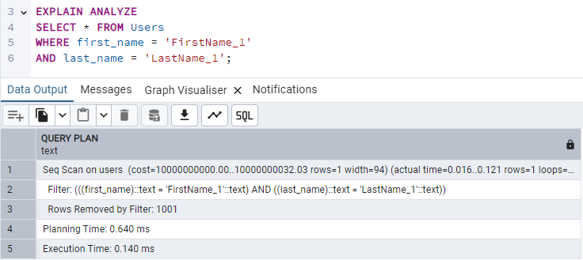
* Z indeksem:  
  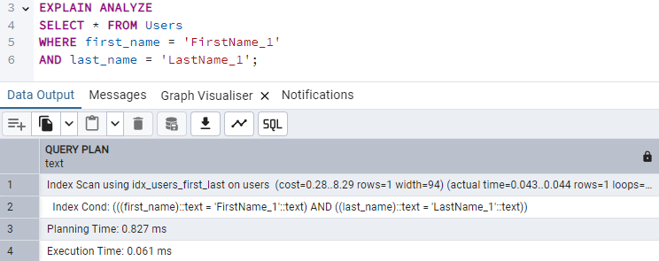

## Idx_users_phone_number

Opis:

Zadaniem indexu jest optymalizacja wykonywania zapytań wyszukujących użytkowników po ich numerze telefonu.

Implementacja:

CREATE INDEX idx_users_phone_number ON Users (phone_number);

Testowanie:

* Bez indeksu:  
  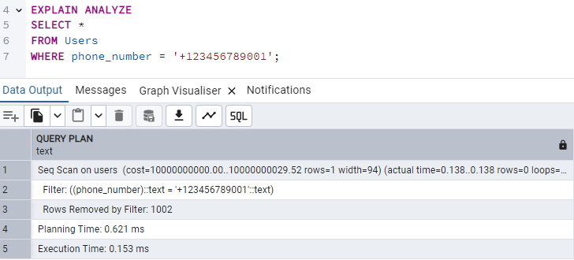
* Z indeksem:  
  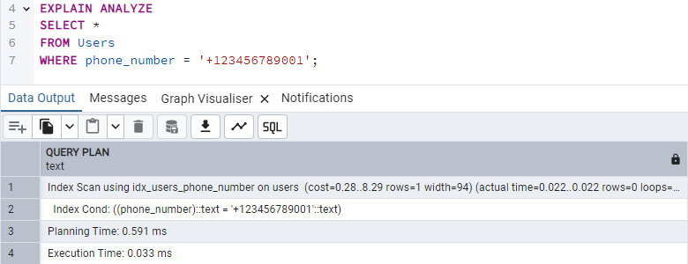

## Idx_users_home_location_id

Opis:

Zadaniem indexu jest optymalizacja wykonywania zapytań wyszukujących użytkowników po regionie ich zamieszkania.

Implementacja:

CREATE INDEX idx_users_home_location_id ON Users (home_location_id);

Testowanie:

* Bez indeksu:   
  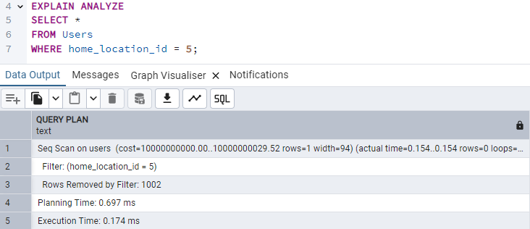
* Z indeksem:  
  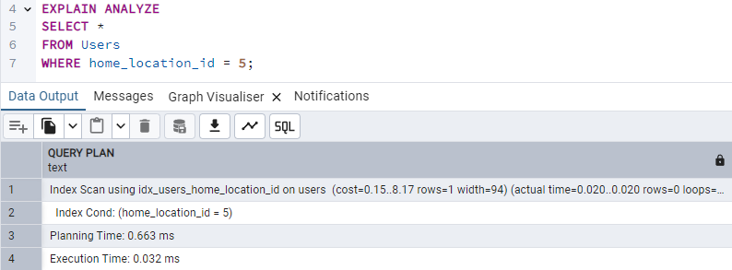

## Idx_costumiers_role_id

Opis:

Zadaniem indexu jest optymalizacja wykonywania zapytań łączących tabelę Costumiers z tabelą Roles oraz filtrowania.

Implementacja:

CREATE INDEX idx_costumiers_role_id ON Costumiers(role_id);

Testowanie:

* Bez indeksu:   
  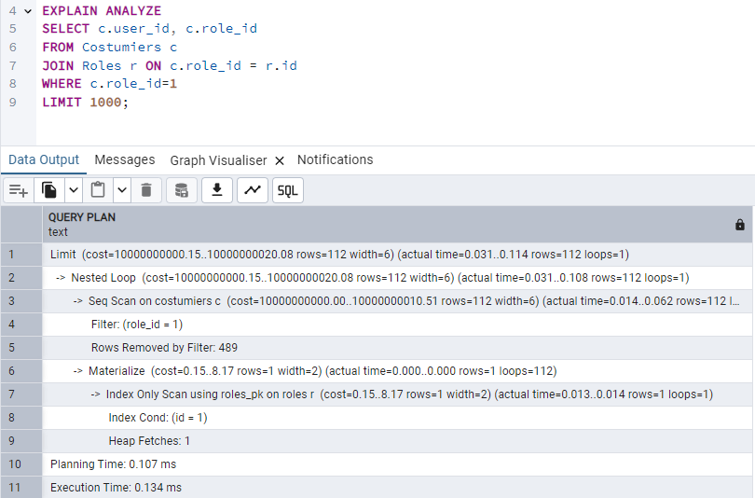
* Z indeksem:  
  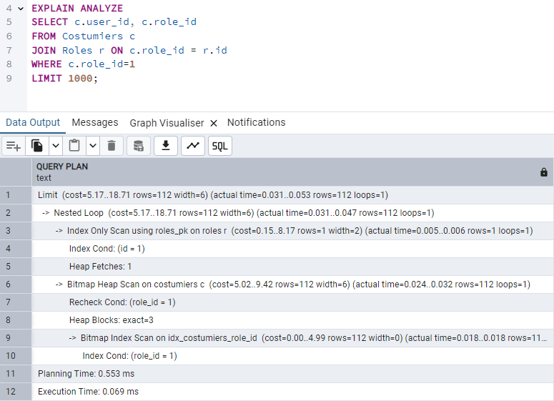

## Idx_costumiers_work_location_id

Opis:

Zadaniem indexu jest optymalizacja wykonywania zapytań łączących tabelę Costumiers z tabelą Locations oraz filtrowania.

Implementacja:

CREATE INDEX idx_costumiers_work_location_id ON Costumiers(work_location_id);

Testowanie:

* Bez indeksu:   
  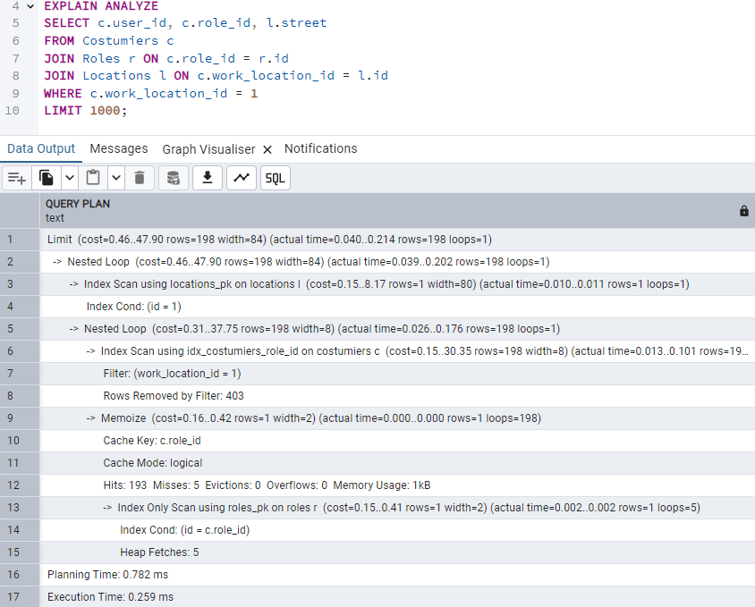
* Z indeksem:  
  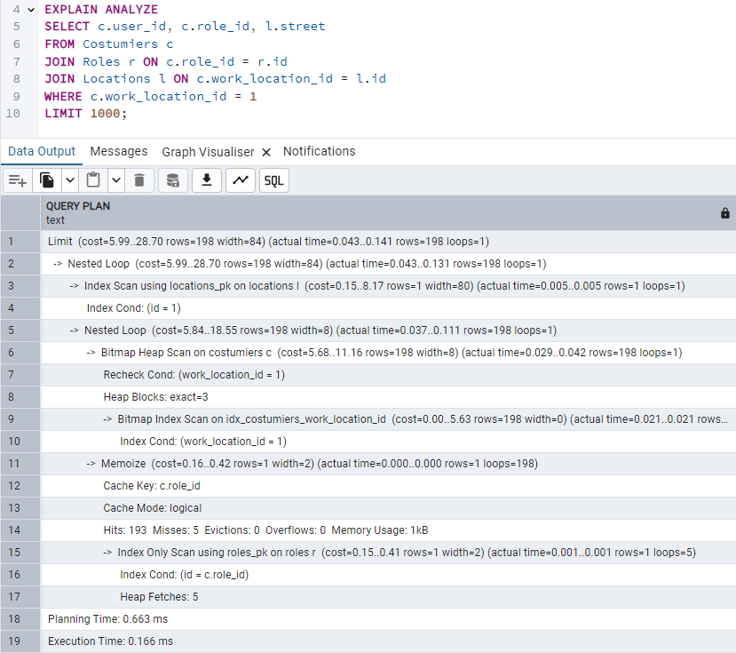

## Idx_singers_role_id

Opis:

Zadaniem indexu jest optymalizacja wykonywania zapytań łączących tabelę Singers z tabelą Roles oraz filtrowania.

Implementacja:

CREATE INDEX idx_singers_role_id ON Singers(role_id);

Testowanie:

* Bez indeksu:   
  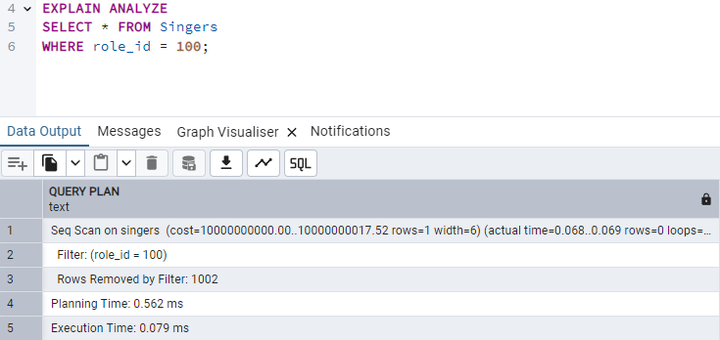
* Z indeksem:  
  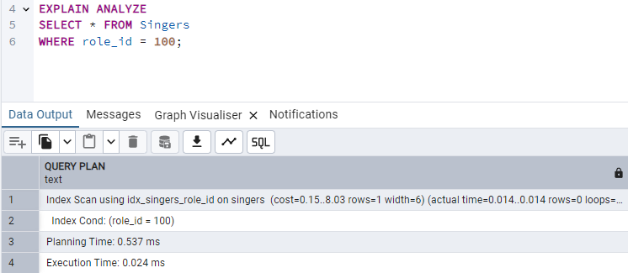

## Idx_musicians_role_id

Opis:

Zadaniem indexu jest optymalizacja wykonywania zapytań łączących tabelę Musicians z tabelą Roles oraz filtrowania.

Implementacja:

CREATE INDEX idx_musicians_role_id ON Musicians(role_id);

Testowanie:

* Bez indeksu:   
  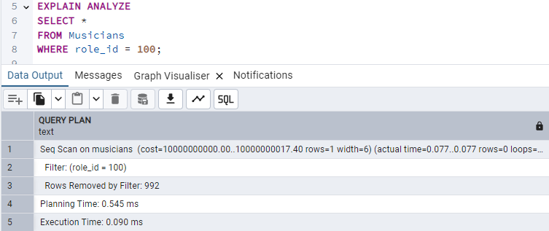
* Z indeksem:  
  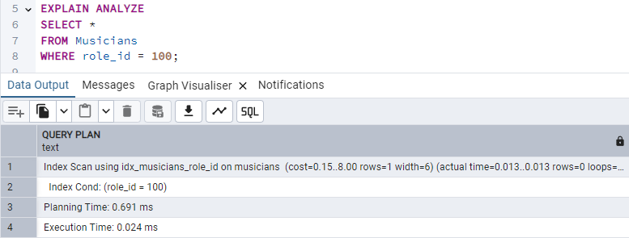

## Idx_dancers_role_id

Opis:

Zadaniem indexu jest optymalizacja wykonywania zapytań łączących tabelę Dancers z tabelą Roles oraz filtrowania.

Implementacja:

CREATE INDEX idx_dancers_role_id ON Dancers(role_id);

Testowanie:

* Bez indeksu:   
  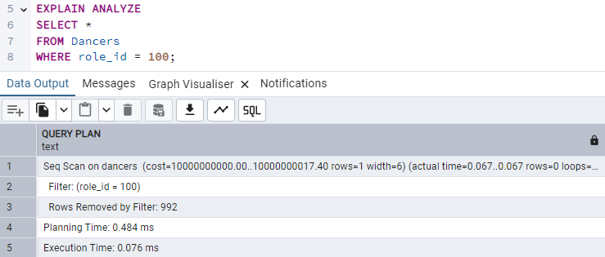
* Z indeksem:  
  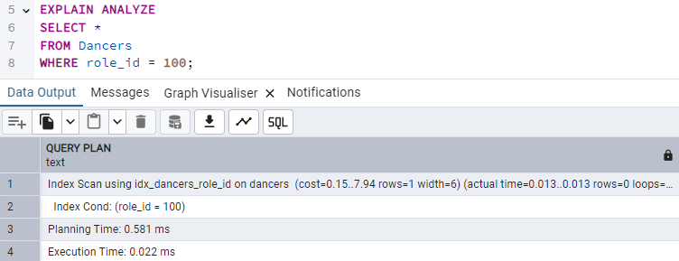

## Idx_costumes_items_collection_id

Opis:

Zadaniem indexu jest optymalizacja wykonywania zapytań łączących tabelę Costumes_items z tabelą Collections oraz filtrowania.

Implementacja:

CREATE INDEX idx_costumes_collection ON Costumes_items (collection_id);

Testowanie:

* Bez indeksu:   
  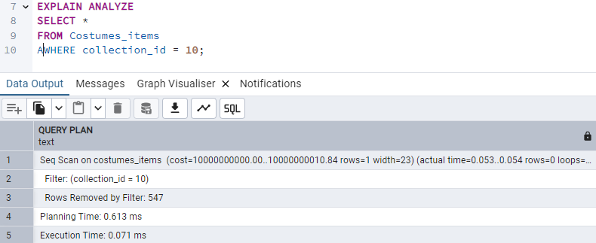
* Z indeksem:  
  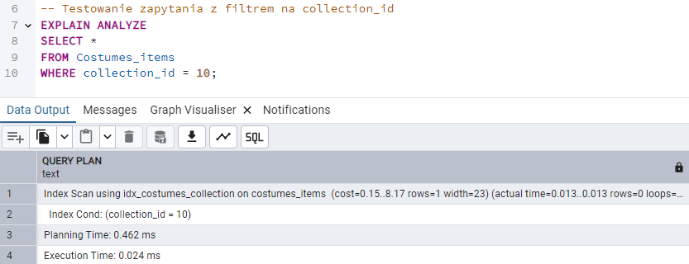

## Idx_costumes_items_gender_id

Opis:

Zadaniem indexu jest optymalizacja wykonywania zapytań łączących tabelę Costumes_items z tabelą Genders oraz filtrowania.

Implementacja:

CREATE INDEX idx_costumes_gender ON Costumes_items (gender_id);

Testowanie:

* Bez indeksu:   
  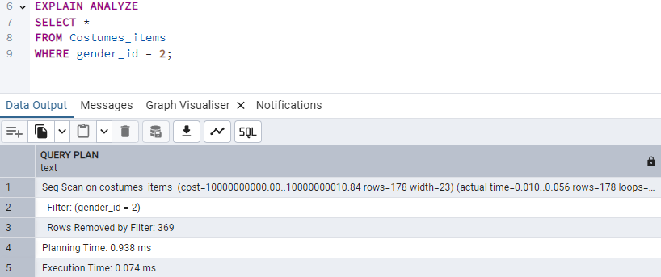
* Z indeksem:  
  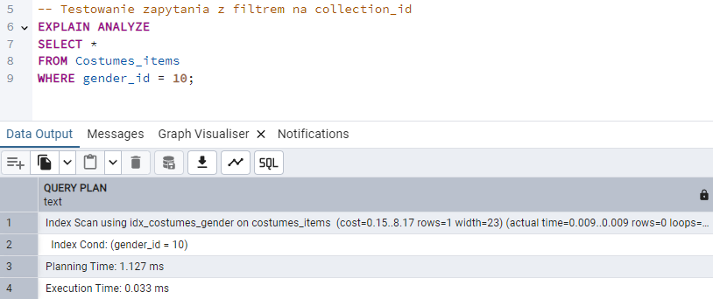

## Idx_costumes_items_color_id

Opis:

Zadaniem indexu jest optymalizacja wykonywania zapytań łączących tabelę Costumes_items z tabelą Colors oraz filtrowania.

Implementacja:

CREATE INDEX idx_costumes_items_color_id ON Costumes_items (color_id);

Testowanie:

* Bez indeksu:   
  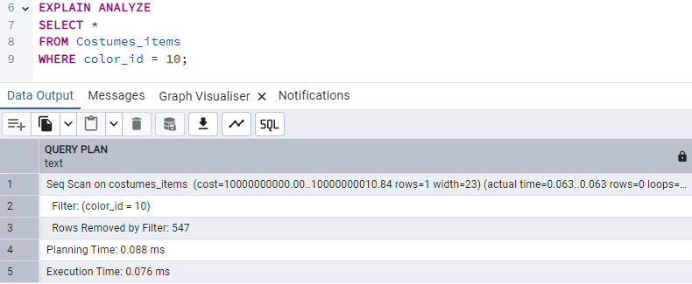
* Z indeksem:  
  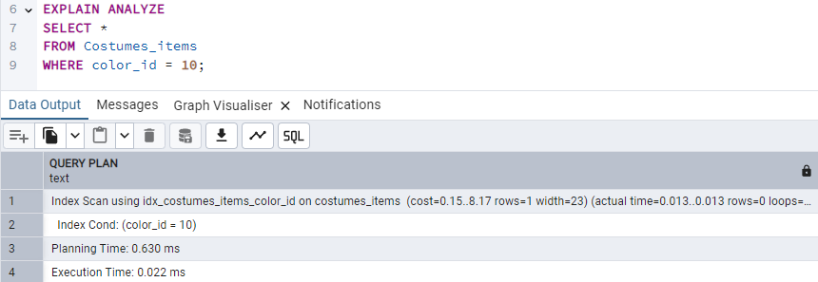

## Idx_costumes_items_location_id

Opis:

Zadaniem indexu jest optymalizacja wykonywania zapytań łączących tabelę Costumes_items z tabelą Locations oraz filtrowania.

Implementacja:

CREATE INDEX idx_costumes_items_location_id ON Costumes_items (location_id);

Testowanie:

* Bez indeksu:   
  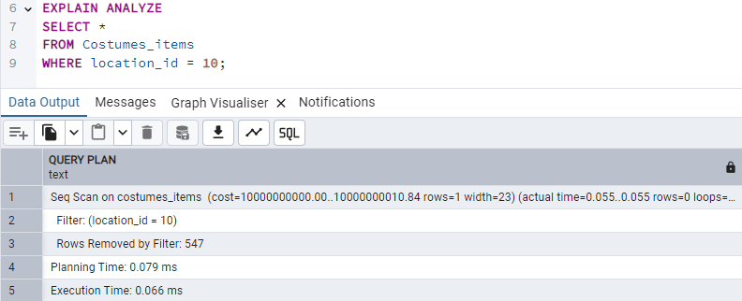
* Z indeksem:  
  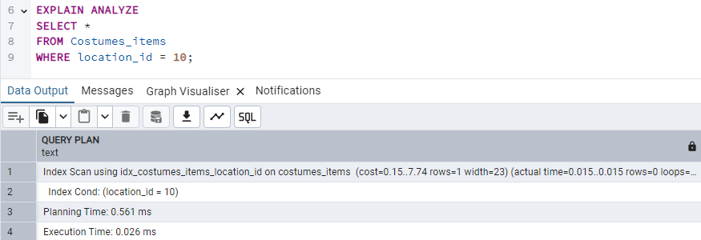

## Idx_head_accessories_category_id

Opis:

Zadaniem indexu jest optymalizacja wykonywania zapytań łączących tabelę Head_accessories z tabelą Head_accessory_categories oraz filtrowania.

Implementacja:

CREATE INDEX Idx_head_accessories_category_id ON Head_accessories(category_id);

Testowanie:

* Bez indeksu:   
  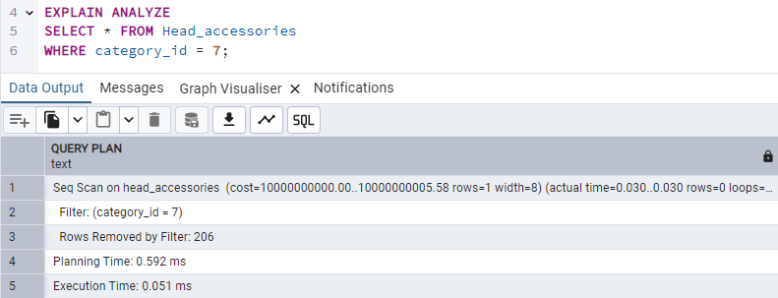
* Z indeksem:  
  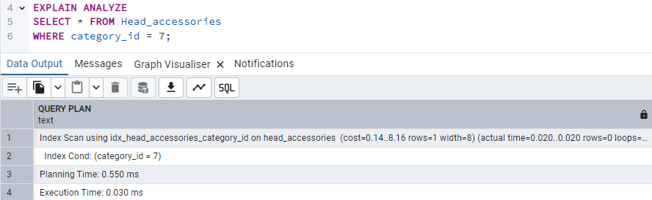

## Idx_aprons_pattern_id

Opis:

Zadaniem indexu jest optymalizacja wykonywania zapytań łączących tabelę Aprons z tabelą Patterns oraz filtrowania.

Implementacja:

CREATE INDEX idx_aprons_pattern_id ON Aprons(pattern_id);

Testowanie:

* Bez indeksu:   
  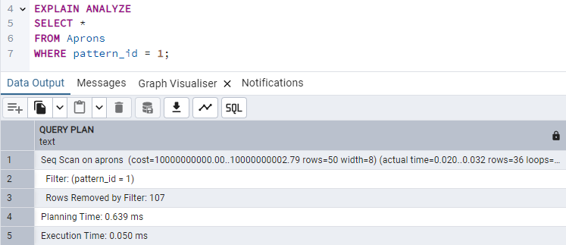
* Z indeksem:  
  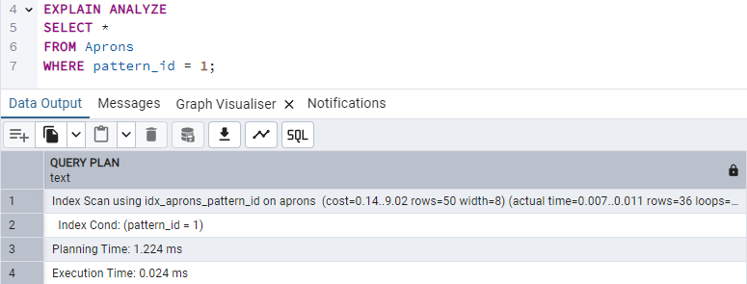

## Idx_costumes_collection_id

Opis:

Zadaniem indexu jest optymalizacja wykonywania zapytań łączących tabelę Costumes z tabelą Collections oraz filtrowania.

Implementacja:

CREATE INDEX idx_costumes_collection_id ON Costumes(collection_id);

Testowanie:

* Bez indeksu:   
  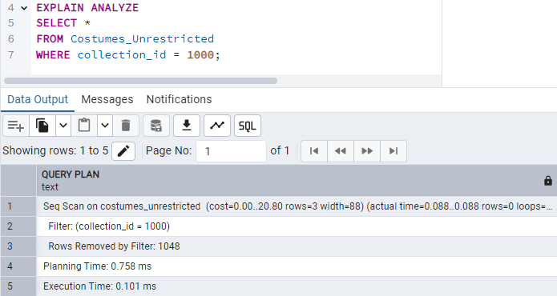
* Z indeksem:  
  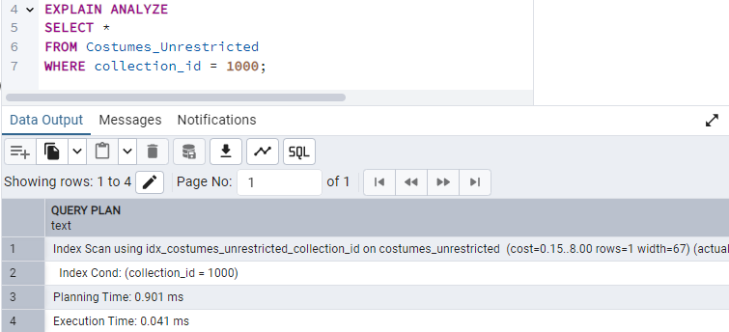

## Idx_costumes_gender_id

Opis:

Zadaniem indexu jest optymalizacja wykonywania zapytań łączących tabelę Costumes z tabelą GEnders oraz filtrowania.

Implementacja:

CREATE INDEX idx_costumes_gender_id ON Costumes(gender_id);

Testowanie:

* Bez indeksu:   
  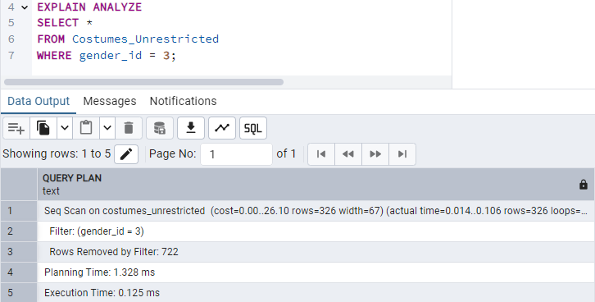
* Z indeksem:  
  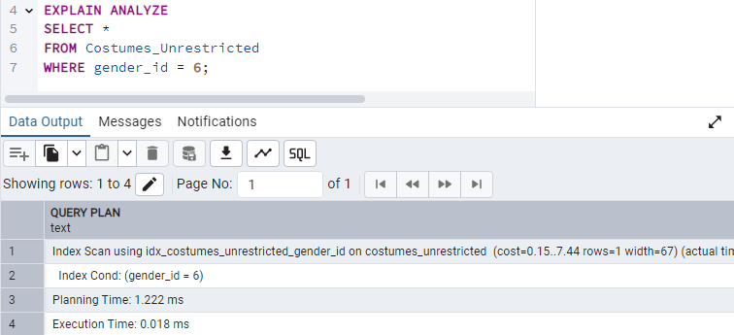

## Idx_costumes_apron_id

Opis:

Zadaniem indexu jest optymalizacja wykonywania zapytań łączących tabelę Costumes z tabelą Genders oraz filtrowania.

Implementacja:

CREATE INDEX idx_costumes_apron_id ON Costumes(apron_id);

Testowanie:

* Bez indeksu:   
  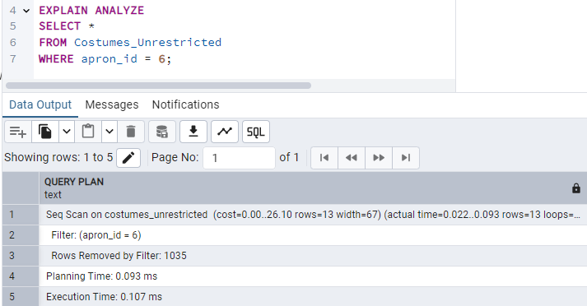
* Z indeksem:  
  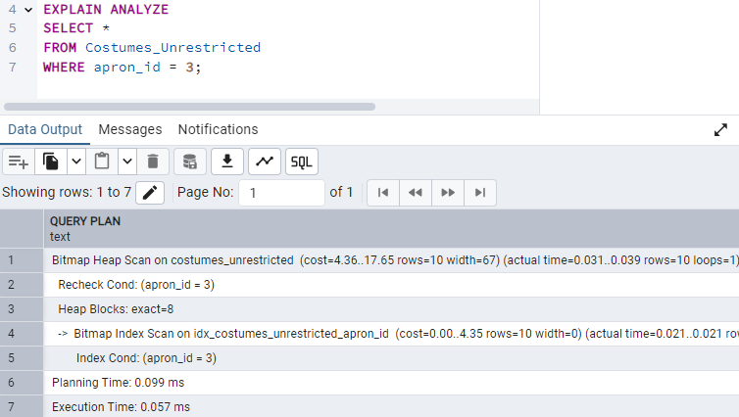

## Idx_costumes_caftan_id

Opis:

Zadaniem indexu jest optymalizacja wykonywania zapytań łączących tabelę Costumes z tabelą Caftans oraz filtrowania.

Implementacja:

CREATE INDEX idx_costumes_caftan_id ON Costumes(caftan_id);

Testowanie:

* Bez indeksu:   
  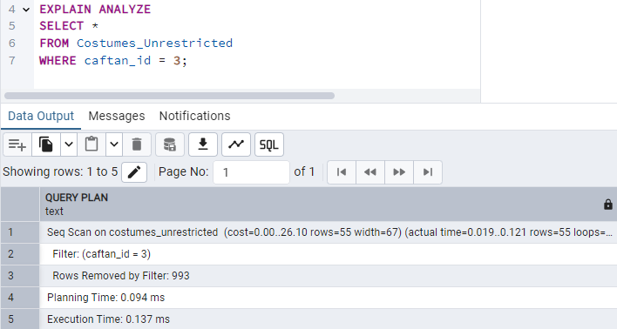
* Z indeksem:  
  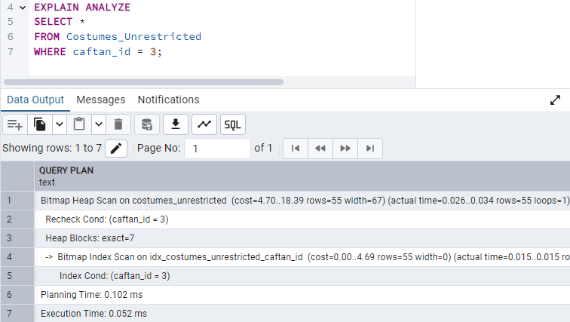

## Idx_costumes_petticoat_id

Opis:

Zadaniem indexu jest optymalizacja wykonywania zapytań łączących tabelę Costumes z tabelą Petticoats oraz filtrowania.

Implementacja:

CREATE INDEX idx_costumes_petticoat_id ON Costumes(petticoat_id);

Testowanie:

* Bez indeksu:   
  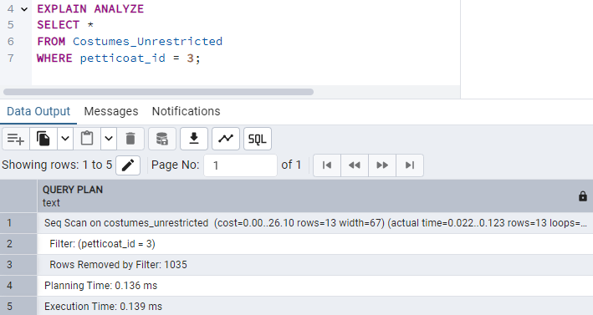
* Z indeksem:  
  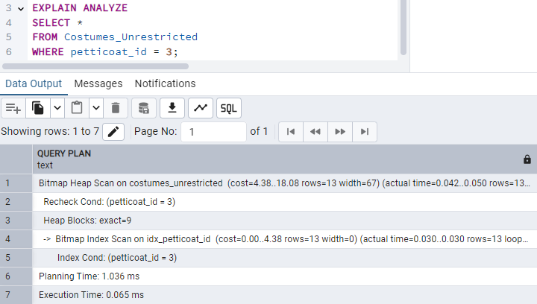

## Idx_costumes_petticoat_id

Opis:

Zadaniem indexu jest optymalizacja wykonywania zapytań łączących tabelę Costumes z tabelą Corsets oraz filtrowania.

Implementacja:

CREATE INDEX idx_costumes_corset_id ON Costumes(corset_id);

Testowanie:

* Bez indeksu:   
  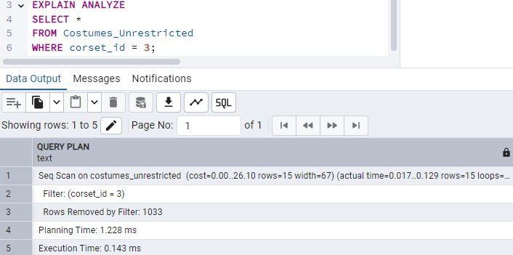
* Z indeksem:  
  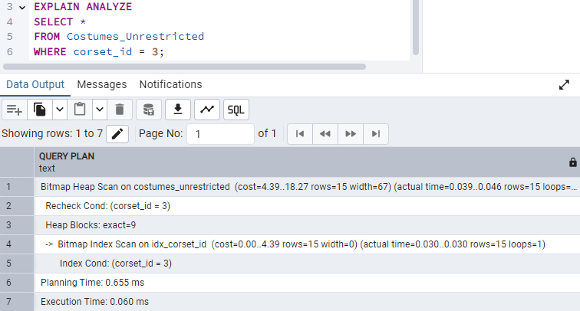

## Idx_costumes_skirt_id

Opis:

Zadaniem indexu jest optymalizacja wykonywania zapytań łączących tabelę Costumes z tabelą Skirts oraz filtrowania.

Implementacja:

CREATE INDEX idx_costumes_skirt_id ON Costumes(skirt_id);

Testowanie:

* Bez indeksu:   
  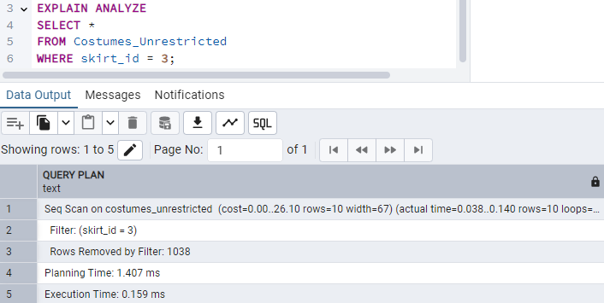
* Z indeksem:  
  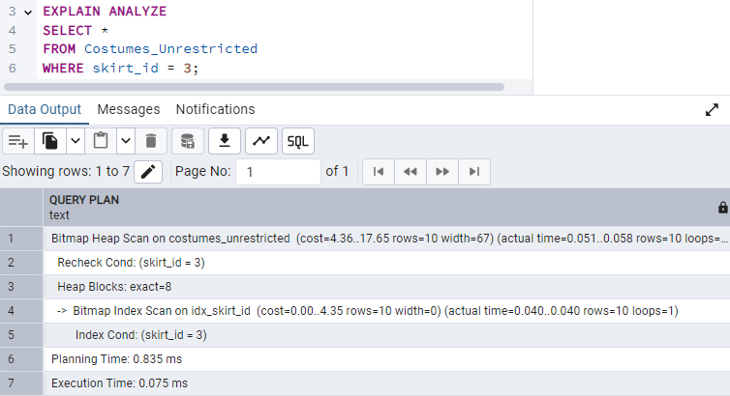

## Idx_costumes_belt_id

Opis:

Zadaniem indexu jest optymalizacja wykonywania zapytań łączących tabelę Costumes z tabelą Belts oraz filtrowania.

Implementacja:

CREATE INDEX idx_costumes_belt_id ON Costumes(belt_id);

Testowanie:

* Bez indeksu:   
  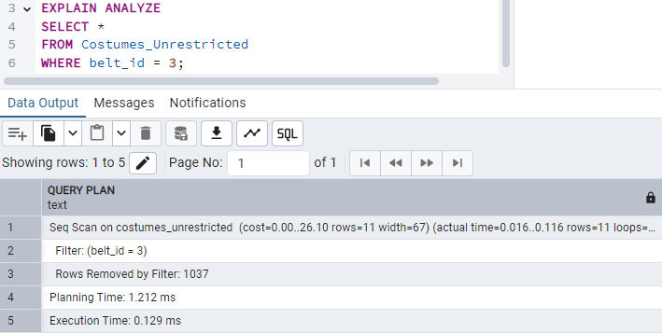
* Z indeksem:  
  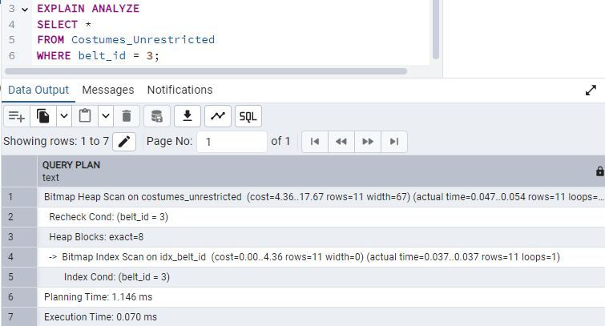

## Idx_costumes_shirt_id

Opis:

Zadaniem indexu jest optymalizacja wykonywania zapytań łączących tabelę Costumes z tabelą Shirts oraz filtrowania.

Implementacja:

CREATE INDEX idx_costumes_shirt_id ON Costumes(shirt_id);

Testowanie:

* Bez indeksu:   
  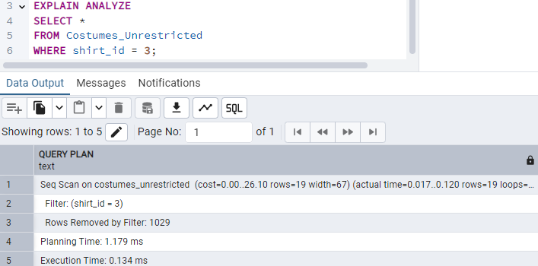
* Z indeksem:  
  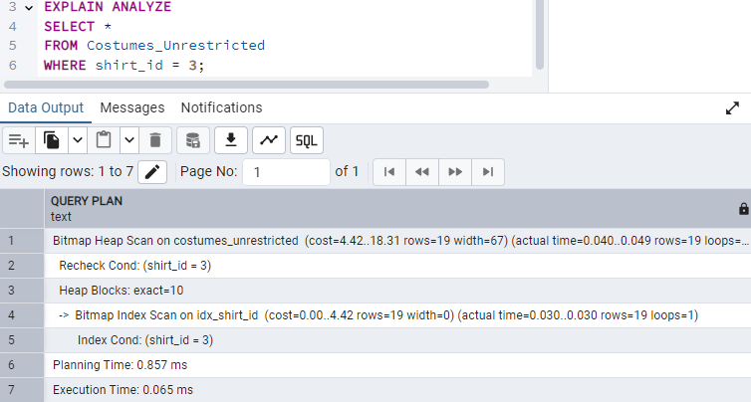

## Idx_costumes_pants_id

Opis:

Zadaniem indexu jest optymalizacja wykonywania zapytań łączących tabelę Costumes z tabelą Pants oraz filtrowania.

Implementacja:

CREATE INDEX idx_costumes_pants_id ON Costumes(pants_id);

Testowanie:

* Bez indeksu:   
  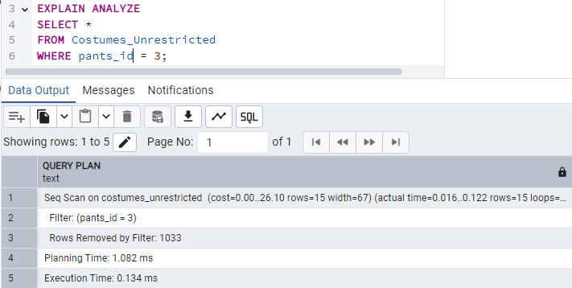
* Z indeksem:  
  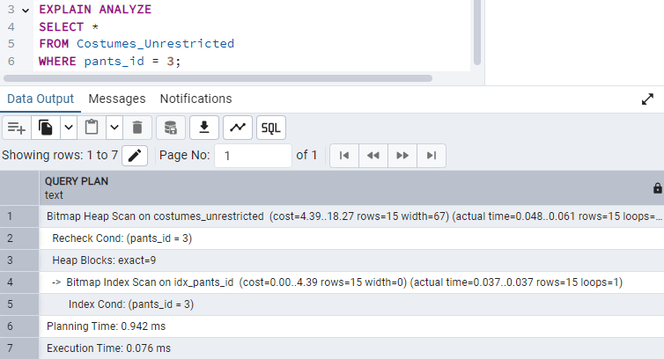

## Idx_costumes_boots_id

Opis:

Zadaniem indexu jest optymalizacja wykonywania zapytań łączących tabelę Costumes z tabelą Boots oraz filtrowania.

Implementacja:

CREATE INDEX idx_costumes_boots_id ON Costumes(boots_id);

Testowanie:

* Bez indeksu:   
  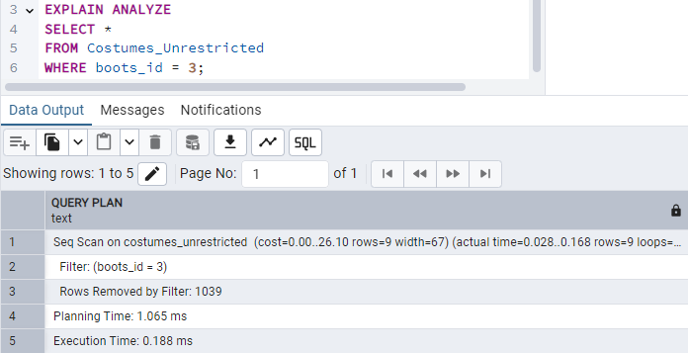
* Z indeksem:  
  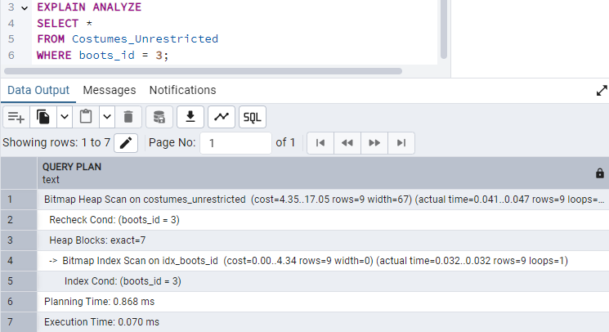

## Idx_costumes_neck_accessory_id

Opis:

Zadaniem indexu jest optymalizacja wykonywania zapytań łączących tabelę Costumes z tabelą Neck_accessories oraz filtrowania.

Implementacja:

CREATE INDEX idx_costumes_neck_accessory_id ON Costumes(neck_accessory_id);

Testowanie:

* Bez indeksu:   
  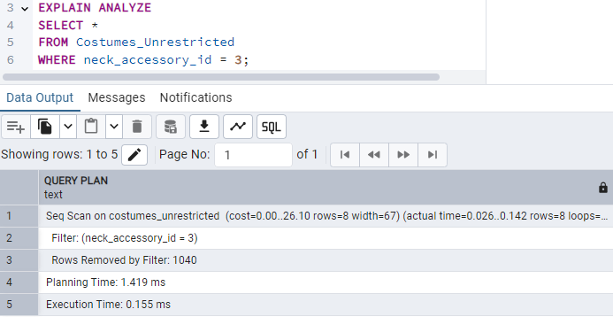
* Z indeksem:  
  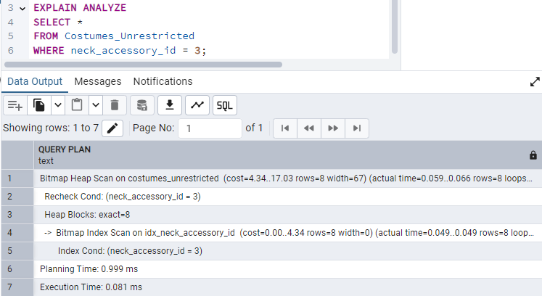

## Idx_costumes_head_accessory_id

Opis:

Zadaniem indexu jest optymalizacja wykonywania zapytań łączących tabelę Costumes z tabelą Head_accessories oraz filtrowania.

Implementacja:

CREATE INDEX idx_costumes_head_accessory_id ON Costumes(head_accessory_id);

Testowanie:

* Bez indeksu:   
  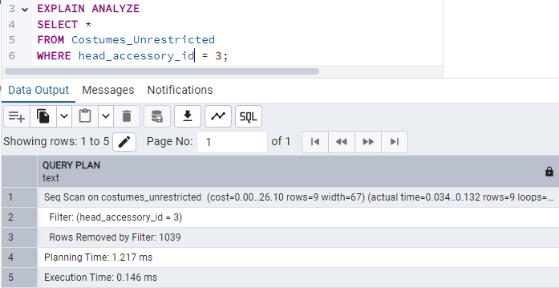
* Z indeksem:  
  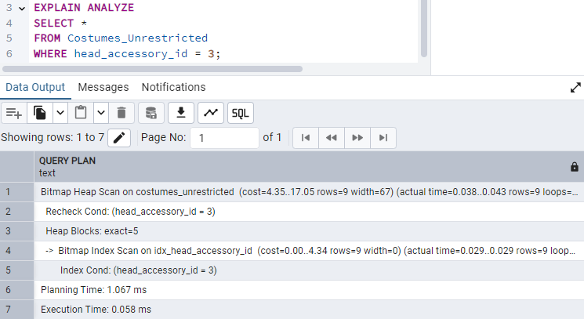

## Idx_requests_state_id

Opis:

Zadaniem indexu jest optymalizacja wykonywania zapytań łączących tabelę Requests z tabelą States_of_requests oraz filtrowania.

Implementacja:

CREATE INDEX idx_requests_state_id ON Requests (state_id);

Testowanie:

* Bez indeksu:   
  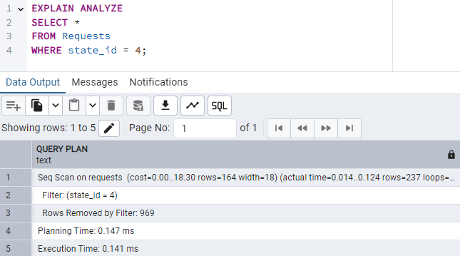
* Z indeksem:  
  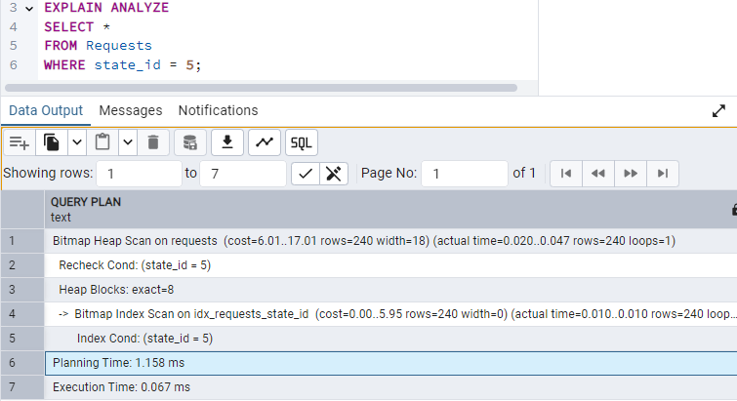

## Idx_requests_requester_user_id

Opis:

Zadaniem indexu jest optymalizacja wykonywania zapytań łączących tabelę Requests z tabelą Users oraz filtrowania.

Implementacja:

CREATE INDEX idx_requests_requester_user_id ON Requests (requester_user_id);

Testowanie:

* Bez indeksu:   
  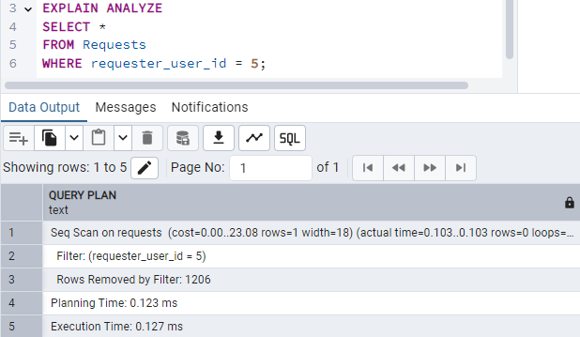
* Z indeksem:  
  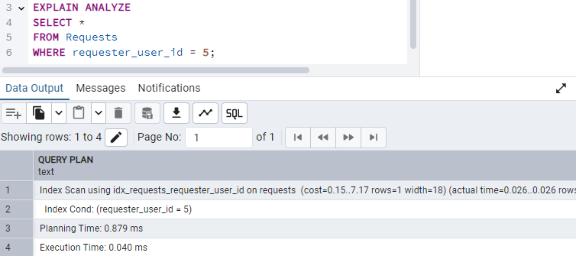

## Idx_requests_datetime

Opis:

Zadaniem indexu jest optymalizacja wykonywania zapytań o żądania, które zostały wydane w określonym przedziale czasie lub innych zapytań filtrujących związanych z kolumną datetime.

Implementacja:

CREATE INDEX idx_requests_datetime ON Requests (datetime);

Testowanie:

* Bez indeksu:   
  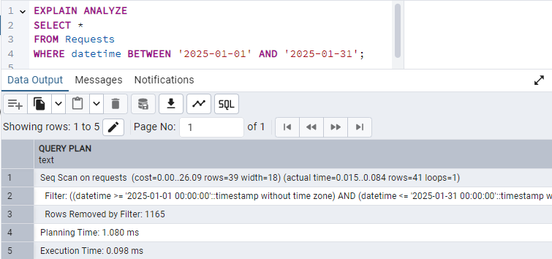
* Z indeksem:  
  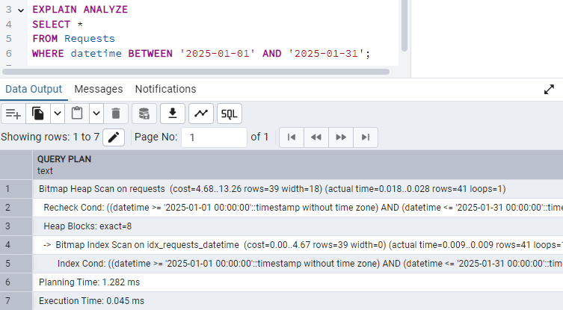

## Idx_rental_requests_costume_item_id

Opis:

Zadaniem indexu jest optymalizacja wykonywania zapytań łączących tabelę Rental_costume_item_requests z tabelą Costumes_items, filtrowania ( przeszukiwania zapytań o dany przedmiot ).

Implementacja:

CREATE INDEX idx_rental_requests_costume_item_id ON Rental_costume_item_requests (costume_item_id);

Testowanie:

* Bez indeksu:   
  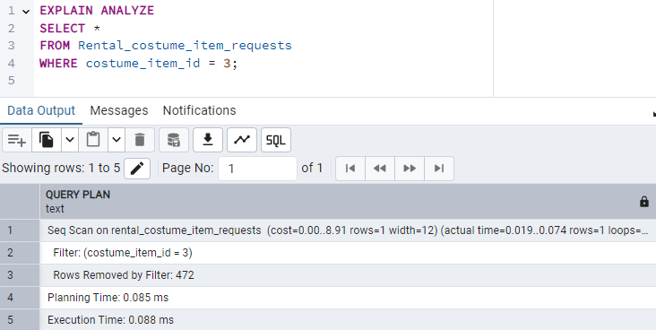
* Z indeksem:  
  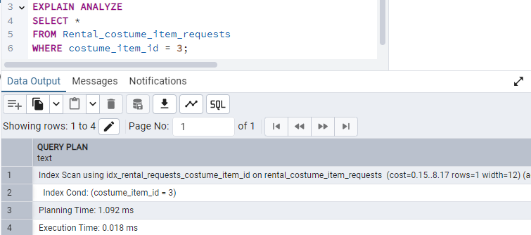

## Idx_rental_requests_approver_costumier_id

Opis:

Zadaniem indexu jest optymalizacja wykonywania zapytań łączących tabelę Rental_costume_item_requests z tabelą Costumiers, filtrowania ( przeszukiwania, który z Costumiers zatwierdził dany request ).

Implementacja:

CREATE INDEX idx_rental_requests_approver_costumier_id ON Rental_costume_item_requests (approver_costumier_id);

Testowanie:

* Bez indeksu:   
  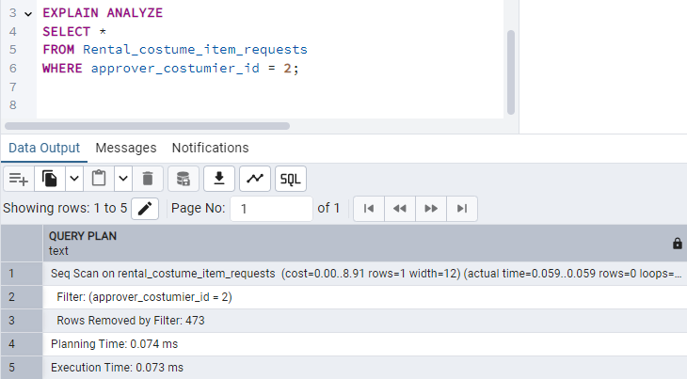
* Z indeksem:  
  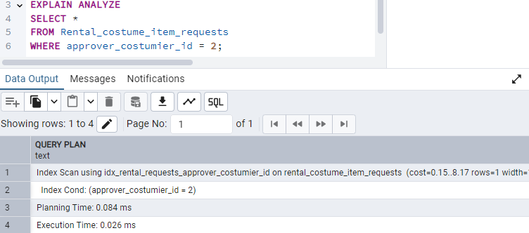

## Idx_return_requests_costume_item_id

Opis:

Zadaniem indexu jest optymalizacja wykonywania zapytań łączących tabelę Return_costume_item_requests z tabelą Costumes_items oraz filtrowania.

Implementacja:

CREATE INDEX idx_return_requests_costume_item_id ON Return_costume_item_requests (costume_item_id);

Testowanie:

* Bez indeksu:   
  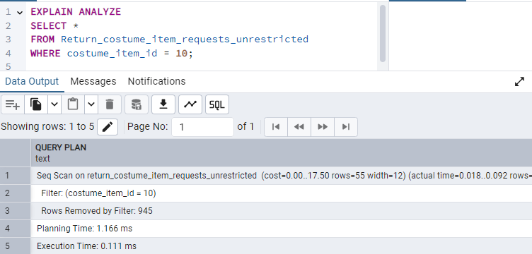
* Z indeksem:  
  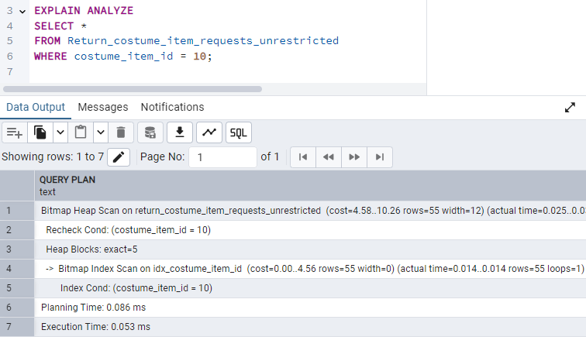

## Idx_return_requests_approver_costumier_id

Opis:

Zadaniem indexu jest optymalizacja wykonywania zapytań łączących tabelę Return_costume_item_requests z tabelą Costumiers, filtrowania ( przeszukiwania, który z Costumiers zatwierdził dany request ).

Implementacja:

CREATE INDEX idx_return_requests_approver_costumier_id ON Return_costume_item_requests (approver_costumier_id);

Testowanie:

* Bez indeksu:   
  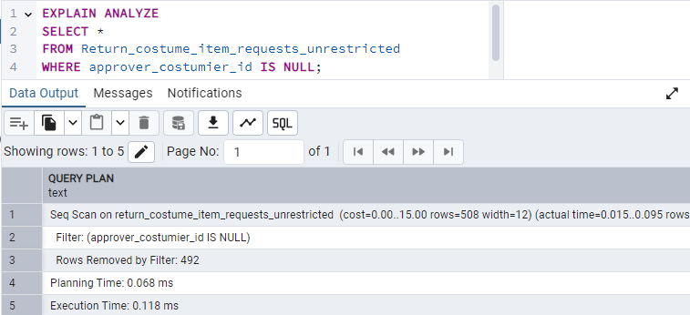
* Z indeksem:  
  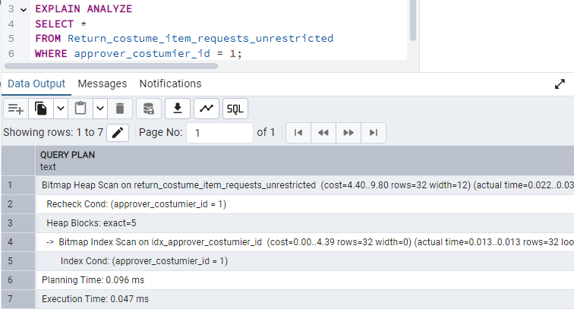

## Idx_borrow_requests_costume_item_id

Opis:

Zadaniem indexu jest optymalizacja wykonywania zapytań łączących tabelę Borrow_costume_item_requests z tabelą Costumes_items oraz filtrowania.

Implementacja:

CREATE INDEX idx_borrow_requests_costume_item_id ON Borrow_costume_item_requests (costume_item_id);

Testowanie:

* Bez indeksu:   
  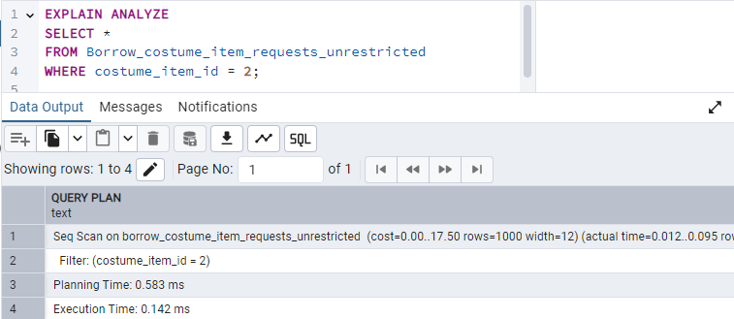
* Z indeksem:  
  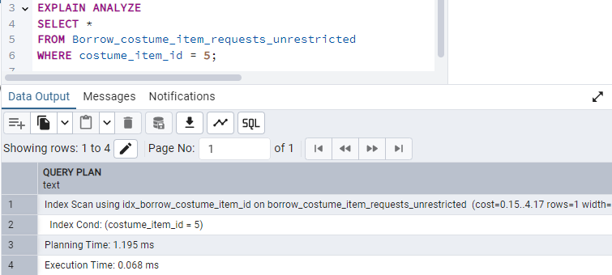

## Idx_borrow_requests_approver_costumier_id

Opis:

Zadaniem indexu jest optymalizacja wykonywania zapytań łączących tabelę Borrow_costume_item_requests z tabelą Costumiers, filtrowania ( przeszukiwania, który z Costumiers zatwierdził dany request ).

Implementacja:

CREATE INDEX idx_borrow_requests_approver_costumier_id ON Borrow_costume_item_requests (approver_user_id);

Testowanie:

* Bez indeksu:   
  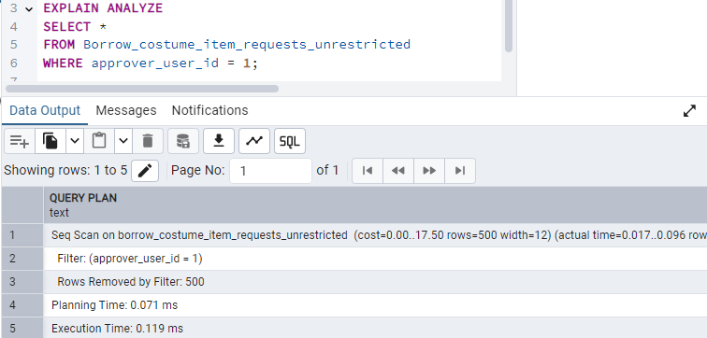
* Z indeksem:  
  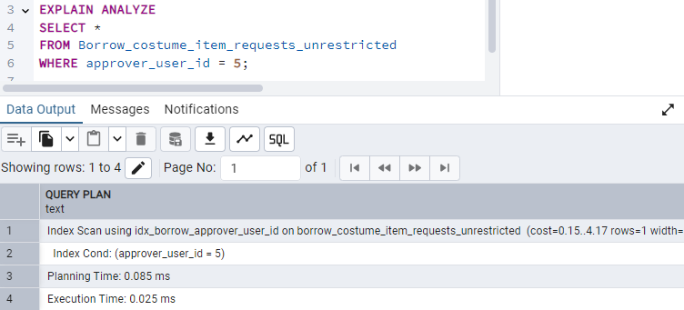

## Idx_notifications_user_id

Opis:

Zadaniem indexu jest optymalizacja wykonywania zapytań łączących tabelę Notifications i Users oraz filtrujących dane po user_id ( wyszukiwanie wszystkich powiadomień skierowanych do danego użytkownika ).

Implementacja:

CREATE INDEX idx_notifications_user_id ON Notifications (user_id);

Testowanie:

* Bez indeksu:   
  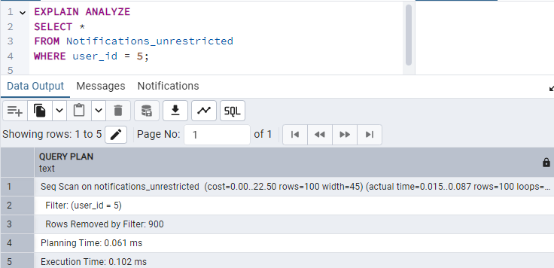
* Z indeksem:  
  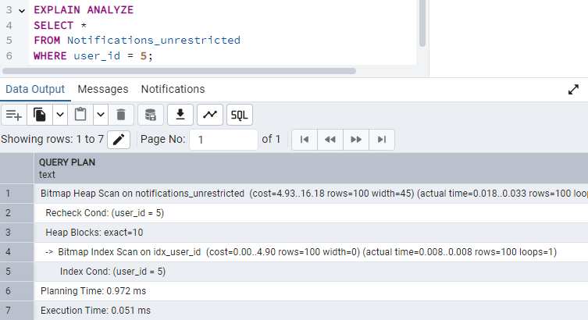

## Idx_notifications_datetime

Opis:

Zadaniem indexu jest optymalizacja wykonywania zapytań o powiadomienia, które zostały odebrane w określonym przedziale czasowym oraz wszelkiego rodzaju filtrowaniu związanego z kolumną datetime.

Implementacja:

CREATE INDEX idx_notifications_datetime ON Notifications (datetime);

Testowanie:

* Bez indeksu:   
  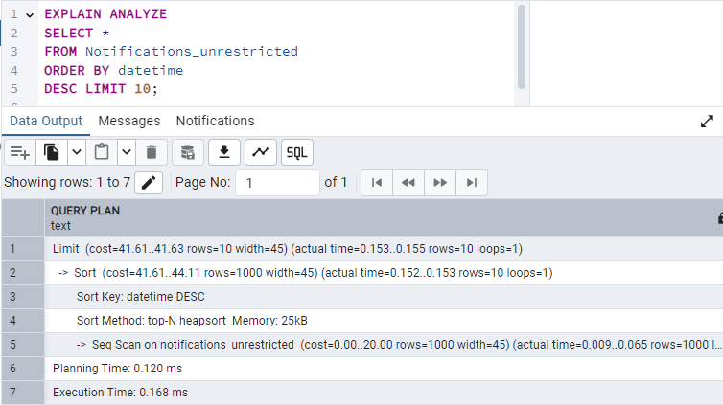
* Z indeksem:  
  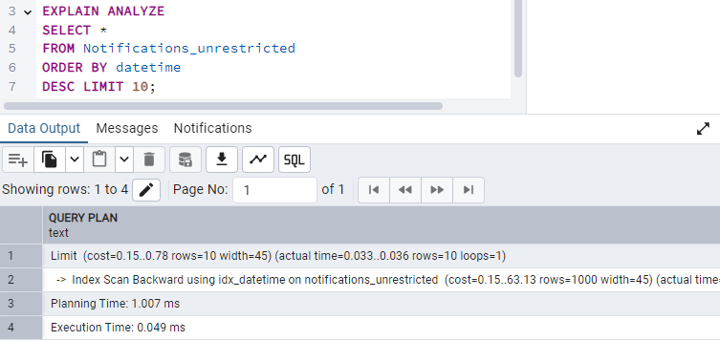

## Idx_notifications_due_to_request_id

Opis:

Zadaniem indexu jest optymalizacja wykonywania zapytań łączących tabelę Notifications i Requests oraz filtrujących dane po user_id ( wyszukiwanie wszystkich powiadomień związanych z danym żądaniem w bazie).

Implementacja:

CREATE INDEX idx_notifications_due_to_request_id ON Notifications (due_to_request_id);

Testowanie:

* Bez indeksu:   
  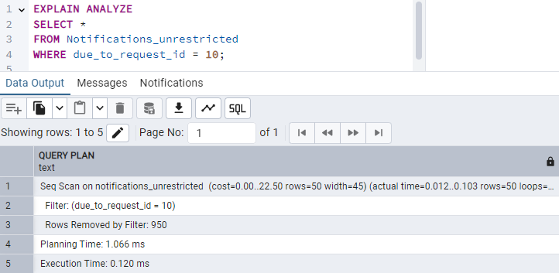
* Z indeksem:  
  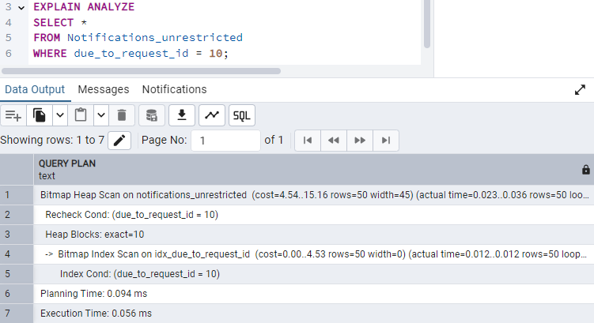

## Idx_rentals_user_id

Opis:

Zadaniem indexu jest optymalizacja wykonywania zapytań łączących tabelę Rentals i Users oraz filtrujących dane po user_id ( wyszukiwanie wszystkich wypożyczeń związanych z danym użytkownikiem).

Implementacja:

CREATE INDEX idx_rentals_user_id ON Rentals (user_id);

Testowanie:

* Bez indeksu:   
  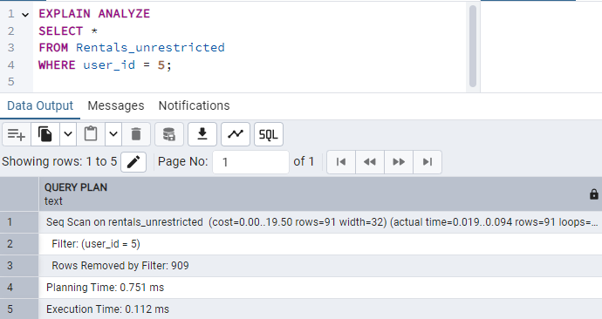
* Z indeksem:  
  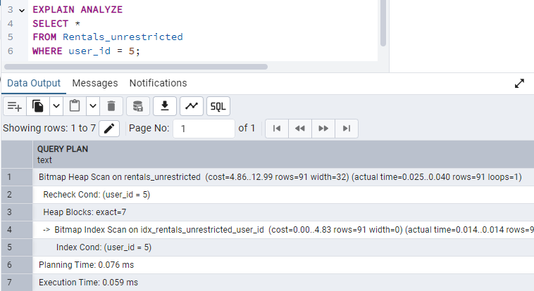

## Idx_rentals_costume_item_id

Opis:

Zadaniem indexu jest optymalizacja wykonywania zapytań łączących tabelę Rentals i Costumes _items oraz filtrujących dane ( wyszukiwanie czy dana część stroju jest już może wypożyczona ).

Implementacja:

CREATE INDEX idx_rentals_costume_item_id ON Rentals (costume_item_id);

Testowanie:

* Bez indeksu:   
  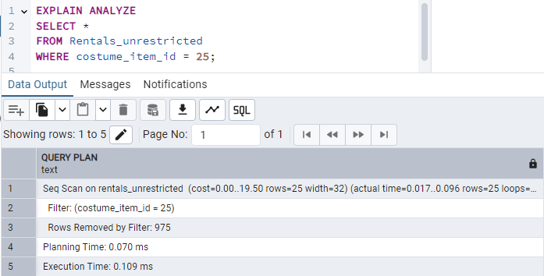
* Z indeksem:  
  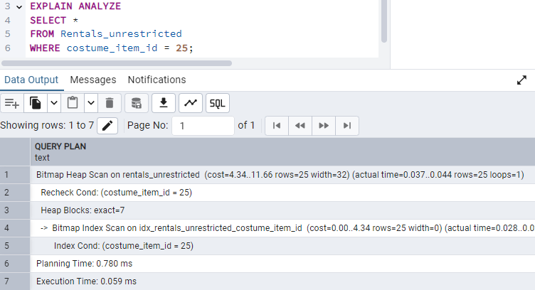

## Idx_rentals_date_of_rental

Opis:

Zadaniem indexu jest optymalizacja wykonywania zapytań związanych na datę wypożyczenia danego przedmiotu.

Implementacja:

CREATE INDEX idx_rentals_date_of_rental ON Rentals (date_of_rental);

Testowanie:

* Bez indeksu:   
  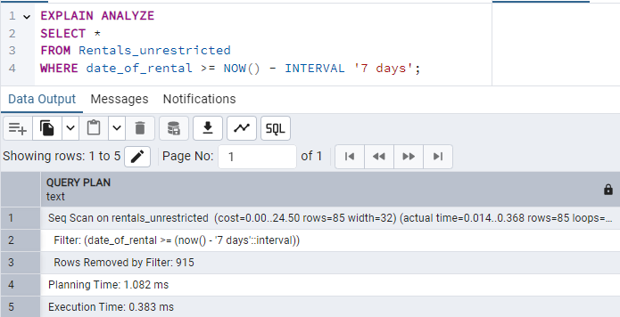
* Z indeksem:  
  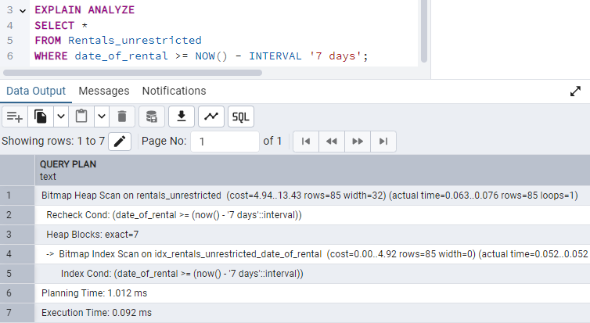

## Idx_rentals_date_of_return

Opis:

Zadaniem indexu jest optymalizacja wykonywania zapytań związanych na datę zwrotu danego przedmiotu.

Implementacja:

CREATE INDEX idx_rentals_date_of_return ON Rentals (date_of_return);

Testowanie:

* Bez indeksu:   
  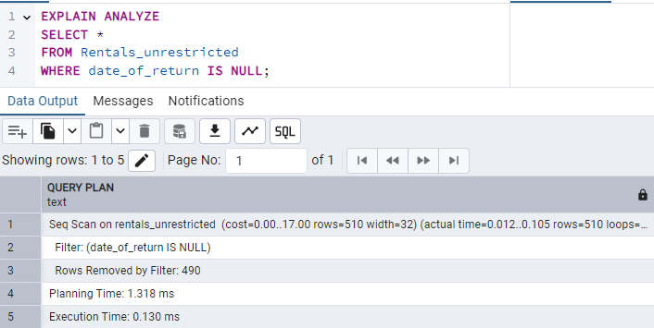
* Z indeksem:  
  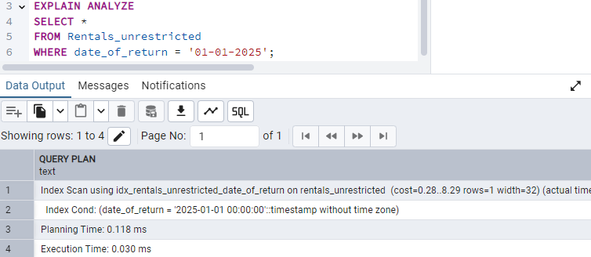

## Idx_rentals_done_due_request_id

Opis:

Zadaniem indexu jest optymalizacja wykonywania zapytań wyszukujących wypożyczenia na podstawie powiązanego żądania.

Implementacja:

CREATE INDEX idx_rentals_done_due_request_id ON Rentals (done_due_request_id);

Testowanie:

* Bez indeksu:   
  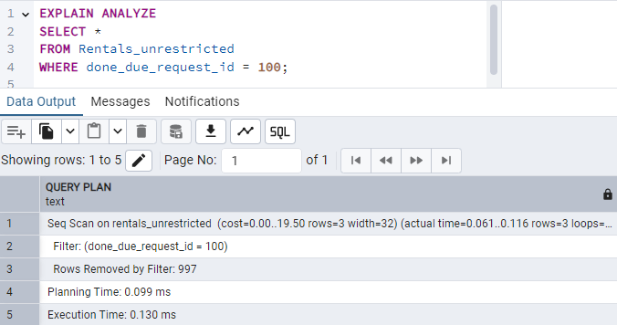
* Z indeksem:  
  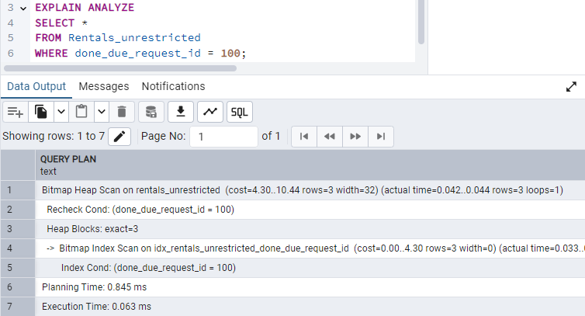

# Użytkownicy

## Normal_user

**Opis**:

* Za pomocę tego konta można wykonać operacje zwykłego użytkownika (np. wypożyczyć i oddać element stroju, złożyć requesty, zobaczyć stroje, powiadomienia itp).

**Uprawnienia:**

CREATE ROLE normal_user WITH LOGIN PASSWORD 'zasxZSXA23!@#';

GRANT EXECUTE ON FUNCTION get_user_unresolved_borrow_requests TO normal_user;

GRANT EXECUTE ON FUNCTION get_user_current_rentals TO normal_user;

GRANT EXECUTE ON FUNCTION get_fits_aprons TO normal_user;

GRANT EXECUTE ON FUNCTION get_fits_boots TO normal_user;

GRANT EXECUTE ON FUNCTION get_fits_petticoats TO normal_user;

GRANT EXECUTE ON FUNCTION get_fits_skirts TO normal_user;

GRANT EXECUTE ON FUNCTION get_fits_caftans TO normal_user;

GRANT EXECUTE ON FUNCTION get_fits_corsets TO normal_user;

GRANT EXECUTE ON FUNCTION get_fits_neck_accessories TO normal_user;

GRANT EXECUTE ON FUNCTION get_fits_head_accessories TO normal_user;

GRANT EXECUTE ON FUNCTION get_fits_belts TO normal_user;

GRANT EXECUTE ON FUNCTION get_fits_pants TO normal_user;

GRANT EXECUTE ON FUNCTION get_fits_shirts TO normal_user;

GRANT EXECUTE ON FUNCTION get_user_unread_notifications TO normal_user;

GRANT EXECUTE ON FUNCTION get_user_unclosed_costume_item_requests TO normal_user;

GRANT EXECUTE ON PROCEDURE add_rental_costume_item_request TO normal_user;

GRANT EXECUTE ON PROCEDURE add_return_costume_item_request TO normal_user;

GRANT EXECUTE ON PROCEDURE add_borrow_costume_item_request TO normal_user;

GRANT EXECUTE ON PROCEDURE delete_request TO normal_user;

GRANT EXECUTE ON PROCEDURE accept_borrow_costume_item_request TO normal_user;

GRANT EXECUTE ON PROCEDURE deny_borrow_costume_item_request TO normal_user;

GRANT EXECUTE ON PROCEDURE borrow_costume_item TO normal_user;

GRANT SELECT ON TABLE Detailed_aprons TO normal_user;

GRANT SELECT ON TABLE Detailed_boots TO normal_user;

GRANT SELECT ON TABLE Detailed_petticoats TO normal_user;

GRANT SELECT ON TABLE Detailed_skirts TO normal_user;

GRANT SELECT ON TABLE Detailed_caftans TO normal_user;

GRANT SELECT ON TABLE Detailed_corsets TO normal_user;

GRANT SELECT ON TABLE Detailed_neck_accessories TO normal_user;

GRANT SELECT ON TABLE Detailed_head_accessories TO normal_user;

GRANT SELECT ON TABLE Detailed_belts TO normal_user;

GRANT SELECT ON TABLE Detailed_pants TO normal_user;

GRANT SELECT ON TABLE Detailed_shirts TO normal_user;

GRANT SELECT ON TABLE Costume_with_costume_items_name TO normal_user;

## Costumier

**Opis**:

* Za pomocę tego konta można wykonać operacje związane elementami strojów i wypożyczaniem (np. dodać element stroju, edytować go, zaakceptować request, zobaczyć statystyki związane z wypożyczeniami itp).

**Uprawnienia:**

CREATE ROLE costumier WITH LOGIN PASSWORD 'vfgESDy^%783';

GRANT EXECUTE ON FUNCTION get_costume_item_rental_history TO costumier;

GRANT EXECUTE ON FUNCTION get_user_rental_history TO costumier;

GRANT EXECUTE ON FUNCTION get_costumier_unresolved_requests TO costumier;

GRANT EXECUTE ON FUNCTION get_user_current_rentals TO costumier;

GRANT EXECUTE ON PROCEDURE add_color TO costumier;

GRANT EXECUTE ON PROCEDURE add_collection TO costumier;

GRANT EXECUTE ON PROCEDURE add_pattern TO costumier;

GRANT EXECUTE ON PROCEDURE add_head_accessory_category TO costumier;

GRANT EXECUTE ON PROCEDURE add_apron TO costumier;

GRANT EXECUTE ON PROCEDURE add_head_accessory TO costumier;

GRANT EXECUTE ON PROCEDURE add_caftan TO costumier;

GRANT EXECUTE ON PROCEDURE add_petticoat TO costumier;

GRANT EXECUTE ON PROCEDURE add_corset TO costumier;

GRANT EXECUTE ON PROCEDURE add_skirt TO costumier;

GRANT EXECUTE ON PROCEDURE add_belt TO costumier;

GRANT EXECUTE ON PROCEDURE add_shirt TO costumier;

GRANT EXECUTE ON PROCEDURE add_pants TO costumier;

GRANT EXECUTE ON PROCEDURE add_boots TO costumier;

GRANT EXECUTE ON PROCEDURE add_neck_accessory TO costumier;

GRANT EXECUTE ON PROCEDURE add_apron TO costumier;

GRANT EXECUTE ON PROCEDURE update_head_accessory TO costumier;

GRANT EXECUTE ON PROCEDURE update_caftan TO costumier;

GRANT EXECUTE ON PROCEDURE update_petticoat TO costumier;

GRANT EXECUTE ON PROCEDURE update_corset TO costumier;

GRANT EXECUTE ON PROCEDURE update_skirt TO costumier;

GRANT EXECUTE ON PROCEDURE update_belt TO costumier;

GRANT EXECUTE ON PROCEDURE update_shirt TO costumier;

GRANT EXECUTE ON PROCEDURE update_pants TO costumier;

GRANT EXECUTE ON PROCEDURE update_boots TO costumier;

GRANT EXECUTE ON PROCEDURE update_neck_accessory TO costumier;

GRANT EXECUTE ON PROCEDURE add_costume TO costumier;

GRANT EXECUTE ON PROCEDURE update_costume_item_location TO costumier;

GRANT EXECUTE ON PROCEDURE accept_rental_costume_item_request TO costumier;

GRANT EXECUTE ON PROCEDURE accept_return_costume_item_request TO costumier;

GRANT EXECUTE ON PROCEDURE deny_rental_costume_item_request TO costumier;

GRANT EXECUTE ON PROCEDURE deny_return_costume_item_request TO costumier;

GRANT EXECUTE ON PROCEDURE rent_costume_item TO costumier;

GRANT EXECUTE ON PROCEDURE return_costume_item TO costumier;

GRANT SELECT ON TABLE Locations_with_settlements_regions_countries TO costumier;

GRANT SELECT ON TABLE Detailed_aprons TO costumier;

GRANT SELECT ON TABLE Detailed_boots TO costumier;

GRANT SELECT ON TABLE Detailed_petticoats TO costumier;

GRANT SELECT ON TABLE Detailed_skirts TO costumier;

GRANT SELECT ON TABLE Detailed_caftans TO costumier;

GRANT SELECT ON TABLE Detailed_corsets TO costumier;

GRANT SELECT ON TABLE Detailed_neck_accessories TO costumier;

GRANT SELECT ON TABLE Detailed_head_accessories TO costumier;

GRANT SELECT ON TABLE Detailed_belts TO costumier;

GRANT SELECT ON TABLE Detailed_pants TO costumier;

GRANT SELECT ON TABLE Detailed_shirts TO costumier;

GRANT SELECT ON TABLE Costume_with_costume_items_name TO costumier;

GRANT SELECT ON TABLE Costume_item_count_by_collection_and_class TO costumier;

GRANT SELECT ON TABLE Costume_item_count_by_class TO costumier;

GRANT SELECT ON TABLE Current_rentals_count_by_costume_item_class TO costumier;

GRANT SELECT ON TABLE Current_rentals_count_by_user_function TO costumier;

GRANT SELECT ON TABLE Detailed_rentals TO costumier;

GRANT SELECT ON TABLE Detailed_current_rentals TO costumier;

GRANT SELECT ON TABLE Colors TO costumier;

GRANT SELECT ON TABLE Collections TO costumier;

GRANT SELECT ON TABLE Patterns TO costumier;

GRANT SELECT ON TABLE Genders TO costumier;

GRANT SELECT ON TABLE Head_accessory_categories TO costumier;

## Manager

**Opis**:

* Za pomocę tego konta można wykonać operacje związane z zarządzaniem użytkownikami (np. dodać lokalizację, użytkownika, nadać funkcje użytkownikowi, zobaczyć statystyki związane z użytkownikami itp).

**Uprawnienia:**

CREATE ROLE mamager WITH LOGIN PASSWORD 'YDjydgdse6F7ca6ki5@7bxZ';

GRANT EXECUTE ON FUNCTION get_user_function_percentage TO mamager;

GRANT EXECUTE ON PROCEDURE add_country TO mamager;

GRANT EXECUTE ON PROCEDURE add_region TO mamager;

GRANT EXECUTE ON PROCEDURE add_settlement TO mamager;

GRANT EXECUTE ON PROCEDURE add_location TO mamager;

GRANT EXECUTE ON PROCEDURE add_gender TO mamager;

GRANT EXECUTE ON PROCEDURE add_role TO mamager;

GRANT EXECUTE ON PROCEDURE add_type_of_voice TO mamager;

GRANT EXECUTE ON PROCEDURE add_type_of_instrument TO mamager;

GRANT EXECUTE ON PROCEDURE add_dance TO mamager;

GRANT EXECUTE ON PROCEDURE add_state_of_request TO mamager;

GRANT EXECUTE ON PROCEDURE add_user TO mamager;

GRANT EXECUTE ON PROCEDURE make_user_costumier TO mamager;

GRANT EXECUTE ON PROCEDURE make_user_dancer TO mamager;

GRANT EXECUTE ON PROCEDURE make_user_musician TO mamager;

GRANT EXECUTE ON PROCEDURE make_user_singer TO mamager;

GRANT EXECUTE ON PROCEDURE add_voice_to_singer TO mamager;

GRANT EXECUTE ON PROCEDURE add_instrument_to_musician TO mamager;

GRANT EXECUTE ON PROCEDURE add_dance_to_dancer TO mamager;

GRANT SELECT ON TABLE Current_rentals_count_by_user_function TO mamager;

GRANT SELECT ON TABLE User_count_by_settlement TO mamager;

GRANT SELECT ON TABLE User_function_counts TO mamager;

GRANT SELECT ON TABLE Detailed_users TO mamager;

GRANT SELECT ON TABLE Detailed_singers TO mamager;

GRANT SELECT ON TABLE Detailed_musicians TO mamager;

GRANT SELECT ON TABLE Detailed_dancers TO mamager;

GRANT SELECT ON TABLE Singer_count_by_voice_type TO mamager;

GRANT SELECT ON TABLE Musician_count_by_instrument_type TO mamager;

GRANT SELECT ON TABLE Dancer_count_by_dance_type TO mamager;

GRANT SELECT ON TABLE Countries TO mamager;

GRANT SELECT ON TABLE Regions TO mamager;

GRANT SELECT ON TABLE Settlements TO mamager;

GRANT SELECT ON TABLE Locations TO mamager;

GRANT SELECT ON TABLE Genders TO mamager;

GRANT SELECT ON TABLE Users TO mamager;

GRANT SELECT ON TABLE Roles TO mamager;

GRANT SELECT ON TABLE Types_of_voices TO mamager;

GRANT SELECT ON TABLE Types_of_instruments TO mamager;

GRANT SELECT ON TABLE Dances TO mamager;

GRANT SELECT ON TABLE Costumiers TO mamager;

GRANT SELECT ON TABLE Singers TO mamager;

GRANT SELECT ON TABLE Singer_voices TO mamager;

GRANT SELECT ON TABLE Musicians TO mamager;

GRANT SELECT ON TABLE Musician_instrument TO mamager;

GRANT SELECT ON TABLE Dancers TO mamager;

GRANT SELECT ON TABLE Dancer_dance TO mamager;

## Para_admin

**Opis**:

* Za pomocę tego konta można wykonać wszystkie użytkowe funkcje i procedury, zobaczyć wszystkie widoki i wykonać operacje na tabelach (SELECET, INSERT, UPDATE, DELETE).

**Uprawnienia:**

CREATE ROLE para_admin WITH LOGIN PASSWORD 'jydseF75@#cBjuF$%sufAQ3%nF^*KpHF0';

GRANT EXECUTE ON FUNCTION get_user_unresolved_borrow_requests TO para_admin;

GRANT EXECUTE ON FUNCTION get_user_current_rentals TO para_admin;

GRANT EXECUTE ON FUNCTION get_fits_aprons TO para_admin;

GRANT EXECUTE ON FUNCTION get_fits_boots TO para_admin;

GRANT EXECUTE ON FUNCTION get_fits_petticoats TO para_admin;

GRANT EXECUTE ON FUNCTION get_fits_skirts TO para_admin;

GRANT EXECUTE ON FUNCTION get_fits_caftans TO para_admin;

GRANT EXECUTE ON FUNCTION get_fits_corsets TO para_admin;

GRANT EXECUTE ON FUNCTION get_fits_neck_accessories TO para_admin;

GRANT EXECUTE ON FUNCTION get_fits_head_accessories TO para_admin;

GRANT EXECUTE ON FUNCTION get_fits_belts TO para_admin;

GRANT EXECUTE ON FUNCTION get_fits_pants TO para_admin;

GRANT EXECUTE ON FUNCTION get_fits_shirts TO para_admin;

GRANT EXECUTE ON FUNCTION get_user_unread_notifications TO para_admin;

GRANT EXECUTE ON FUNCTION get_user_unclosed_costume_item_requests TO para_admin;

GRANT EXECUTE ON FUNCTION get_costume_item_rental_history TO para_admin;

GRANT EXECUTE ON FUNCTION get_user_rental_history TO para_admin;

GRANT EXECUTE ON FUNCTION get_costumier_unresolved_requests TO para_admin;

GRANT EXECUTE ON FUNCTION get_user_function_percentage TO para_admin;

GRANT EXECUTE ON PROCEDURE add_rental_costume_item_request TO para_admin;

GRANT EXECUTE ON PROCEDURE add_return_costume_item_request TO para_admin;

GRANT EXECUTE ON PROCEDURE add_borrow_costume_item_request TO para_admin;

GRANT EXECUTE ON PROCEDURE delete_request TO para_admin;

GRANT EXECUTE ON PROCEDURE accept_borrow_costume_item_request TO para_admin;

GRANT EXECUTE ON PROCEDURE deny_borrow_costume_item_request TO para_admin;

GRANT EXECUTE ON PROCEDURE borrow_costume_item TO para_admin;

GRANT EXECUTE ON PROCEDURE add_apron TO para_admin;

GRANT EXECUTE ON PROCEDURE add_head_accessory TO para_admin;

GRANT EXECUTE ON PROCEDURE add_caftan TO para_admin;

GRANT EXECUTE ON PROCEDURE add_petticoat TO para_admin;

GRANT EXECUTE ON PROCEDURE add_corset TO para_admin;

GRANT EXECUTE ON PROCEDURE add_skirt TO para_admin;

GRANT EXECUTE ON PROCEDURE add_belt TO para_admin;

GRANT EXECUTE ON PROCEDURE add_shirt TO para_admin;

GRANT EXECUTE ON PROCEDURE add_pants TO para_admin;

GRANT EXECUTE ON PROCEDURE add_boots TO para_admin;

GRANT EXECUTE ON PROCEDURE add_neck_accessory TO para_admin;

GRANT EXECUTE ON PROCEDURE add_apron TO para_admin;

GRANT EXECUTE ON PROCEDURE update_head_accessory TO para_admin;

GRANT EXECUTE ON PROCEDURE update_caftan TO para_admin;

GRANT EXECUTE ON PROCEDURE update_petticoat TO para_admin;

GRANT EXECUTE ON PROCEDURE update_corset TO para_admin;

GRANT EXECUTE ON PROCEDURE update_skirt TO para_admin;

GRANT EXECUTE ON PROCEDURE update_belt TO para_admin;

GRANT EXECUTE ON PROCEDURE update_shirt TO para_admin;

GRANT EXECUTE ON PROCEDURE update_pants TO para_admin;

GRANT EXECUTE ON PROCEDURE update_boots TO para_admin;

GRANT EXECUTE ON PROCEDURE update_neck_accessory TO para_admin;

GRANT EXECUTE ON PROCEDURE add_costume TO para_admin;

GRANT EXECUTE ON PROCEDURE update_costume_item_location TO para_admin;

GRANT EXECUTE ON PROCEDURE accept_rental_costume_item_request TO para_admin;

GRANT EXECUTE ON PROCEDURE accept_return_costume_item_request TO para_admin;

GRANT EXECUTE ON PROCEDURE deny_rental_costume_item_request TO para_admin;

GRANT EXECUTE ON PROCEDURE deny_return_costume_item_request TO para_admin;

GRANT EXECUTE ON PROCEDURE rent_costume_item TO para_admin;

GRANT EXECUTE ON PROCEDURE return_costume_item TO para_admin;

GRANT EXECUTE ON PROCEDURE add_color TO para_admin;

GRANT EXECUTE ON PROCEDURE add_collection TO para_admin;

GRANT EXECUTE ON PROCEDURE add_pattern TO para_admin;

GRANT EXECUTE ON PROCEDURE add_head_accessory_category TO para_admin;

GRANT EXECUTE ON PROCEDURE add_country TO para_admin;

GRANT EXECUTE ON PROCEDURE add_region TO para_admin;

GRANT EXECUTE ON PROCEDURE add_settlement TO para_admin;

GRANT EXECUTE ON PROCEDURE add_location TO para_admin;

GRANT EXECUTE ON PROCEDURE add_gender TO para_admin;

GRANT EXECUTE ON PROCEDURE add_role TO para_admin;

GRANT EXECUTE ON PROCEDURE add_type_of_voice TO para_admin;

GRANT EXECUTE ON PROCEDURE add_type_of_instrument TO para_admin;

GRANT EXECUTE ON PROCEDURE add_dance TO para_admin;

GRANT EXECUTE ON PROCEDURE add_state_of_request TO para_admin;

GRANT EXECUTE ON PROCEDURE add_user TO para_admin;

GRANT EXECUTE ON PROCEDURE make_user_costumier TO para_admin;

GRANT EXECUTE ON PROCEDURE make_user_dancer TO para_admin;

GRANT EXECUTE ON PROCEDURE make_user_musician TO para_admin;

GRANT EXECUTE ON PROCEDURE make_user_singer TO para_admin;

GRANT EXECUTE ON PROCEDURE add_voice_to_singer TO para_admin;

GRANT EXECUTE ON PROCEDURE add_instrument_to_musician TO para_admin;

GRANT EXECUTE ON PROCEDURE add_dance_to_dancer TO para_admin;

GRANT SELECT ON TABLE Locations_with_settlements_regions_countries TO para_admin;

GRANT SELECT ON TABLE Detailed_aprons TO para_admin;

GRANT SELECT ON TABLE Detailed_boots TO para_admin;

GRANT SELECT ON TABLE Detailed_petticoats TO para_admin;

GRANT SELECT ON TABLE Detailed_skirts TO para_admin;

GRANT SELECT ON TABLE Detailed_caftans TO para_admin;

GRANT SELECT ON TABLE Detailed_corsets TO para_admin;

GRANT SELECT ON TABLE Detailed_neck_accessories TO para_admin;

GRANT SELECT ON TABLE Detailed_head_accessories TO para_admin;

GRANT SELECT ON TABLE Detailed_belts TO para_admin;

GRANT SELECT ON TABLE Detailed_pants TO para_admin;

GRANT SELECT ON TABLE Detailed_shirts TO para_admin;

GRANT SELECT ON TABLE Costume_with_costume_items_name TO para_admin;

GRANT SELECT ON TABLE Costume_item_count_by_collection_and_class TO para_admin;

GRANT SELECT ON TABLE Costume_item_count_by_class TO para_admin;

GRANT SELECT ON TABLE Current_rentals_count_by_costume_item_class TO para_admin;

GRANT SELECT ON TABLE Current_rentals_count_by_user_function TO para_admin;

GRANT SELECT ON TABLE Detailed_rentals TO para_admin;

GRANT SELECT ON TABLE Detailed_current_rentals TO para_admin;

GRANT SELECT ON TABLE User_count_by_settlement TO para_admin;

GRANT SELECT ON TABLE User_function_counts TO para_admin;

GRANT SELECT ON TABLE Detailed_users TO para_admin;

GRANT SELECT ON TABLE Detailed_singers TO para_admin;

GRANT SELECT ON TABLE Detailed_musicians TO para_admin;

GRANT SELECT ON TABLE Detailed_dancers TO para_admin;

GRANT SELECT ON TABLE Singer_count_by_voice_type TO para_admin;

GRANT SELECT ON TABLE Musician_count_by_instrument_type TO para_admin;

GRANT SELECT ON TABLE Dancer_count_by_dance_type TO para_admin;

GRANT SELECT ON TABLE Not_read_notifications TO para_admin;

GRANT SELECT ON TABLE Detailed_rental_costume_item_requests TO para_admin;

GRANT SELECT ON TABLE Detailed_return_costume_item_requests TO para_admin;

GRANT SELECT ON TABLE Detailed_borrow_costume_item_requests TO para_admin;

GRANT SELECT ON TABLE Detailed_costume_item_requests TO para_admin;

GRANT SELECT, INSERT, UPDATE, DELETE ON TABLE Colors TO para_admin;

GRANT SELECT, INSERT, UPDATE, DELETE ON TABLE Collections TO para_admin;

GRANT SELECT, INSERT, UPDATE, DELETE ON TABLE Patterns TO para_admin;

GRANT SELECT, INSERT, UPDATE, DELETE ON TABLE Head_accessory_categories TO para_admin;

GRANT SELECT, INSERT, UPDATE, DELETE ON TABLE Countries TO para_admin;

GRANT SELECT, INSERT, UPDATE, DELETE ON TABLE Regions TO para_admin;

GRANT SELECT, INSERT, UPDATE, DELETE ON TABLE Settlements TO para_admin;

GRANT SELECT, INSERT, UPDATE, DELETE ON TABLE Locations TO para_admin;

GRANT SELECT, INSERT, UPDATE, DELETE ON TABLE Genders TO para_admin;

GRANT SELECT, INSERT, UPDATE, DELETE ON TABLE Users TO para_admin;

GRANT SELECT, INSERT, UPDATE, DELETE ON TABLE Roles TO para_admin;

GRANT SELECT, INSERT, UPDATE, DELETE ON TABLE Types_of_voices TO para_admin;

GRANT SELECT, INSERT, UPDATE, DELETE ON TABLE Types_of_instruments TO para_admin;

GRANT SELECT, INSERT, UPDATE, DELETE ON TABLE Dances TO para_admin;

GRANT SELECT, INSERT, UPDATE, DELETE ON TABLE Costumiers TO para_admin;

GRANT SELECT, INSERT, UPDATE, DELETE ON TABLE Singers TO para_admin;

GRANT SELECT, INSERT, UPDATE, DELETE ON TABLE Singer_voices TO para_admin;

GRANT SELECT, INSERT, UPDATE, DELETE ON TABLE Musicians TO para_admin;

GRANT SELECT, INSERT, UPDATE, DELETE ON TABLE Musician_instrument TO para_admin;

GRANT SELECT, INSERT, UPDATE, DELETE ON TABLE Dancers TO para_admin;

GRANT SELECT, INSERT, UPDATE, DELETE ON TABLE Dancer_dance TO para_admin;

GRANT SELECT, INSERT, UPDATE, DELETE ON TABLE Costumes_items TO para_admin;

GRANT SELECT, INSERT, UPDATE, DELETE ON TABLE Head_accessories TO para_admin;

GRANT SELECT, INSERT, UPDATE, DELETE ON TABLE Aprons TO para_admin;

GRANT SELECT, INSERT, UPDATE, DELETE ON TABLE Caftans TO para_admin;

GRANT SELECT, INSERT, UPDATE, DELETE ON TABLE Petticoats TO para_admin;

GRANT SELECT, INSERT, UPDATE, DELETE ON TABLE Corsets TO para_admin;

GRANT SELECT, INSERT, UPDATE, DELETE ON TABLE Skirts TO para_admin;

GRANT SELECT, INSERT, UPDATE, DELETE ON TABLE Belts TO para_admin;

GRANT SELECT, INSERT, UPDATE, DELETE ON TABLE Shirts TO para_admin;

GRANT SELECT, INSERT, UPDATE, DELETE ON TABLE Pants TO para_admin;

GRANT SELECT, INSERT, UPDATE, DELETE ON TABLE Boots TO para_admin;

GRANT SELECT, INSERT, UPDATE, DELETE ON TABLE Neck_accessories TO para_admin;

GRANT SELECT, INSERT, UPDATE, DELETE ON TABLE Costumes TO para_admin;

GRANT SELECT, INSERT, UPDATE, DELETE ON TABLE States_of_requests TO para_admin;

GRANT SELECT, INSERT, UPDATE, DELETE ON TABLE Requests TO para_admin;

GRANT SELECT, INSERT, UPDATE, DELETE ON TABLE Rental_costume_item_requests TO para_admin;

GRANT SELECT, INSERT, UPDATE, DELETE ON TABLE Return_costume_item_requests TO para_admin;

GRANT SELECT, INSERT, UPDATE, DELETE ON TABLE Borrow_costume_item_requests TO para_admin;

GRANT SELECT, INSERT, UPDATE, DELETE ON TABLE Notifications TO para_admin;

GRANT SELECT, INSERT, UPDATE, DELETE ON TABLE Rentals TO para_admin;

# Przykłady użycia

## Akceptacja request’u wypożycz

**Opis**:

* Kostiumolog (id=10) sprawdza powiadomienia -> sprawdza nieodsłużone requesty -> daje approval do reqesta (id=25) wypożycz -> oznacza powiadomienie (id=34) jako przeczytane.

**Implementacja**:

SELECT * FROM get_user_unread_notifications(10);

SELECT * FROM get_costumier_unresolved_requests();

CALL accept_rental_costume_item_request(25, 10, 'Przyjdź 10.01.2025 do głównej siedziby o 17:15 po odbiór');

CALL mark_notification_as_read(34);

## Finalizacja wypożyczenia

**Opis**:

* Kostiumolog finalizuje wypożyczenie z Akceptacja request’u wypożycz.

**Implementacja**:

CALL rent_costume_item(8, 12, 25);

## Odmowa request’u pożycz

**Opis**:

* Użytkownik (id=13) sprawdza powiadomienia -> sprawdza nieodsłużone requesty Pożycz -> daje deny do requesta (id=37) -> oznacza powiadomienie (id=45) jako przeczytane.

**Implementacja**:

SELECT * FROM get_user_unread_notifications(13);

SELECT * FROM get_user_unresolved_borrow_requests(13);

CALL deny_borrow_costume_item_request(37, 'Potrzebuję ten element bo jest występ w środę');

CALL mark_notification_as_read(45);

## Użytkownik wypożycza koszulę

**Opis**:

* Użytkownik (id=25) sprawdza swoje aktualne wypożyczenia -> sprawdza pasujące koszule do wypożyczenia -> składa request o wypożyczenie (zła koszula id=16) -> sprawdza stan requestów -> anuluje request (id=54) -> składa request o wypożyczenie (poprawna koszula id=17) -> sprawdza stan requestów.

**Implementacja**:

SELECT * FROM get_user_current_rentals(25);

SELECT * FROM get_fits_shirts(25);

CALL add_rental_costume_item_request(25, 16);

SELECT * FROM get_user_unclosed_costume_item_requests(25);

CALL delete_request(54);

CALL add_rental_costume_item_request(25, 17);

SELECT * FROM get_user_unclosed_costume_item_requests(25);

## Dodanie i poprawa informacji o fartuszku

**Opis**:

* Kostiumolog dodaje nowy fartuszek -> wyświetla informację o fartuszkach (zauważa błąd [5cm zamiast 55cm długości]) -> poprawa błąd.

**Implementacja**:

CALL add_apron('Fartuszek #34', 1::SMALLINT, 2::SMALLINT, 7::SMALLINT, 2::SMALLINT, 5::SMALLINT, 3::SMALLINT);

SELECT * FROM Detailed_aprons;

CALL update_apron(21, 'Fartuszek #34', 1::SMALLINT, 2::SMALLINT, 7::SMALLINT, 2::SMALLINT, 55::SMALLINT, 3::SMALLINT);

## Sprawdzenie wypożyczenia elementu stroju.

**Opis**:

* Kostiumolog sprawdza historię wypożyczenia butów (id=6)

**Implementacja**:

SELECT * FROM get_costume_item_rental_history(6);

1. https://www.facebook.com/mietniowiacy